Craft for: Backyard Bear

Paper Bag Bear Puppet

Materials:
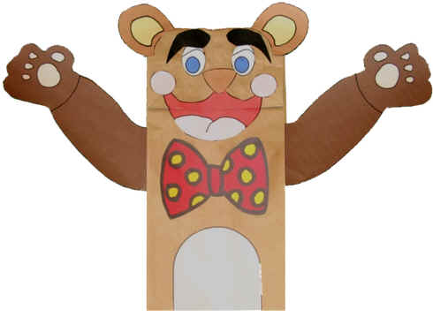
- A paper bag
- Crayons
- Scissors
- Glue
- Paper, preferably construction paper
Optional:
- Wiggly eyes
- Brown wool
- Brown paint
- Red pompom

Instructions:

- Get familiar with the paper bag, while it is lying flat. The side that is smooth is the back of the bear. On the other side is a flippy tab, which is the bear’s head. Underneath of this tab is the mouth. There is a flap of paper on the sides of the bag, which is where the arms will be slipped into.
- Give each child a copy of the templates, which they can colour and cut out. The pieces could also be coloured after gluing to the bag. This craft can be made simpler by using just template #1, or template #1 and template #2.
- Glue the mouth underneath the flippy tab, so that most of it shows when the tab is closed. Glue the second mouth piece on top of the flippy tab.
- Glue the nose onto the head above the mouth. As an alternative, a large red pompom could be used for the nose instead of the paper template piece.
- Glue the eyes onto the head above the nose. As an alternative, wiggly eyes could be used instead of the paper template eyes.
- Glue the cheeks and eyebrows onto the head.
- If using the arms from template #2, glue them into the flap
- If using the chest and bow from template #3, glue the chest onto the body at the bottom of the bag. Glue the bow under the mouth for a boy bear or on top of the head for a girl bear.
- The bear can be considered finished at this point. If desired, the body and back can be decorated with the brown yarn, brown paint, or crayons.

Template #1

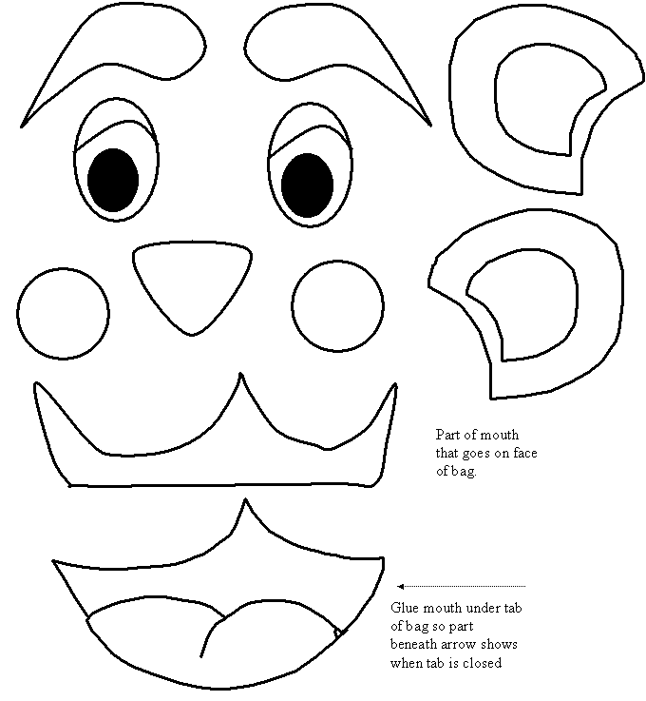

Template #2
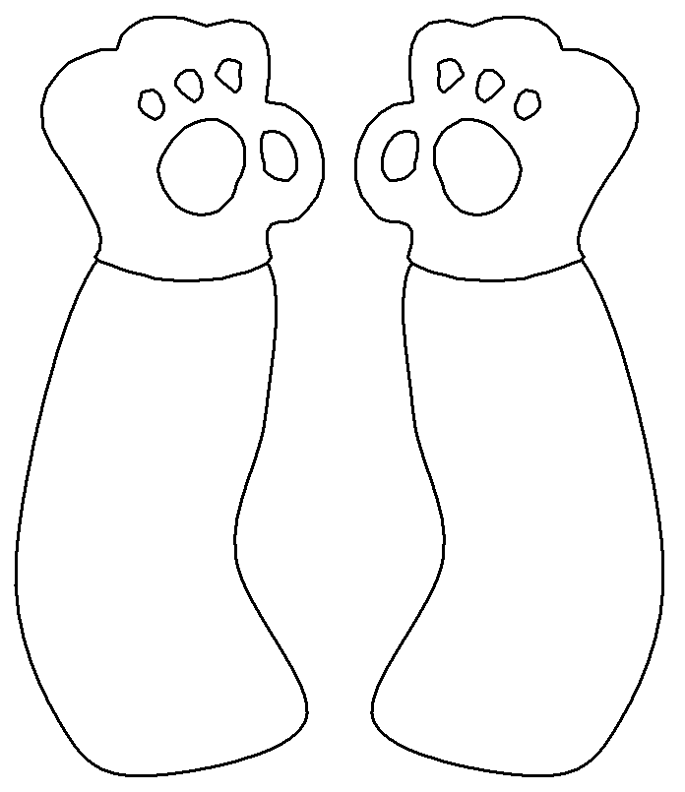

Template #3

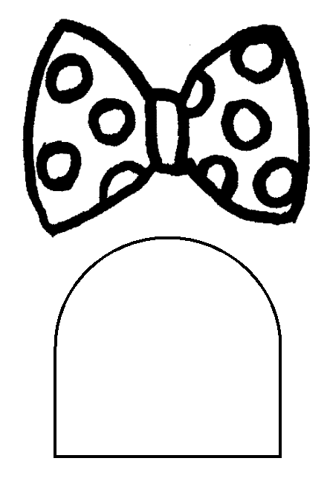

Craft for: Bad Bears go Visiting

Puffy the Polar Bear

Materials:
- Toothpicks
- 2 large marshmallows
- 6 mini marshmallows
- 2 white jelly beans, halved
- Royal icing (you can use glue, but the bears won’t be edible)
- 1 brown mini M&M
- Scissors
- Black shoestring licorice

Instructions:

- Have the children attach the two large marshmallows together with a toothpick to make Puffy’s body and head.
- For each arm, the children can thread two mini marshmallows onto one end of a toothpick and poke the other end into the body. For each leg, do the same, but use one marshmallow for the leg and one half of a white jelly bean for the foot (so the bear will stand up more easily).
- Using royal icing, have the children glue on two jelly bean halves for ears and the M&M for a nose. Snip two short licorice lengths and glue them in place for the eyes.

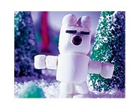

Craft for: Bearcub and Mama

Pom Pom Bear

Materials:
- One 1 ½" pompom (body)
- One 1" pompom (head)
- Two 5/8" pompoms (legs)
- Two ½" pompoms (arms)
- Two 3/8" pompoms (ears)
- Black scraps of foam or small black pompom
- Two wiggle eyes
- Tacky glue

Instructions:

- Glue the head pompom onto the body.
- Glue the legs nears the bottom of the body.
- Glue the arms just above the legs.
- Glue the ears and the eyes onto the head.
- Either cut a small circle of foam for the nose or use a small black pompom. Glue onto the head.

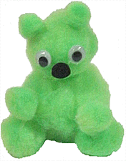

Alternate Craft: for Bearcub and Mama

Circle Bear

Materials:
- Glue
- Scissors
- Something to colour with
- Paper
- Optional: old CD

Instructions:

- Print out the template for each child.
- Have the children colour and cut out the pieces.
- The children can also sort the circles into big, medium, small, smaller and smallest.
- To put the bear together, the children can first glue the medium circle (the muzzle) onto the big circle (the head).
- Next they can glue the smallest circle (the nose) onto the muzzle.
- Finally, glue the small circles (ears) onto the head and the smaller circles (ear middles) onto the ears.
- As an option, glue the circle bear onto an old CD. You can cover with clear contact paper and use as a coaster.
- Another option is to have the children glue a tongue depressor or popsicle stick on the back to make a puppet.

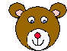

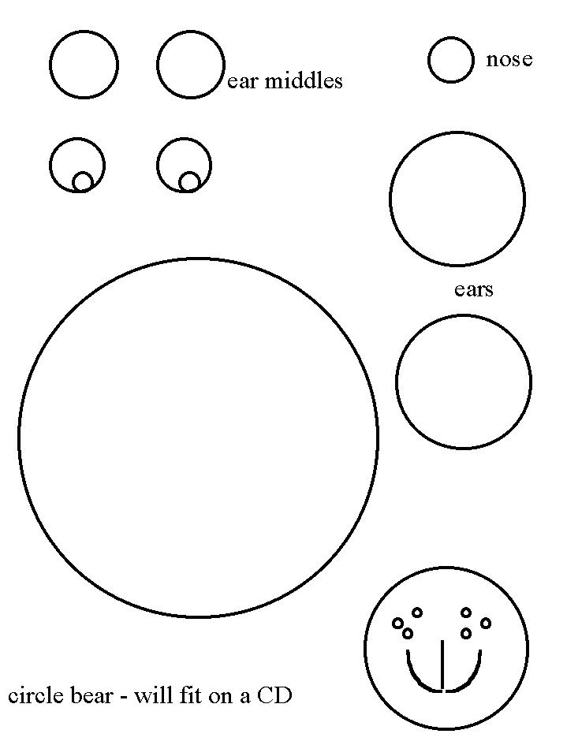
Craft for: The Bear on the Bed

Teddy Bear Rubbings

Materials:
- Paper doilies, sandpaper, or other textured paper
- Thin white paper
- Crayons
- Tape

Instructions:

- Create stencils from the bear templates. Copy the bear shapes onto the doilies or sandpaper, or both if desired.
- Either cut the bear shapes out of the textured paper beforehand, or have the children do this.
- Tape the cut-out textured bear shapes to the table in front of each child.
- Place the thin white paper on top of the bear shapes.
- Have the children rub a crayon over the bear shapes.
- The children can then create a scene on the white paper with the bear rubbings, such as trees, water, a bed, etc.
- If the white paper is too thin to use for a large picture, the bear rubbings could be cut out and glued to thicker paper.

Template
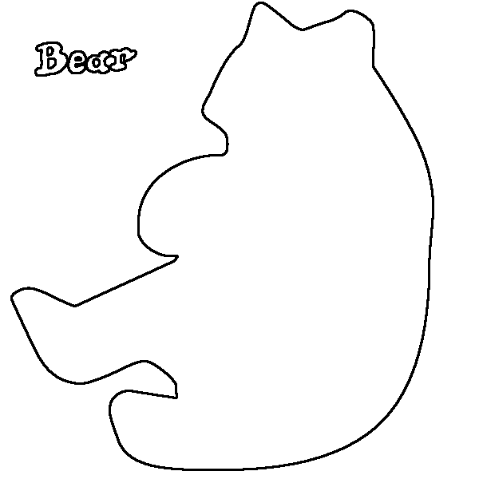
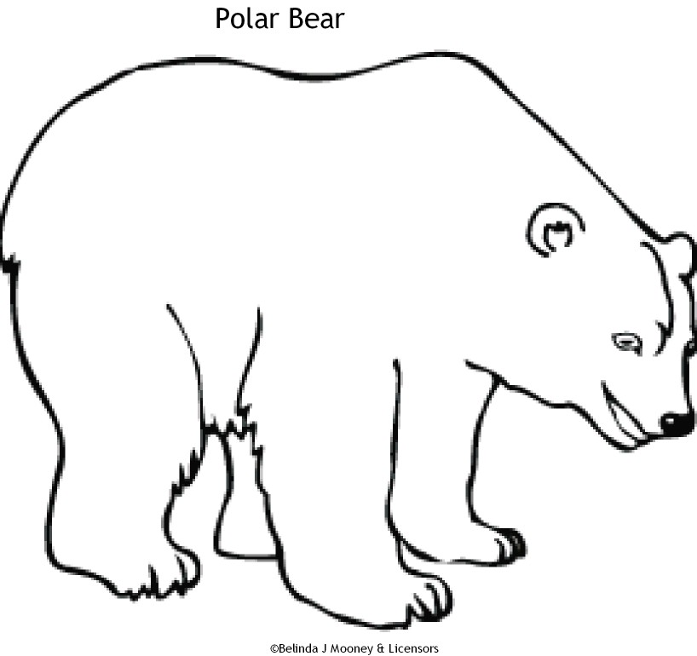

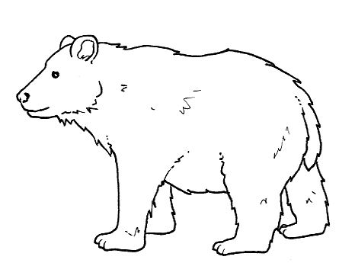
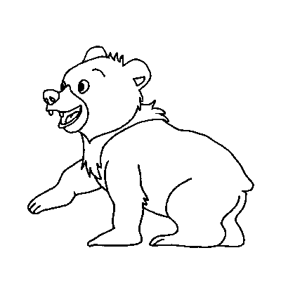

Craft for: Bear Snores On

Hibernating Bear

Materials:
- Cardboard
- Brown paper bag
- Tape
- Construction paper

Instructions:

- Make a copy of the bear template for each child.
- Have the children colour and cut out the bears.
- Give each child a square of cardboard and a paper bag.
- Have the children crumple the paper bag, and tape it to the cardboard in the shape of a cave, leaving an opening.
- Attach an L-shaped piece of cardboard to the back of each bear.
- The children can tape the bottom of the L-shape into the cave, so that the bear stands up.
- The children can then peek inside their caves to see the bears hibernating.

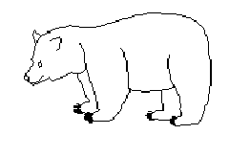

Alternate Craft for: Bear Snore On

Brown Bag Bears

Materials:
- Brown paper bag
- Newspaper
- Brown construction paper
- Markers or crayons
- Material for decoration bear-ribbon, pompoms, yarn, etc.

Instructions:
- Give each child a paper bag, and have them fill the bag with the crumpled newspaper
- Seal the bag shut with glue or staples.
- Have the children cut ears out of construction paper and glue to the top of the bear
- Facial features can be added with crayons or markers, or any suitable material on hand.
- Other decorations may be added, such as a ribbon around the neck, or a tuft of fur from yarn or pompoms on the top of the head.

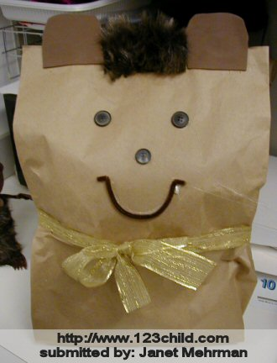

Craft for: Blueberries for Sal

Teddy Bear Bookmark

Materials:
- Colourful construction paper
- Colourful pipe cleaners
- Scissors
- Crayons
- Any other suitable material to decorate the bears with

Instructions:

- Print out the bear template on a variety of colours of paper.
- Give each child three bears in different colours to cut out.
- After the bears are cut out, the children can colour and decorate them as desired. Could also use small pompoms, small wiggly eyes, etc.
- Once the bears are decorated, the children can attach them to the pipe cleaners. This can be done by either threading the pipe cleaner through the bears, or gluing/taping the pipe cleaners to the back of the bears.

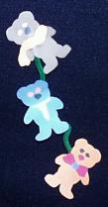

Craft for: Brown Bear, Brown Bear

Styrofoam and drinking straw puppets

Materials:
- Styrofoam trays (heavy paper or cardboard could be substituted)
- Drinking straws
- Pens, gel pens, or markers
- Tape
- Googly eyes
- Construction paper
- Optional: yarn for whiskers or hair

Instructions:

- On the Styrofoam trays, draw a picture of a bear and/or some of the animals Bear sees in the story.
- Have the children cut the animal shapes out, or have them pre-cut.
- Have the children add details to the animals. This can be done with the markers or pens. Features can also be cut out of construction paper and glued on. Yarn can be glued on the puppets for hair and whiskers.
- Glue on the googly eyes
- Tape the drinking straw to the back of the animal head.
- Children can do one or several of these puppets, depending on how well detailed the children make the features of their puppets.

Templates

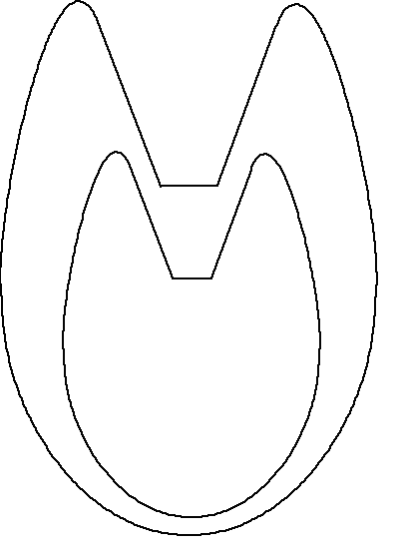Cat

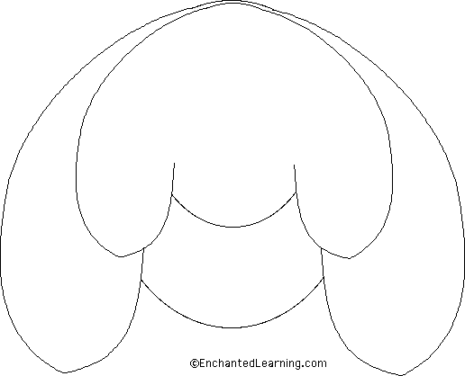Dog

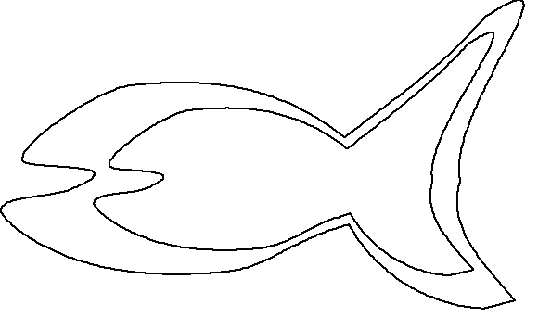Fish

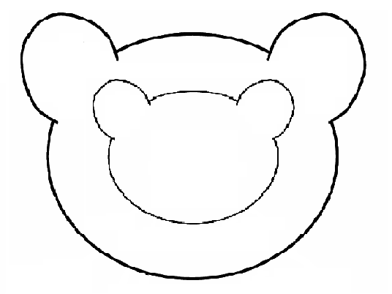Bear

Alternate Craft for: Brown Bear, Brown Bear

Bear Over the Mountain Puppet

The following craft is from Crafts from Your Favorite Children’s Songs by Kathy Ross.

Craft for: Climb the Family Tree, Jesse Bear

Create a Family Tree

Materials:
- Paper
- Scissors
- Glue
- Something to colour with

Instructions:

- Print out the template for each child.
- Have the children fill in the boxes as per the direction on the template. They can fill in as many or few boxes as they want.
- To stay with the bear theme, the children could draw their family members as bears. Have a bit of fun with this.
- Instead of using the template tree, the children could draw their own trees to put their family members on.
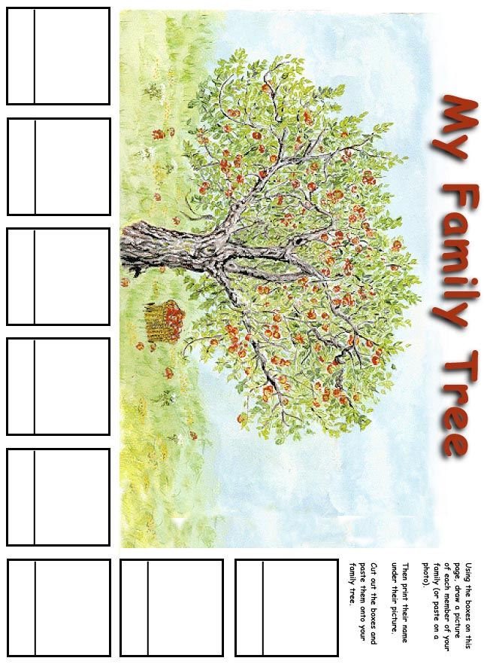
Craft for: Dusty Locks and the Three Bears

Paper Plate Teddy Bears

Materials:
- Brown paint, brown crayons, or brown construction paper
- Paper plates
- Red construction paper
- Brown yarn
- Black pompom

Instructions:

- Have the children paint the plate brown, colour it with crayon, or cover with brown construction paper.
- Add construction paper ears, eyes, and bow tie/hair bow. The children can either design these parts themselves, or cut out a template.
- Draw on a mouth and glue on the black pompom nose.
- Glue on brown yarn for hair.
- The children can also design a cowboy hat, or colour and cut out a template, to put on their bears.

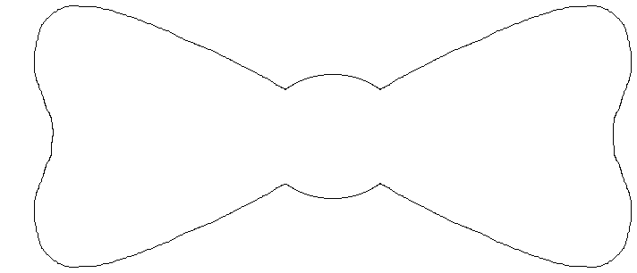

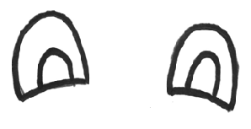
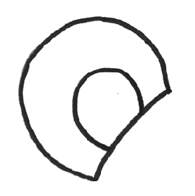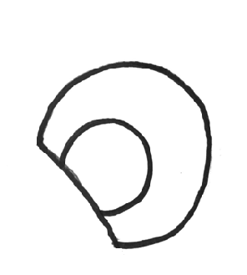

Craft for: Goldilocks Returns

Wake-up Bear Bag Puppet

The following craft is from Crafts to Make in the Spring by Kathy Ross.

Craft for: Goldilocks and the Three Bears

Bear Finger Puppet

Materials:
- Construction paper- either in brown, or white for the children to colour
- Scissors
- Glue
Optional
- Stapler
- Tape
- Hole punch
- Yarn

Instructions:

- Print the template onto the construction paper. The children could do one bear, or could also do all three bears.
- Have the children glue around the edges of the body to make a pocket for their fingers.
- Glue the ears and paws onto the bear.
- Draw a face on the bear, and any other features as desired.
- If the glue will take to long to dry for the children to use the puppets, then the puppets could be sealed with staples or tape.
- To make the project a bit more interesting, there could be holes punched around the side of the bear, which the children could sew shut with yarn.

Baby Bear

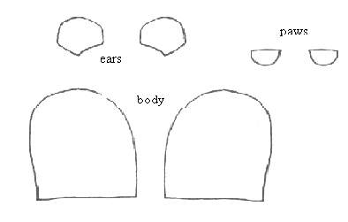

Momma Bear

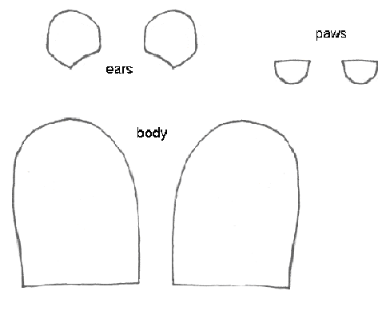

Papa Bear

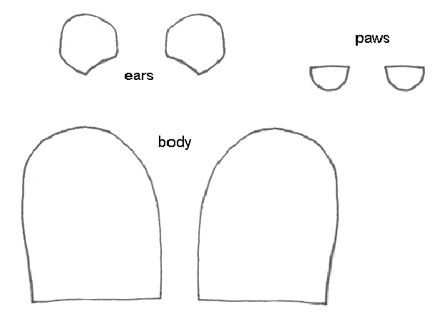

Craft for: One Dark Night

Bear Yarn Bug

Materials:
- Brown Yarn
- Brown craft foam and/or heavy paper
- Empty egg carton or Styrofoam ball
- Square of heavy cardboard
- Wiggly eyes

Instructions:

- Print pattern for ears, nose, and feet onto paper. If using craft foam, print on regular paper, staple to the foam and trim the outlines. Either cut the pieces out ahead of time or have the children cut their own pieces out.
- Make a pompom by wrapping yarn around the heavy cardboard at least 100 times.
- Cut a 6 inch piece of yarn and slide it under one side of the wrapped yarn and tie tightly.
- Turn the yarn wrapped cardboard over and cut completely through the yarn on this side. Turn the yarn blob sideways and smooth down strands
- Give each child either one section of the egg carton or a Styrofoam ball.
- Glue the egg carton or ball to the feet.
- Glue the pompom to the carton or ball.
- Glue on the eyes, nose, and ears.

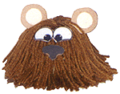

Templates

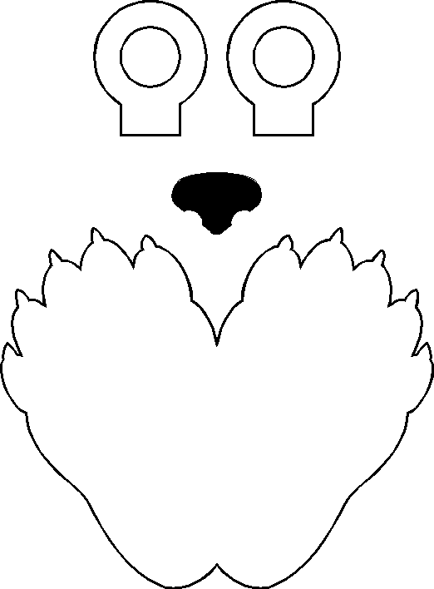

Alternate Craft for: One Dark Night

Toilet Roll Golf Bear

Materials:
- Toilet paper tube
- Paper
- Crayons
- Scissors
- Glue

Instructions:

- Print out the template for each child to colour and cut out.
- The children can then glue the large rectangular piece on first to cover the tube.
- Next, the children can glue on the head, legs, arms and golf club.
- Glue on the tie for a formal golf date with the boss or leave it out for a less formal look.

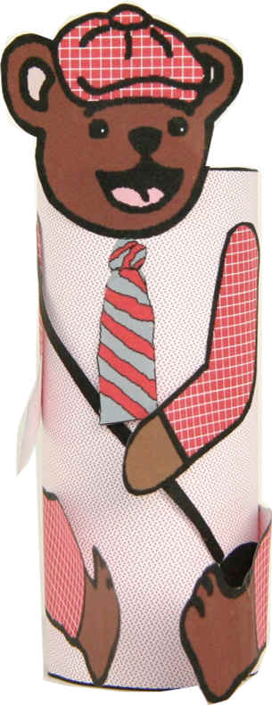

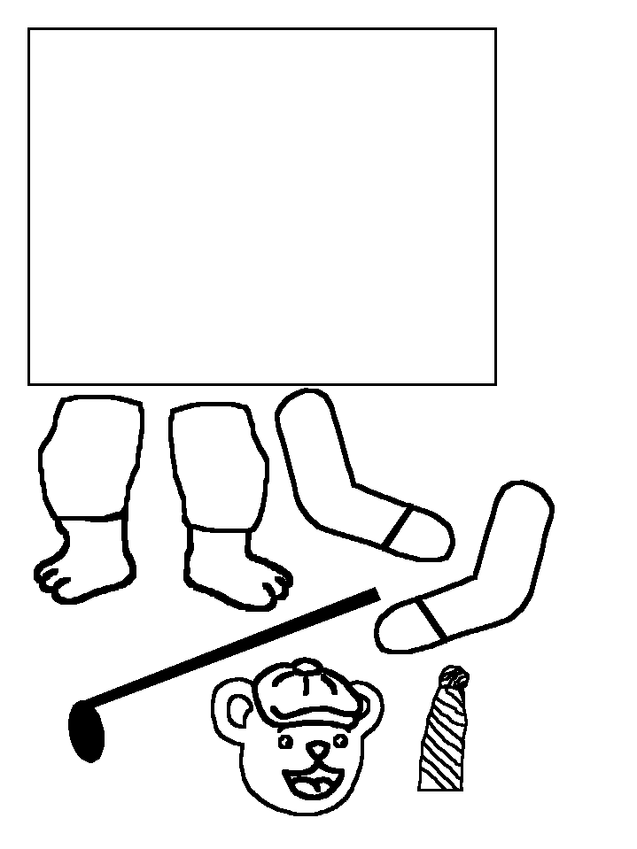
Craft for: Panda Bear, Panda Bear

Hearts Panda Craft
This craft can be completed with just the head for an easier craft, or with the head and the body.

Materials:
- Paper
- Black and red crayons or markers
Optional:
- Wiggly eyes
- String
- Craft stick

Instructions:

- Print a copy of the template for each child.
- Have the children colour each heart accordingly (the grey heart is coloured red, the large hearts are white, and the rest are black), and cut out. Alternatively, the hearts could be cut out in advance.
- Show the children how to glue the hearts together in order to make the panda.
- Wiggly eyes can be used instead of the paper template eyes.
- A piece of string can be attached to the back of the panda so it can be used as a decoration.
- A craft stick can be attached to the back of the panda head so it can be used as a puppet.



Head Template
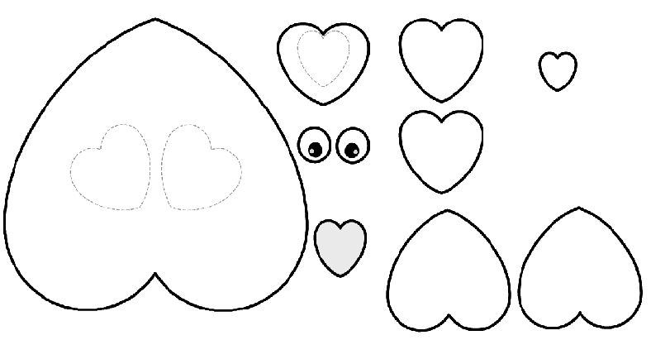

Body Templates

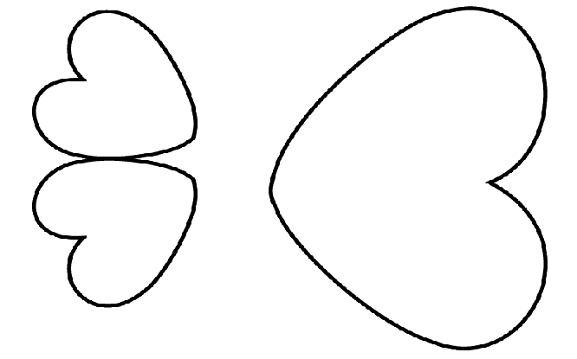

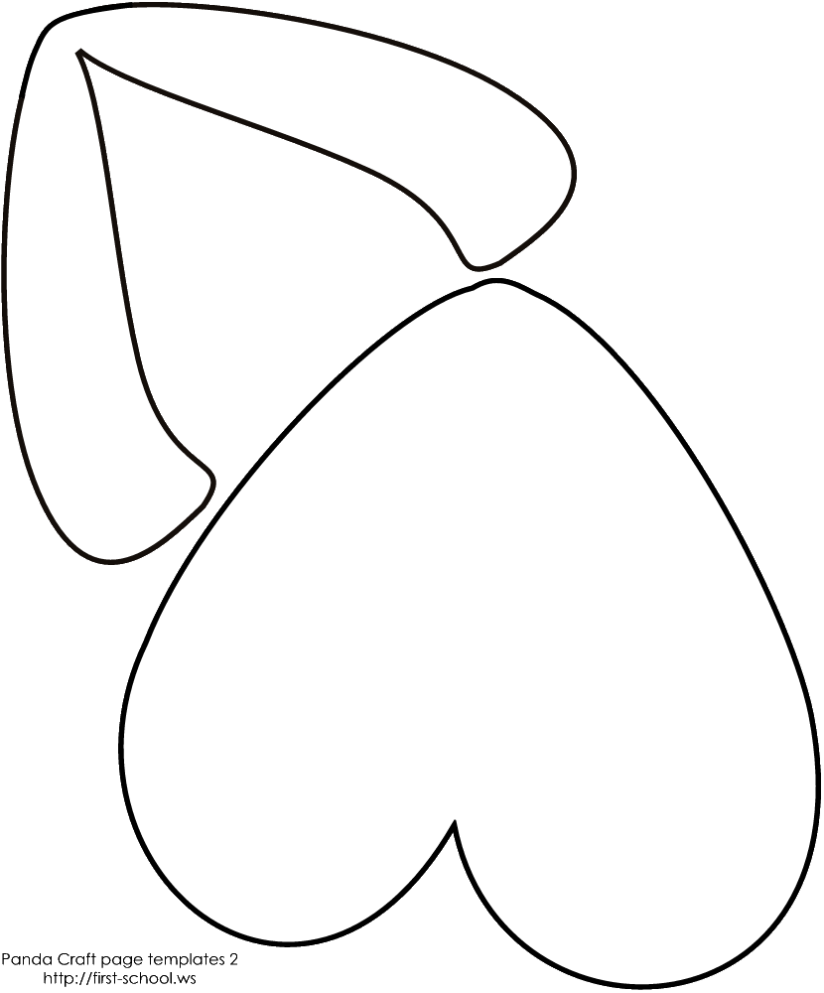

Craft for: Rainy Days with Bear

Teddy Bear Ears

Materials:
- Brown construction paper
- Glue or tape or stapler

Instructions:
- Measure each child’s head, and cut a piece of construction paper long enough to create a headband.
- Glue, tape, or staple the headband together.
- Have the children draw what they think their bear ears should look like, or simply use the template ears.
- The children can cut their ears out, and decorate a little with any suitable material on hand if desired.
- Attach the ears to the headband.
- The children can pretend to be bears with their headbands on.

Template

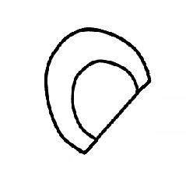
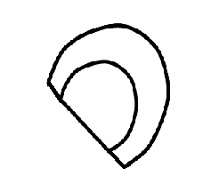

Alternate Craft for: Rainy Days with Bear

Bear Puzzle

Materials:
- Plain white paper
- Heavier weight paper
- Scissors
- Glue
- Something to colour with

Instructions:

- Print out the template for each child.
- Have the children glue the template onto the heavier weight paper.
- The children can colour the picture.
- Next, cut the picture out along the puzzle template lines.
- The children can try to put the puzzle back together again.
- To make it a bit harder, cut the puzzle into smaller pieces.

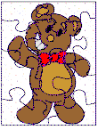

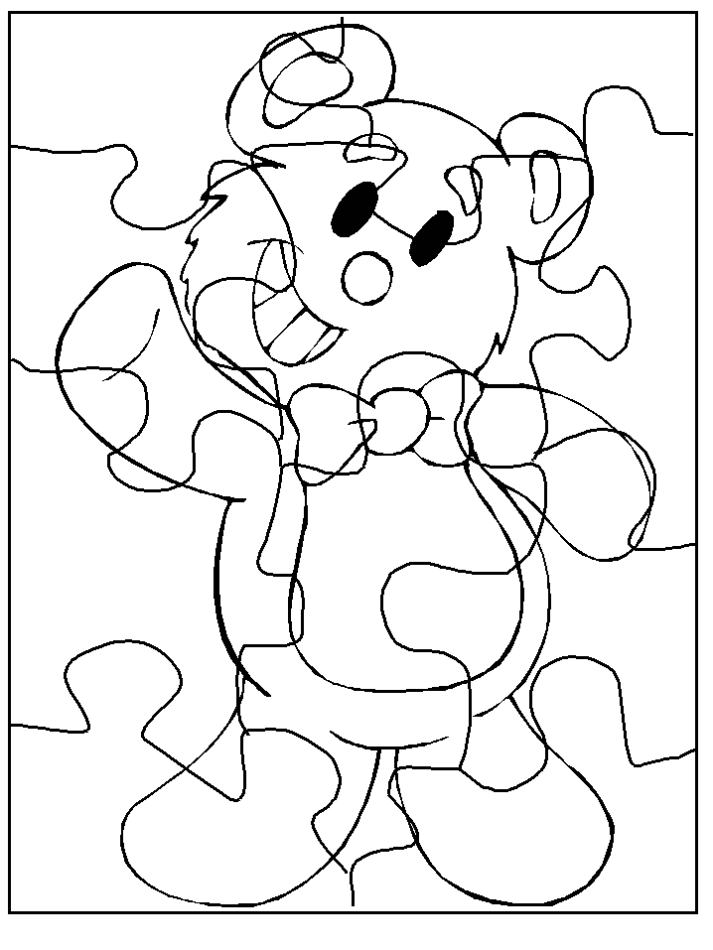
Craft for: The Three Bears Christmas

Jointed Bears

Materials:
- Brown paper, preferably heavier paper
- Metal fasteners
- Crayons, markers, etc for decorating

Instructions:

- Print the template onto brown paper for each child. Or draw your own for a fatter teddy bear.
- Have the children cut out the pieces of the bear.
- The arms, legs, and head can be attached with the metal fasteners so the parts can rotate.
- Have the children draw a face on their bear, and any other features they would like, such as a Santa hat to go with the story.

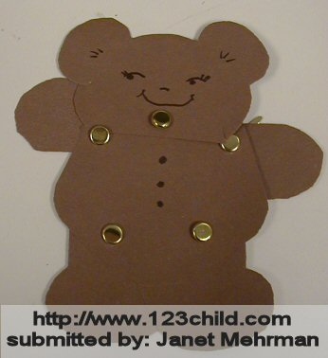

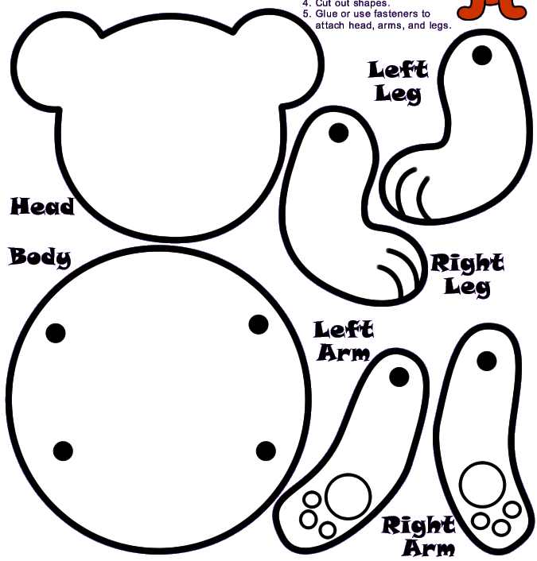

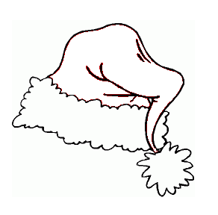

Craft for: Tom Goes to Kindergarten

Panda Mask or Wall Hanging

Materials:
- Paper plate
- Black, white, and brightly coloured construction paper
- Black crayon
- Stapler
- Optional: yarn, if creating a face mask
- Glue
- Scissors

Instructions:

- Print out the templates for the ears, eye patches, and nose on the black paper. Print out the bow template on the brightly coloured paper. If not making a mask, print out the eye template on the white paper.
- To make the mask, hold each child’s plate up to his or her face. Lightly mark on the plate where the child’s eyes are. Assist the children in cutting a small circle for their eyes.
- Have the children cut out the template pieces.
- Show the children where on the plate to glue the black eye pieces and the ears.
- If not doing the mask, glue the eyes on.
- If doing the mask, cut a hole in the black eyes over top of the hole already cut in the plate.
- Staple the bow to the bottom of the plate.
- To finish the mask, use a hole punch to make a hole in each side of the plate. Tie a piece of yarn through each hole. The two pieces of string can be tied around the child’s head.
- To finish the wall hanging, attach a loop of yarn to the back of the plate.
- The children could also decorate their bows if desired.

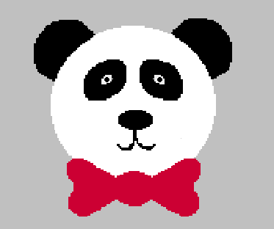

Eye Patches
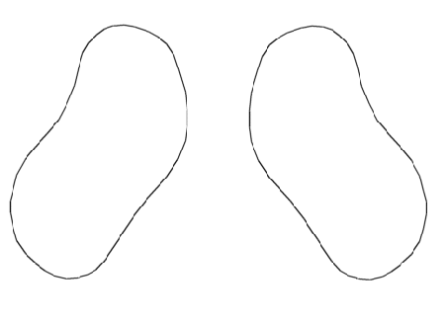
Eyes
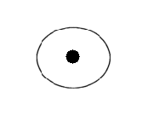
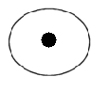

Nose

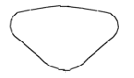

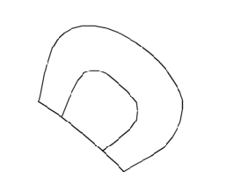
Ears
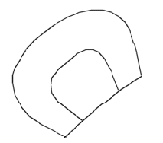

Bow

Craft for: Victor Vito and Freddie Vasco

Postcards

Materials:
- Card stock
- Something to colour with
- Stamps (or something similar)

Instructions:

- Cut the card stock into postcard-sized pieces.
- Give each child a postcard (or more than one, however many you would like to do).
- Have the children draw a scene from Victor and Freddie’s trip on the front of the postcard.
- On the back of the postcard, the children can either write a message, or draw a small picture where the message would go. You may want to have a real postcard on hand to show the children where things go on the back of a postcard.
- Have the children sign their names on the bottom of their message or picture.
- The children can then add a stamp or something similar.
- On the back of each postcard, write a description of the picture on the front, like a real postcard.

Craft for: The Wild Girl

Coffee Bear

Materials:
- Tan paper
- Coffee grounds
- Glue
- Scissors

Instructions:

- Print out the template for each child on the tan paper.
- Have the children cut their bears out.
- The children can then spread glue over the bear and sprinkle with the coffee grounds, to make a great smelling bear!

Template
