Richard Kenig
richard@marigold.ab.ca
March 2019
Version 1.02
PLS Website Manual
EZ Platform

Contents
Logging In 6
Changing your Password 7
Moving to the New Platform 8
General Features 9
GoTo Top Navigation 9
eResources 9
Top Navigation 10
Contact Dropdown 10
TRACpac link 10
Search 11
How Content is Organized 13
Accessing Content 13
Finding Content 15
Creating Content 16
Editing Content 17
Saving Content 18
Preview your Page 19
Content Versions 20
Preview Version 21
Copy a version 21
Edit the current version 21
Compare two versions 22
Remove a version 22
Deleting an Item 24
Using the Editor 26
Main Content Body 26
Text Links 28
Edit a Link 29
Remove a Link 29
Internal Links 29
Open Links in New Window 31
Buttons 32
Images 34
Insert/Edit Object 37
Insert Custom Tag 38
Accordions 38
Blockquote 39
LibraryAware Widget 40
Youtube/Vimeo Video 40
Content Types 42
Content Title 42
General Page 43
Side Menu 43
General Page Fields 44
Static Link 45
Hero Image 45
Body 46
Galleries 47
Gallery Landing Page 47
Create a new Gallery Landing Page 48
Gallery 50
Date 50
Description 51
Adding Images to a Gallery 53
Title 54
Image 55
Caption 55
Uploading Multiple Images 55
Editing Gallery Images 59
News 61
News Page 61
Author 61
Date 62
Short Description 63
Image 63
Body 64
Contact Us 65
Custom Form 66
Description 66
Fields 66
Field Name 67
Required 67
Validators 68
Field Type 68
Re-Order Fields 71
Remove Field 72
Recipient 72
Thank You Text 72
View Form Submissions 73
Remove Form Submissions 74
Exporting Form Data 75
Viewing Registrations for Different Dates 76
Folder 78
Book List 79
Short Description 79
Read Alike Header 80
Books 81
Featured Book List 81
Importing a Book List 82
Events 84
Image 84
Date Information 85
Multiple Schedules 86
Location 87
Cost 88
Short Description 88
Description 88
Categories 89
Event Schedule Exceptions 90
Event Registration Forms 91
Fields 92
Registration/Wait List Limit 93
Recipient 93
Event Type Checkbox 94
Review Registrations 94
Home Page Objects 95
Banners 96
Title 96
Description 96
Image 97
Call to Action 97
Text Orientation 98
Blend Background Colour 98
Featured Cards 99
Code 99
Description 100
CTA Text 100
CTA Link 100
Background Image 100
Background Colour Overlay 101
Fun Facts 102
Title 102
Text 102
Background Image 103
Library Information and HomePage 104
Library General Information 105
Opening Hours 105
Opening Hours Description 107
E-mail Address 107
Social Media (Facebook/Twitter/Instagram etc) 107
Services Provided 108
Map Link 108
Newsletter 108
Support your library links 108
Design Template 110
Logo 110
Favicon 110
Map 111
Theme Colours 111
System 115
Homepage 116
Banner Carousel 118
News 121
Events 122
Book List 122
Fun Fact 124
Featured Cards 126
Menu Structure 128
Link Order 129
Creating Links 131
Internal Link 131
Link 133
Main Menu 134
Main Menu Item 135
Title 135
Links 135
Menu Column 137
Title 138
Image 138
Image Description 139
Links 139
Sub Menu Item 140
Title 140
Display as Header 140
Links 141
Quick Links 142
Copyright Links 143
Advanced Tips 144
Testing 144
Navigation 145
Breadcrumbs 145
Moving between edit and live 145
Create Here 146
Manipulate Content 147
Move or Copy Content 148
Change Page URL 152
Hide a page 154
Custom Code 156
Creating an HTML Block 156
Embedding HTML Block 157
Version History 158
Version 1.02 158

Logging In

First navigate to your logon page by typing the address in your address bar. This will always be: http://manage.production.peacelibrarysystem.ab.ca
You will be prompted for credentials to access the staff site:
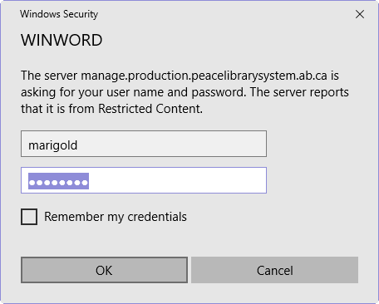
Both the username and password are “marigold”
You will then be directed to the main login page:
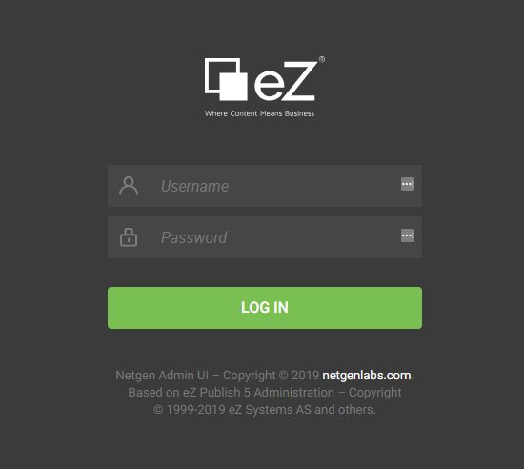
Enter your username and password – your username will be in the form: name@library.com (your email address)

Changing your Password

While logged in to the site. Click on user symbol in the lower left corner of the screen. Then click on “Change Password” on the slider that opens out. Clicking on Change Information will let you edit your password and email address.
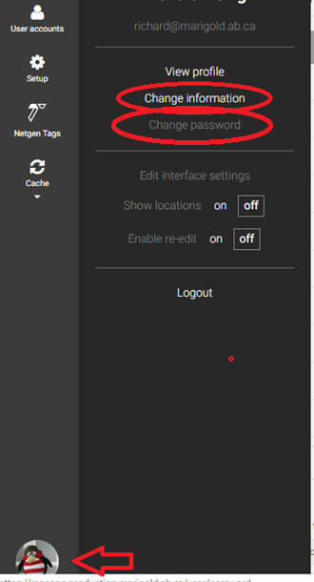
This will open your account in the main content area. Click in to the Password fields, then click on the “Send for Publishing” link in the upper right.

Moving to the New Platform

While you are building your website on the new platform we want to make sure that the current website is still visible and functional for users while providing you the ability to create and view your new website. Until your “live” website is directed to the new platform, you can view your “new” website at a URL similar to the following:
https://library.production.peacelibrarysystem.ab.ca
Replace “library” with your library name; for Valleyview it would be:
https://valleyview.production.peacelibrarysystem.ab.ca
Once you have completed your website (or are satisfied with your progress and would like to transition), please contact Peace Library System IT to have your domain directed to the new website.

General Features

There are several features on the website that have been pre-designed and are not directly customizable. They function the same on everyone’s website and are generally designed to provide a specific function to the users.
These items are:
- GoTo Top Navigation
- eResources
- Top Navigation
  - Contact Dropdown
  - Tracpac Login
- Search

GoTo Top Navigation
While exploring the website and scrolling down you will see a small arrow appear in the lower right corner of the screen.
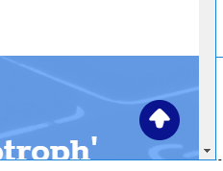
You can click on this arrow to return to the top of the screen at any time.

eResources
The eResources are added and updated by PLS staff. Each site has access to an eResources page (http://www.mylibrarysite.com/eResources). This page is sorted alphabetically. Users can filter based on multiple criteria to locate a type of resource, or they can do a “ctrl+f” find to locate a specific resource on the page.

Top Navigation
There are two links on the top bar of your website. The first is a Contact Dropdown, the second is a link to TRACpac.

Contact Dropdown
The contact dropdown is dynamically generated by information you have filled out about your website (see “Library General Information” section below for how to edit).
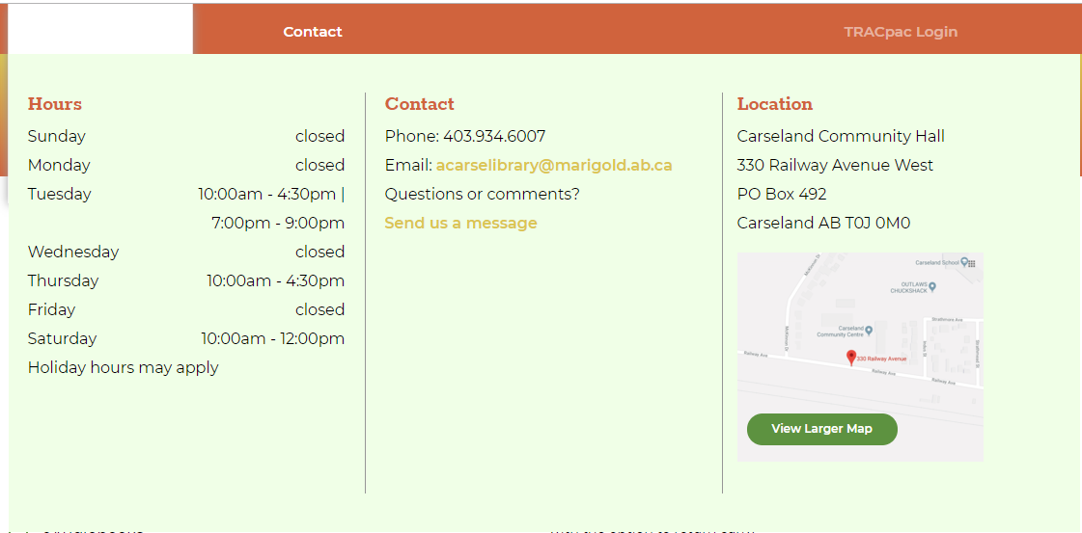
Clicking on the “Contact” link will take a user to the Contact Us Page.

TRACpac link
This link takes a user directly to their login page on the PAC.

Search
Clicking on the magnifying glass in the header will open the search screen.
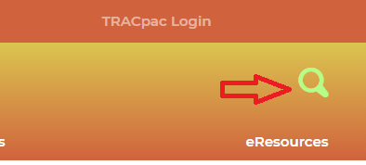
By default the search screen will search TRACpac using a Keyword search. The search can be changed by clicking the dropdown and selecting Website.
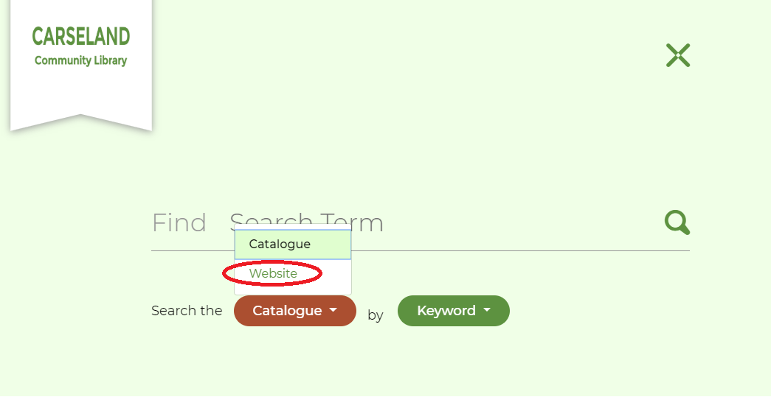
Or by clicking Keyword and choosing a different search type for the catalogue.
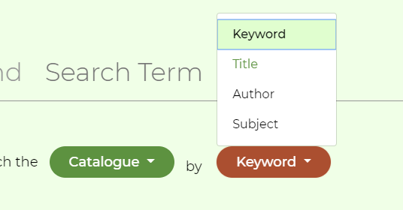
When searching the website users can filter their results by content type to more easily find what they are searching for.
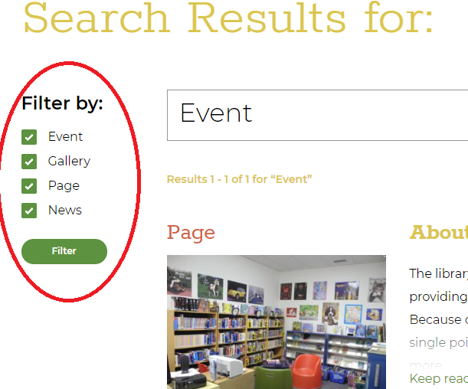

How Content is Organized
This section explores how to use the platform editor and how to move around to add/edit content.

Accessing Content
When first logging in to the site you will be shown the content structure and general content page.
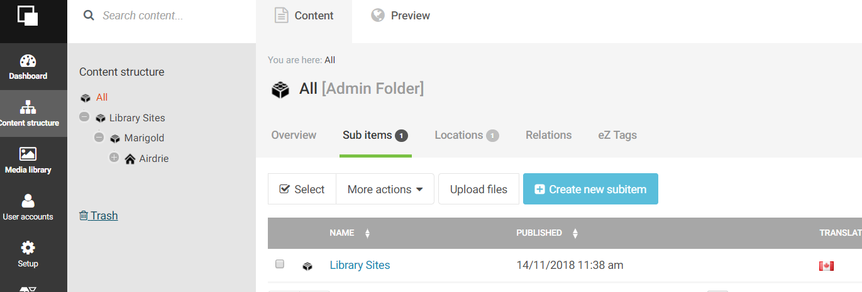
The Black bar on the far left will allow you to navigate through the administrative parts of the site. You will only need to access the “Content Structure” (where you are now), and the “Media Library”.
The “Content Structure” appears in a “tree” format where you can open and close various branches of the tree. Click on the + symbol next to your library to expand the content tree.
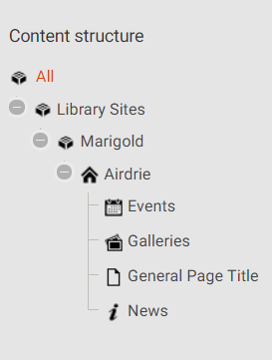
General pages and other content categories will appear here for quick access. Primarily you will interact with your site through the main content structure panel. Click on the name of your library to open it for editing.
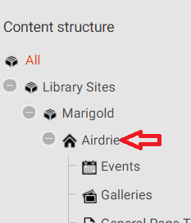
This will open the content structure of your site in the main window
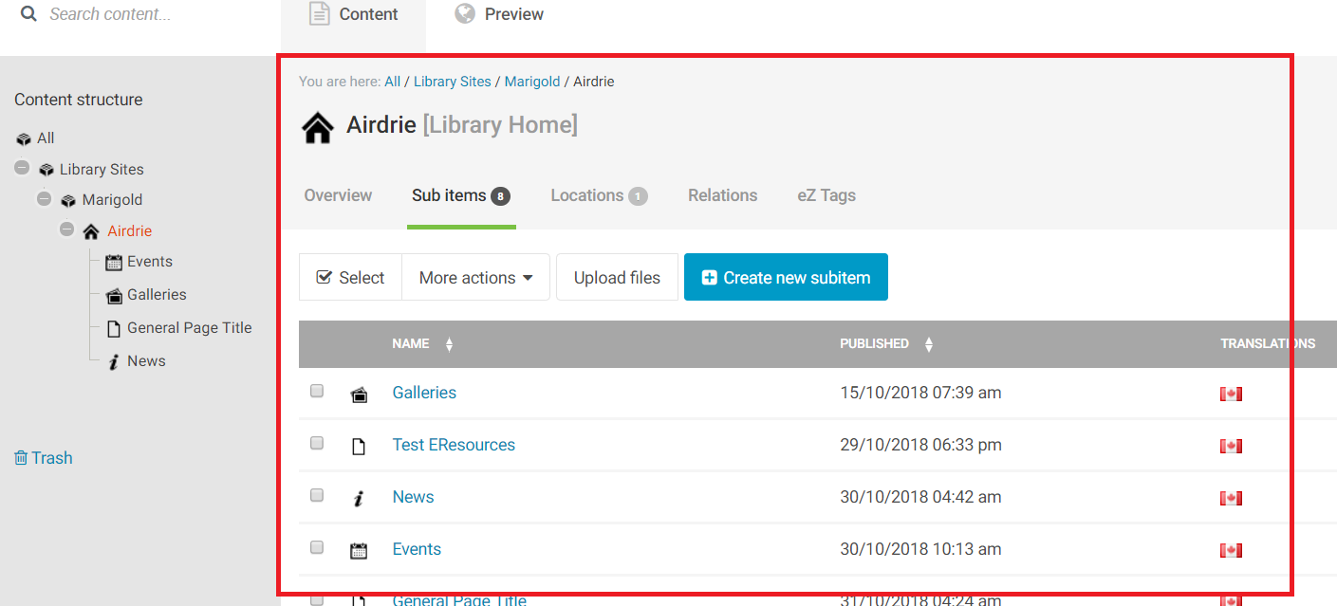
Clicking on an item in the content list will open that item for editing.

Finding Content
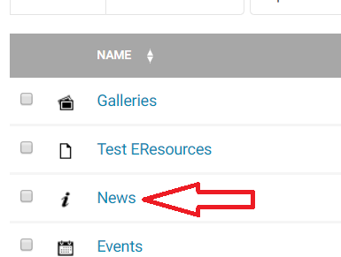
This opens the News container to view the news items
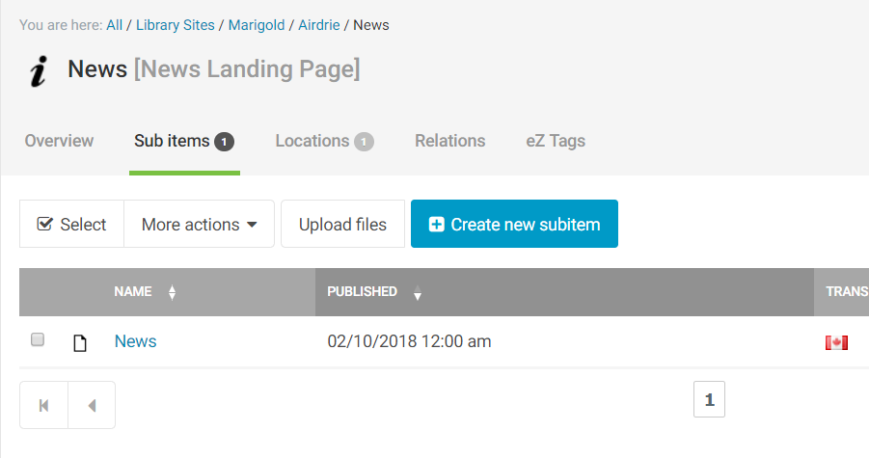

Creating Content
To add a new piece of content, click on the “Create new subitem” button, then select the type of content you want to create.
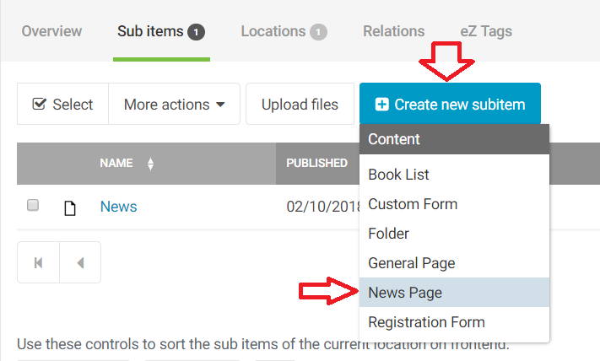

Editing Content
You can edit the page you are currently on by clicking the Edit link in the upper right.
Edit a piece of content in the list by clicking on the icon next to it and selecting edit.
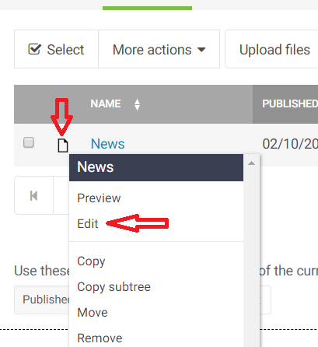

Saving Content
While you are editing content, the navigation bar will be greyed out and you will be unable to click on anything. Across the top of your screen you will see the editing buttons
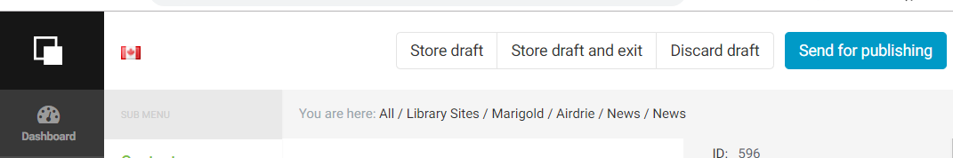
“Store Draft” saves your current draft and keeps you on the editing page.
“Store draft and exit” saves your changes to the draft, then exits the editor page and takes you back to the previous content container.
“Discard draft” removes any changes you have made and takes you back to the previous content container.
“Send for publishing” saves your changes and updates the website with the new changes.
NOTE: Saving drafts does not update what people see on the website, only when you publish the page does the website change. Drafts are saved in the background, so you can make changes without affecting the site, and then later publish the changes when you are finished editing.
NOTE: To see changes made to the live site, you must refresh the page twice. If the content does not appear, make sure you have published the draft, then contact support.

Preview your Page
While editing a page you will find the “Preview” button on the right side of the screen.
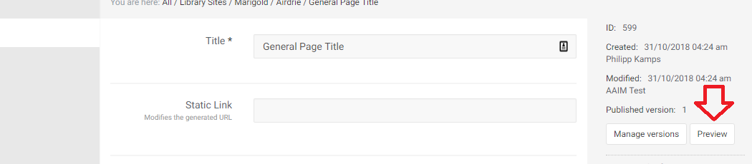
Clicking on this button will load the current draft that you are working on, so you can see how the changes you have made will look on the live version of the site.
There are several buttons across the top of the preview page where you can change the “size” of the page to see what it will look like on mobile devices.
To return to editing click “Back to Edit.”
To save your changes and update the live version of the site click “Publish.”

Content Versions
Whenever a draft is saved and/or published to the site, a new version is created. Old versions are stored so they can be referenced (or reverted to) later. To access these click on the “Manage Versions” button while editing a piece of content.
This will take you to the versions page
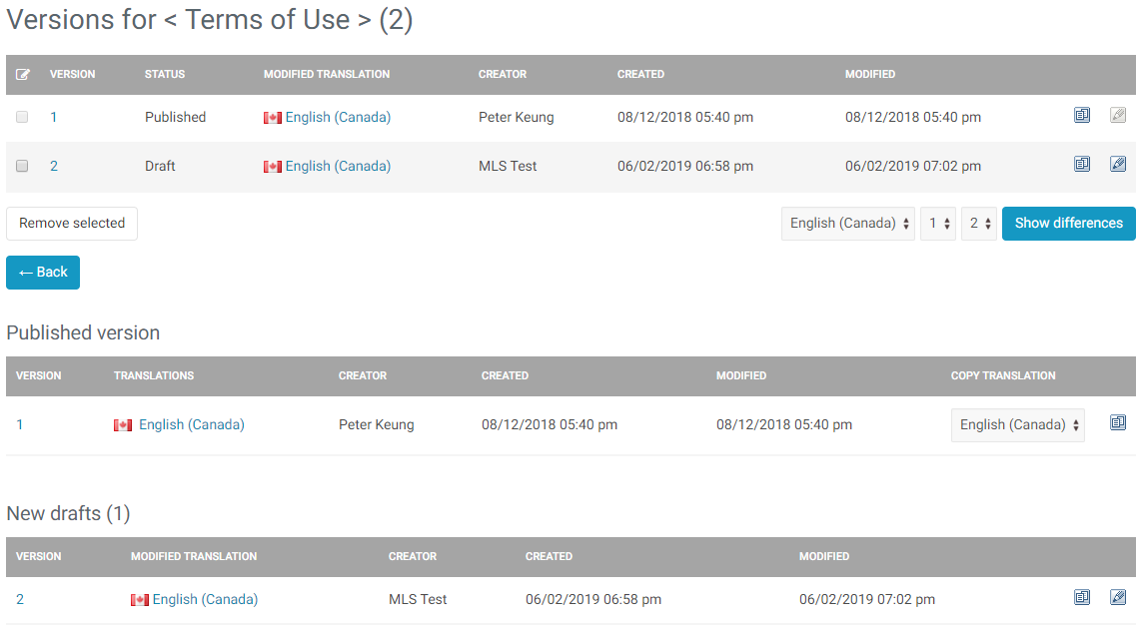
There are multiple things you can do at this stage. You can:
- Preview the different versions
- Copy a version to overwrite the current version
- Edit the current version (or draft)
- Compare two different versions
- Remove a version (delete current or older version)

Preview Version
Click on the number under the “Version” heading to launch a preview of the version.
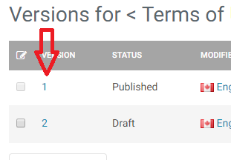

Copy a version
Click the copy icon to the right of the version you want to copy (and overwrite the current version).
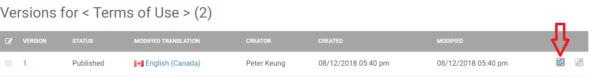
This will create a new draft version.
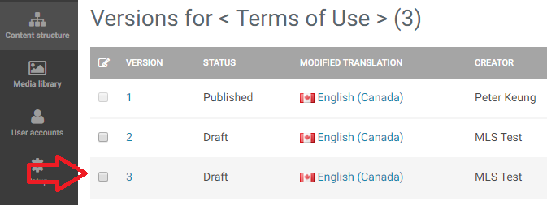
Which you can then edit and publish. This new draft will become the current version when published.

Edit the current version
Click on the edit button on the right of the page to open the version for editing. Only the most recent version, or draft versions, can be edited.
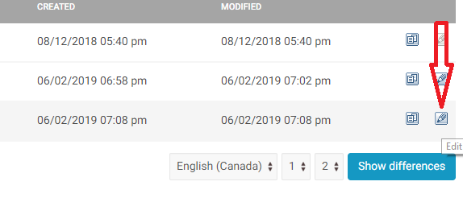

Compare two versions
Use the option boxes on the lower right to select versions to compare, then click “Show Differences.”
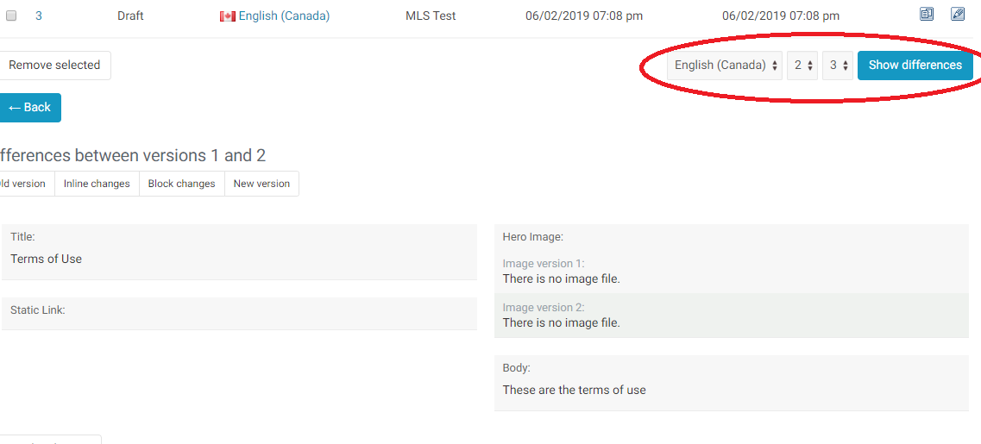
You will be shown the differences between the two versions underneath.

Remove a version
Click on the checkbox to the left of the version to select it, then click “Remove Selected.” This will remove the selected version from the list.
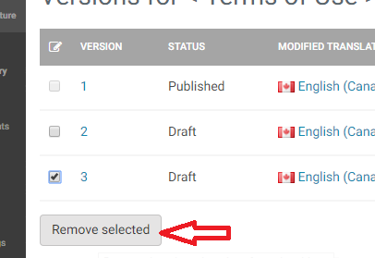

Deleting an Item
You can remove items in multiple ways.
Navigate to the container of the item and click the icon next to it to bring up the menu. Select “Remove”
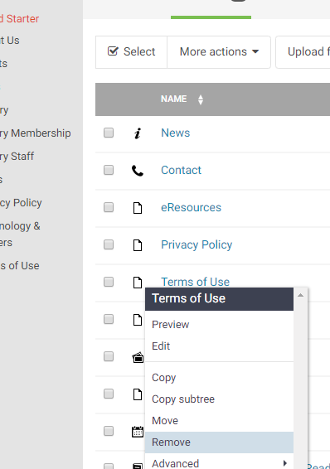
Navigate to the page itself and click the “…” icon next to the edit button and select “Remove”
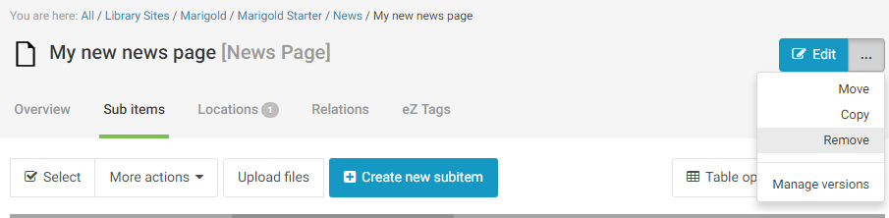
You will be asked to confirm the removal.
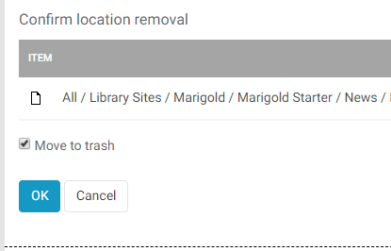

Using the Editor

Filling in content on the site is a simple process. Each time you create a new content type you will be asked to fill in a form with the data that you want to be displayed. The form is laid out top to bottom with only a few required fields. Each content type has different fields to fill in and those will be explained in more detail in the Content Types section.

Main Content Body
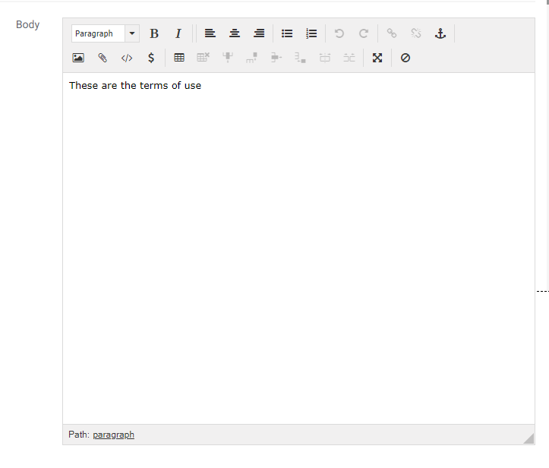The editor that you will be using is referred to as a WYSIWYG (What you see is what you get) editor. This means it has buttons along the top of the screen that perform functions for you. By clicking on those buttons you can format the page to your preferences.
You should be familiar with many of the buttons from other text editing programs. They perform the same ways. Hovering over a button for a few seconds will display a small popup briefly explaining the purpose of that button.
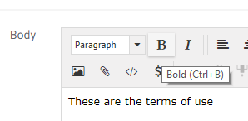
In the editor, in addition to basic formatting, you can add the following:
- Text Links
- Tables
- Book Lists (use the paperclip “Embed” icon)
- HTML Blocks (use the paperclip “Embed” icon)
- Accordions (use the </> “Custom tag” icon)
- Blockquotes (use the </> “Custom tag” icon)
- LibraryAware widgets (use the </> “Custom tag” icon)
- YouTube videos (use the </> “Custom tag” icon)
- Vimeo videos ((use the </> “Custom tag” icon)
- Buttons (select the appropriate class when editing a link)
- Images, with optional right/left floating

Text Links
To create a link either to another page on the website, or to an external page, enter the text that you would like to convert. Select it, and then click the “Edit/Insert Link Button”.
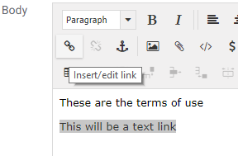
This will open the new <link> window
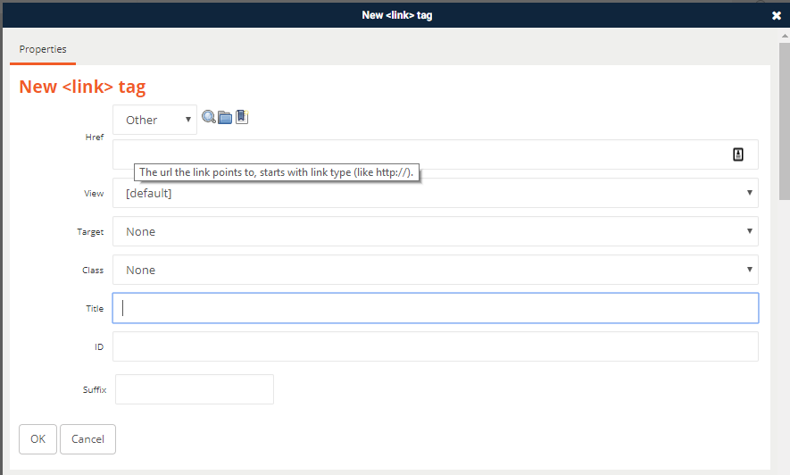
If you hover over one of the text fields, the system will prompt you for the type of information to provide. As above, in the Href field it is asking for the http:// link to the item.
Once you have filled in the information (only the Href field is mandatory) click “OK” to save the link.
The link will now appear as a link in your content editor.
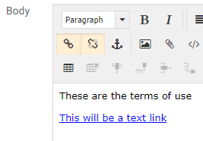

Edit a Link
To make changes or edit a link, place your cursor inside the link and click the “edit/insert” link button.

Remove a Link
To remove a link, place your cursor inside the link and click the “unlink” button.

Internal Links
If you are linking to another page on the website, you can either fill in the web address in the Href field, or click the “Search” or “Browse” buttons to locate the page on the site.
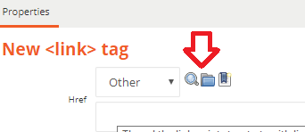

Searching for Links
Clicking on the search button will bring up the search page. If you know the name of the page, you can type it in the search bar. If you don’t know the name, or know only part of the name, use “*” as a wildcard to search for all “like” pages.
You can filter your results by content type by selecting the type of content you are looking for from the content type list.
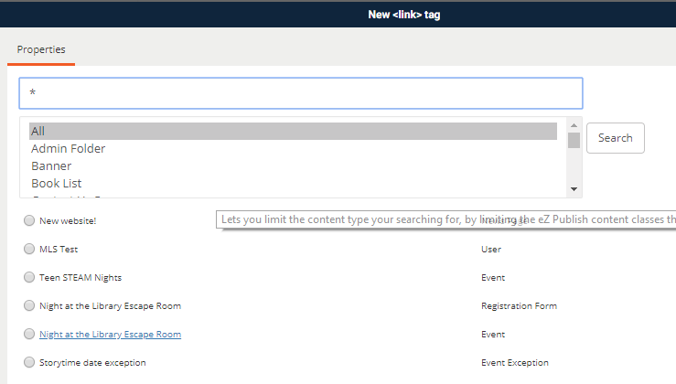
Once you have found your content, click on the button to the left of it. This will import the node ID into the link.
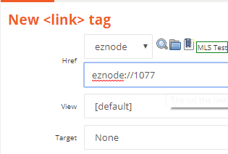
If you can’t find your page, click the red X in the upper right to return to the link screen.

Browsing for Links
Clicking the Browse button will open the media browser. If you are linking to another content page, you will look for content. If you want to link to an image, file or other type of object you will click on Media at the top.
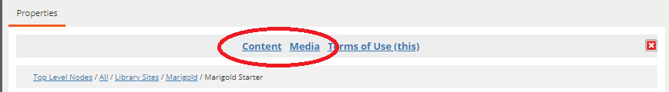
By default, you will be in the “Content” area.
Click on the links to open the content folders, or select the item by clicking the button to the left of it.
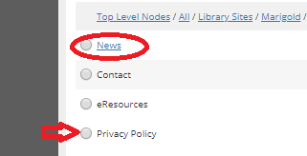
If you can’t find your page, click the red X in the upper right to return to the link screen.

Open Links in New Window
If you want your link to launch in a new tab, select “New Window” from the target dropdown.
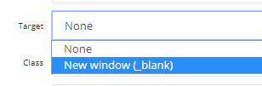

Buttons
Buttons are created in the same fashion as text links. Add the text in the editor, then select it and click the “edit/insert link” button.
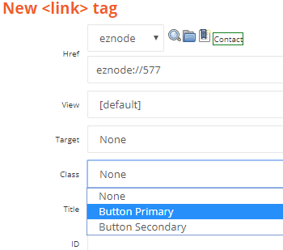
In the “Class Field” select either Button Primary, or Button Secondary. The buttons use the colours from your website template.
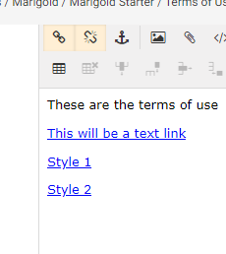
These will appear the same as text links in your editor but will show as buttons when the page is published.
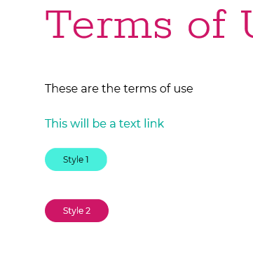

Images
Images can be inserted by clicking on the “Insert/Edit Image” button.
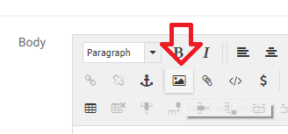
This will open the “Upload New Image” window.
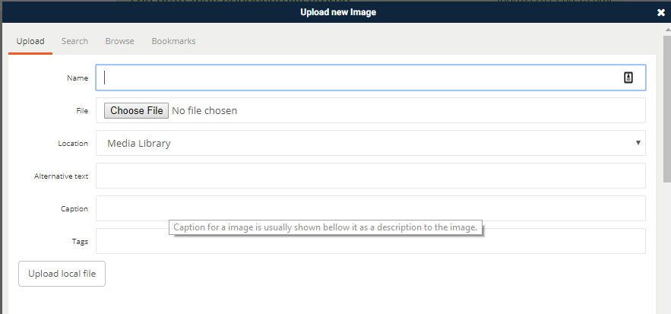
You can use an existing image by Searching or Browsing for it in the same manner as creating a text link (see Text links section). To upload a new image from your computer, type in a Name for the image, then click “Choose File.”
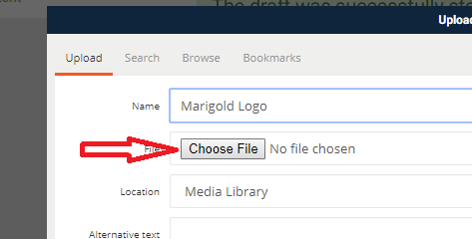
Select the image from your computer.
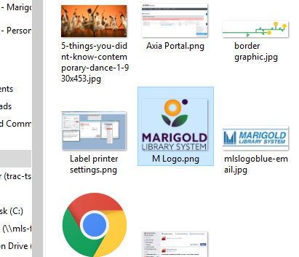
Fill in the other fields as necessary, then click “Upload Local File.”
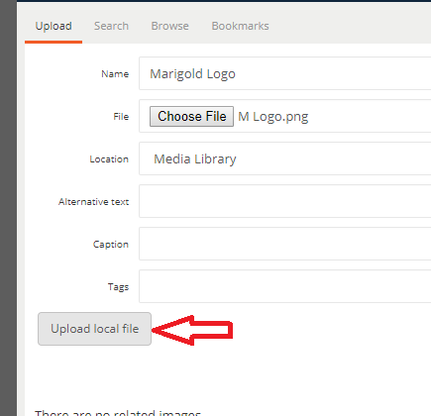
This will open the Embed tag page.
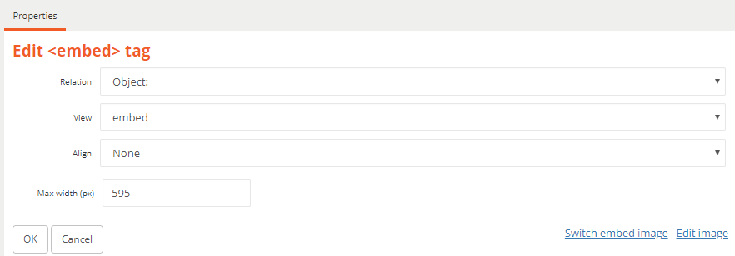
You can select how you want the image aligned here, or use the alignment buttons on the editor after it has been inserted.
NOTE: To change the Image size, edit the “Max Width (px)” to a different value. It will default to the current size of the image.
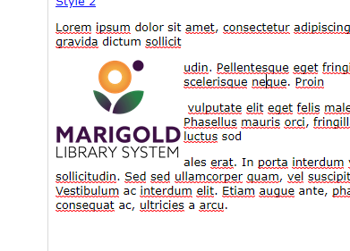

Insert/Edit Object
Using the Paperclip embed icon you can insert multiple types of content in to your page.
- Files
- Book Lists
- HTML Blocks
This functions the same as the “Insert Image” window, but you can upload any type of file from your computer, and/or link to content objects on the site, like book lists and HTML blocks.
Embedded objects appear as so:
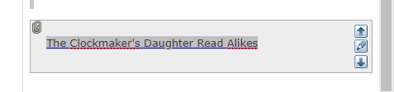

Insert Custom Tag
Using the custom embed icon you can insert multiple types of content in to your page.
- Accordions
- Blockquotes
- LIbraryAware Widgets
- Youtube Videos
- Vimeo Videos

Accordions
Accordions are objects that can be expanded by clicking on them to show the content inside. Insert an Accordion by clicking on the embed icon.
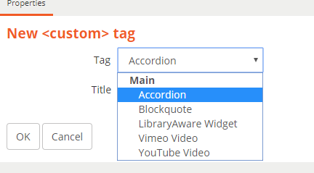
Select Accordion from the dropdown, enter the Title (Header) for the object and click OK
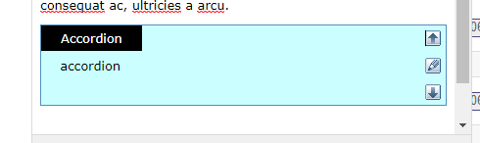
You can move the Accordion up and down by clicking the arrows on the right. Clicking the center button opens the “embed” window to edit the title.
Enter your text inside the blue area.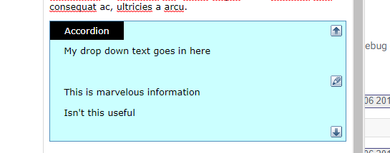
On the live site it will be formatted based on your template colours.
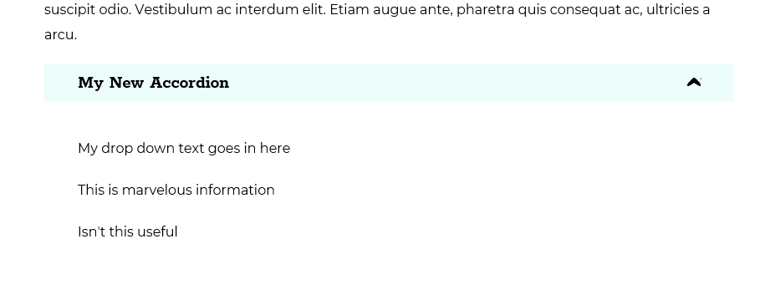

Blockquote
To format text as a quote, type the text in to the editor, then select it and click the custom embed button. Select “blockquote” from the dropdown and click OK.
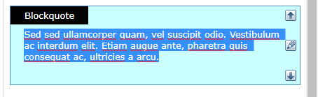
On the live site it will be formatted based on your template.
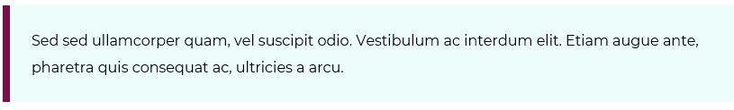

LibraryAware Widget
To insert a LibraryAware widget, click on the embed button and input the ID in the custom tag window.
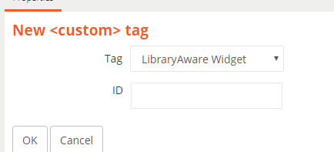

Youtube/Vimeo Video
To embed a video, click the embed button and input the video ID. You can adjust the default Width and Height for the embedded video as well.
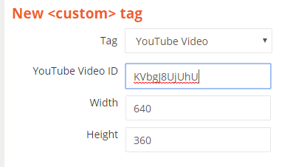
For Youtube videos, the ID is at the end following the v=
EX: https://www.youtube.com/watch?v=KVbgJ8UjUhU
For Vimeo videos the ID is at the end of the link following the “/.”
EX: https://vimeo.com/315269363

Content Types

There are several different content types that can be created on the website. Each is designed for a specific purpose (apart from the General page that is made to fit every other use).
The content types are:
- General Page
  - Use this for general purpose pages containing information.
- Galleries
  - Use this to group images into a gallery structure for users to browse.
- News
  - News items present information to visitors in a chronological format.
- Contact Us
  - This page contains basic library information and a form for users to contact the library.
- Custom Form
  - Forms can be used for multiple purposes and allow users to submit information to the library.
- Folder
  - Folders group other content types for ease of management, just like folders on a computer.
- Book List
  - Book lists display catalogue items in different views for users to browse and discover library materials.
- Events
  - Events appear on the calendar and contain information for users looking to attend, register for, or discover programming or important events at the library.
- Library Home
  - The library home contains multiple sections allowing staff to change information about the library and the colours and template scheme used on the website. This also allows staff to determine what type of content is laid out on the library home page and how it is displayed.

Content Title
Each page must have a title. The link to this page is formatted based on the title of the page. For example, if I name my page “My Title” – the website address will be: librarywebsite/folder/My-Title
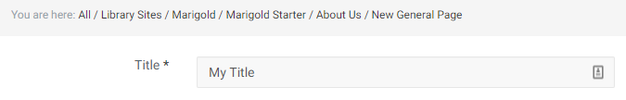
NOTE: The Use of Title is the same on every content type.

General Page
Most of the content on your website will be built using general pages. They are multi-purpose, can fill a variety of needs and display all different types of subject matter. To create a general page Navigate to the location that you want to create it, then click on the “Create New Subitem Menu”.
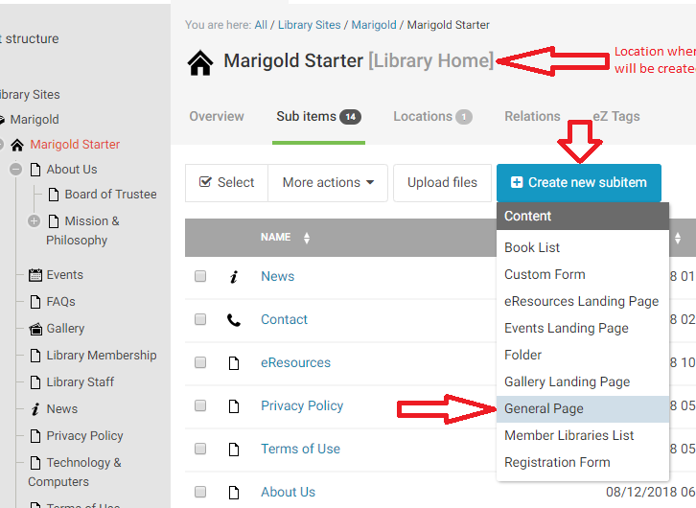

Side Menu
NOTE: When creating General pages, you should mirror the structure of your website navigation. This is because side menus are created dynamically for you, and they are based upon how the pages are nested inside the tree structure.
Editor View: Menu View:
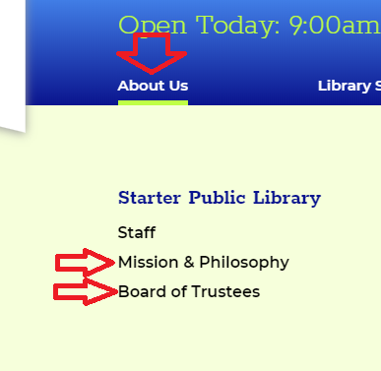
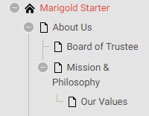

Side Menu View:
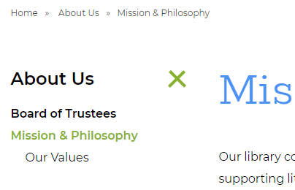

This is accomplished by creating a new general page, while on the main general page in the editor.
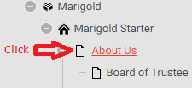
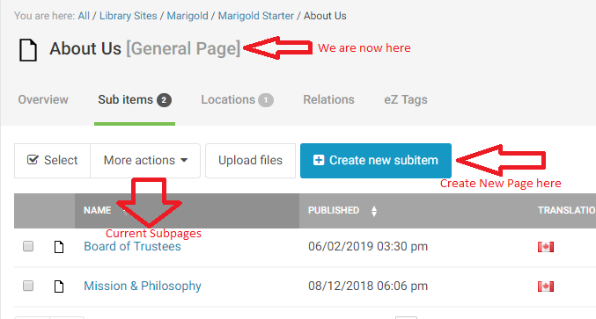
NOTE: You can also Move content after creating it. See Manipulate Content Section

General Page Fields
General pages have 4 fields to fill in:
- Title (Required)
- Static Link
- Hero Image
- Body

Static Link
If you would like to modify the URL of your page to make it easier to type directly in to a browser – for example, if the title of your page is “My Super Awesome Page of Information for All People” that would create a very long URL [http://www.peacelibrarysystem.ab.ca.ab.ca/About-US/My-Super-Awesome-Page-of-Information-for-All-People], it would be much easier to type in simply [http://www.peacelibrarysystem.ab.ca/About-US/Awesome].
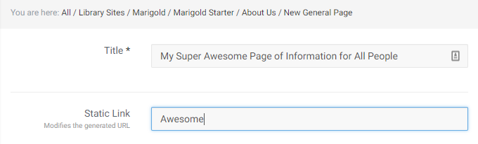
NOTE: Unless you have a specific purpose to change the URL, it is unnecessary. When people click on links to navigate the site they don’t have to manually enter the address, nor do they usually pay much attention to it. However, if you were handing our pamphlets or flyers and wanted to direct people to a specific page on your website that was relevant, you might want to shorten the URL to make it easier for them to find.

Hero Image
This image displays across the top of the page and is used to add visual impact and design to your site. While it is not necessary to have a hero image, it does add to the overall aesthetics of your website. People are highly visual, and having high quality imagery at the top of your page creates a positive first impression. Make sure to use high quality images for this purpose; low quality images will create the exact opposite impression.
To add a Hero image, click the Browse Button and select a file from your computer. NOTE: Image max size is 1440 x 400 pixels. IF you upload a larger image, it will be automatically cropped by the system.
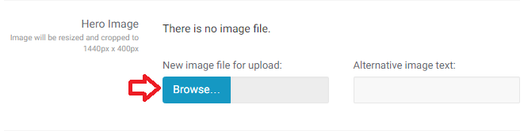
Alternative image text will appear if for some reason the image is unable to load and for visually impaired users this description is used by their screen reader. You can enter a brief description (one sentence or less) of the image here.

Hero Image from Library
If you have already uploaded an image to the image gallery you can re-use that image as your hero image by using the next field
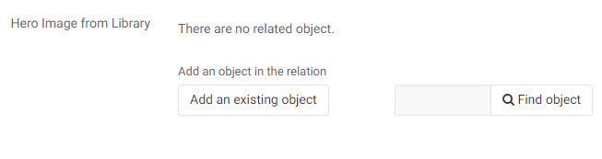
Click “Add an existing object” to browse the site, or type a portion of the name in the find box and click “Find Object”

Body
Most of your page content is added through the Body content editor. For help on using the content editor please see Using the Editor
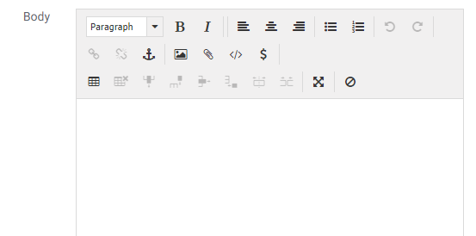

Galleries
Galleries are broken down into two page types. Gallery Landing pages, and Gallery.
The Gallery Landing page contains a visual listing of all the different galleries associated with it. In general you will only need 1 gallery landing page, unless there is a specific reason to separate your galleries into different groups.
The Gallery contains a group of images to be displayed in the gallery format. You must create the Gallery before you can begin uploading images.

Gallery Landing Page
A gallery landing page has been provided for you. It is called Gallery and located in your content tree. You can navigate to it by clicking the item in the tree menu or selecting it from the Sub Items list under your library name.
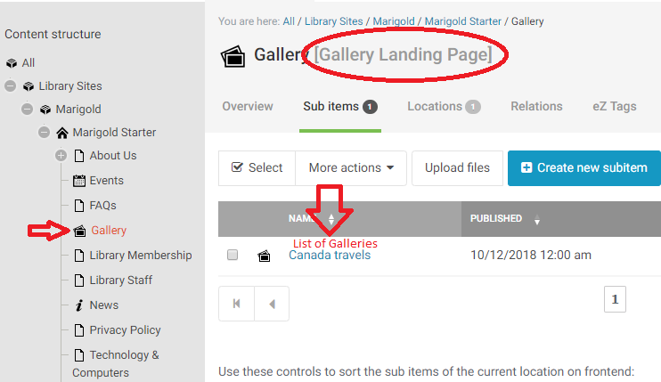
NOTE: you can NOT create a new gallery landing page from within a gallery landing page.
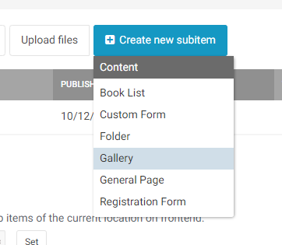

Create a new Gallery Landing Page
To create a new Gallery Landing Page, navigate to the root of your site (your library name on the tree).
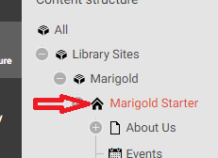
Click “Create new Subitem” and select “Gallery Landing Page.”
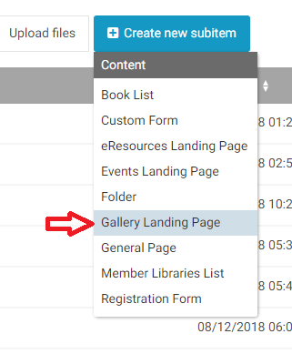
NOTE: You cannot create a Gallery unless you are inside a Gallery Landing Page
The only field necessary to create a Gallery Landing Page is the Title. Add one, then save or publish your page.
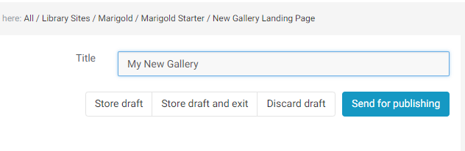

Gallery
Galleries contain collections of images, normally with a common theme or purpose.
To create a new gallery, first navigate to the Gallery Landing Page where you want the gallery to reside. Then click “Create new subitem” and select “Gallery.”
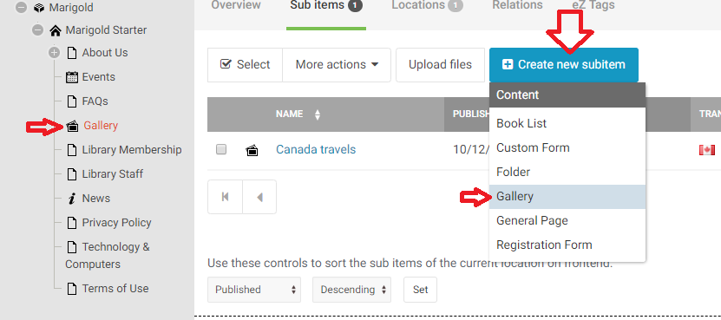
There are 3 Fields to fill out for the gallery:
- Title
- Date
- Description

Date
The Date field can be the date the gallery was created, or the date the pictures were taken. This date is shown on the Gallery Landing Page.
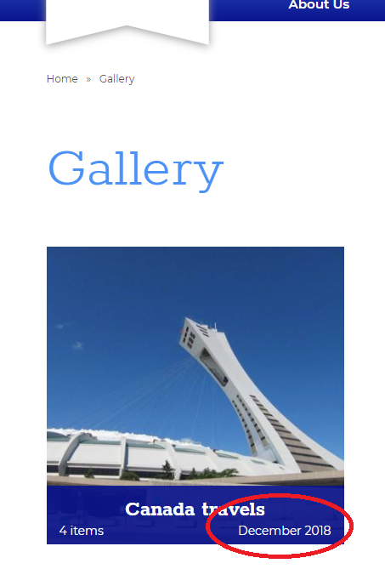
To input the date, you can either manually enter the Year, Month and Day, or use the Calendar icon to select it from a visual calendar.
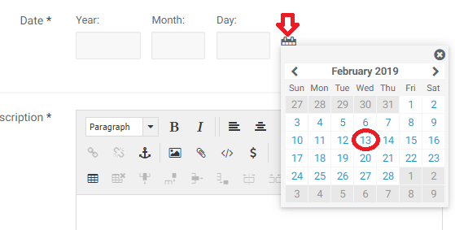

Description
The description shows at the top of the gallery once a user has clicked into it. This should be a relatively short description (1 paragraph or less) of what the images in the gallery are about/for.
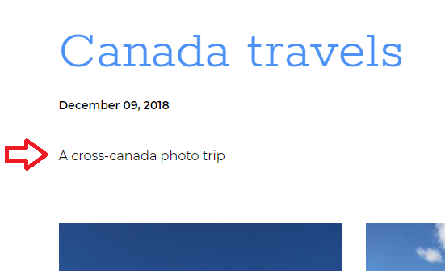

Adding Images to a Gallery
To add images to a gallery, navigate to the gallery. If you have just created the Gallery and published it, you will be sent to this page by default.
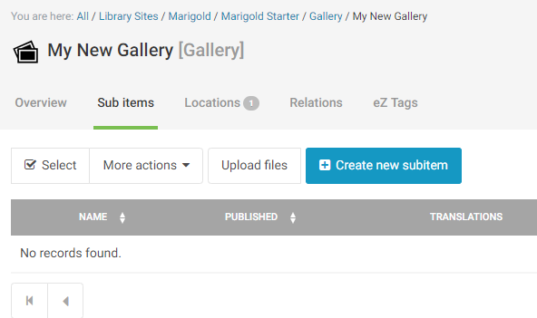
Alternatively: To locate your gallery -> Select the Gallery Landing page from the tree menu (or from the sub item menu from the root of your site) then click on the Gallery where you would like to add images.
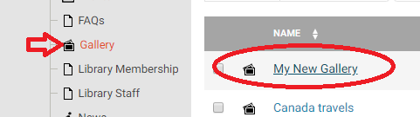
You can upload images either one at a time, or in bulk. To add one image at a time, click “Create new Subitem” and select “Gallery Item.”
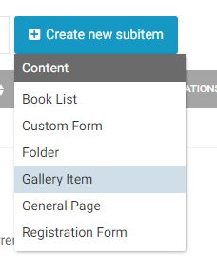
There are three fields to fill out for a gallery item:
- Title
- Image
- Caption

Title
The title of the gallery item is a very short description of the image. It will appear on the image when a user hovers over it.
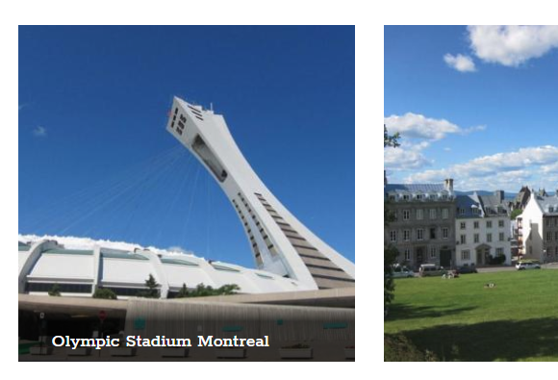

Image
To add an image, click the Browse Button and select a file from your computer. NOTE: Image max width is 990 pixels. IF you upload a larger image, it will be automatically resized by the system.
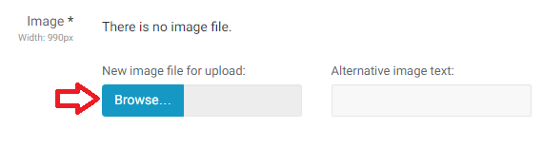
Alternative image text will appear if for some reason the image is unable to load and for visually impaired users this description is used by their screen reader. You can enter a brief description (one sentence or less) of the image here.

Caption
The caption appears below the image when a user clicks on the thumbnail to view the larger image.
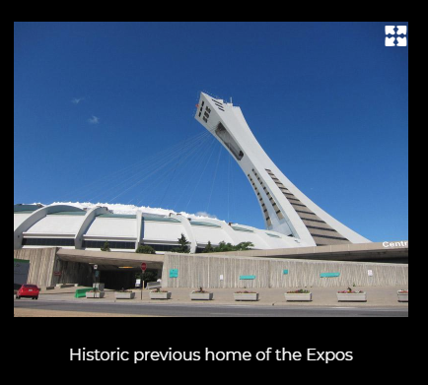

Uploading Multiple Images
You can bulk upload images to the gallery by clicking on the “Upload Files” button while inside the gallery page.
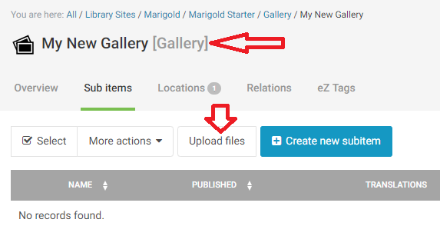
This will open a file chooser to select images from your computer. You can select multiple images by clicking and dragging a box around them, by clicking one item, and holding the shift key while clicking on another item, or by holding the control key and clicking on each item. Once you have highlighted all the images you want to upload, click “Open” in the lower right.
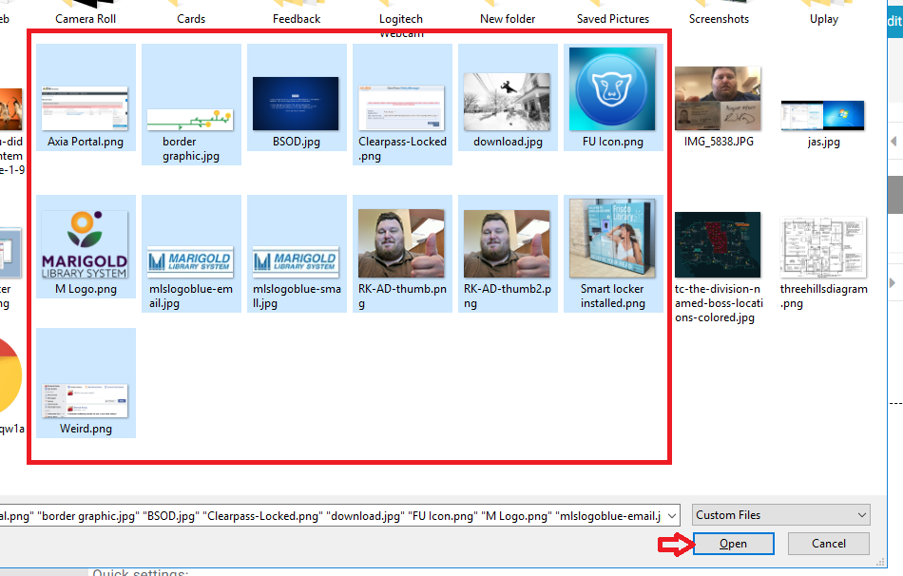
The system will upload the files for you, and a popup will appear similar to the following:
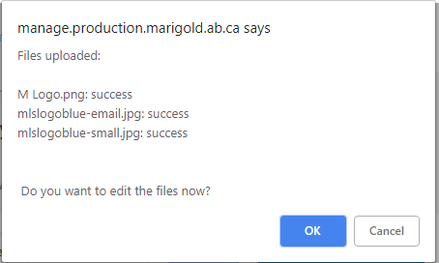
Click OK to continue and edit the files. The system will auto-fill the titles of the files based on the file name when they were uploaded. You can then add the Alternative text and caption.
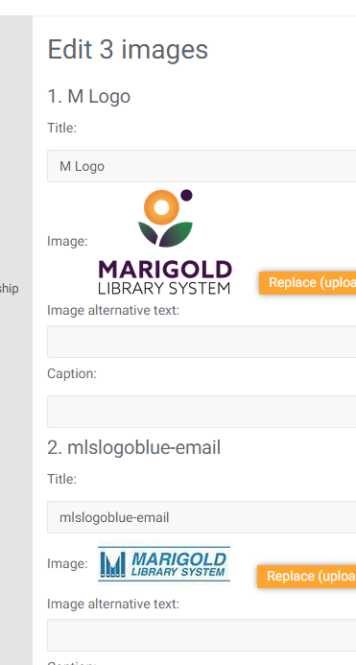
When you are finished click the “Save” button at the bottom.
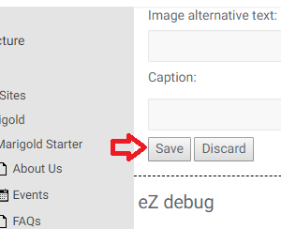

Editing Gallery Images
You can edit all the Gallery images at once (to bulk add/change Titles and/or captions), or you can edit each item individually.

Bulk Edit
Click the “Edit All Gallery Images” button at the top of the page.
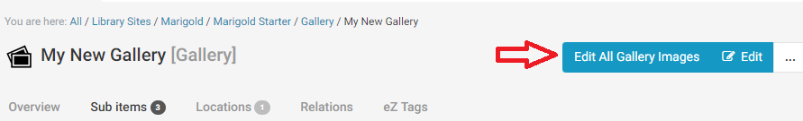

Edit individual
To edit an individual item, click on the Image icon and select “edit” from the dropdown, or click on the item and use the Edit button in the upper right.
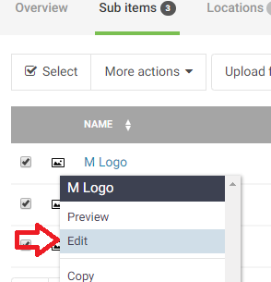

News
News is broken down into two page types., “News Landing” page, and “News Page.”
The “News Landing” page contains a chronological listing of all the news pages on the site. There is only one News Landing Page and it has been created for you. You can find it by Clicking “News” in your tree view.
The News Page is very similar to a general page; the goal is to present content to users.

News Page
To create a news page, navigate to the News Landing Page, click “Create new subitem” and select “News Page”
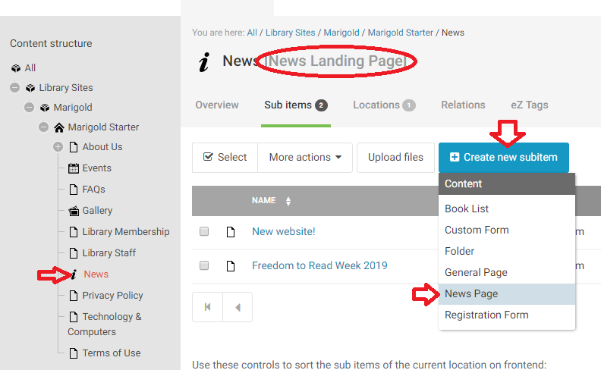
News pages have 6 fields:
- Title
- Author
- Date
- Short Description
- Image
- Body

Author
This field is not required and lists the Author of the news item. This appears both on the News Landing Page, and on the news page itself.
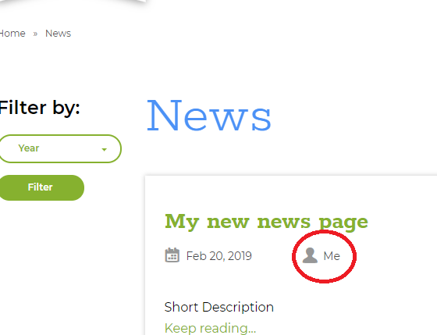

Date
The Date field is the date the news page was originally written. This date is used to order the News Pages on the News Landing Page – with the most recent item appearing at the top of the list.
To input the date, you can either manually enter the Year, Month and Day, or use the Calendar icon to select it from a visual calendar.

Short Description
The short description appears on the News Landing Page as a “teaser” or description of the content contained in the full News page. You can simply copy and paste the first portion of the News Page in this field, or type a custom description of the contents on the News Page.

Image
The image serves two purposes for the News Pages. It appears on the News Landing Page next to the short description, and is used as the “Hero Image” for the News Page.
NOTE: To get the best effect from this image, it should be close to 1440 pixels wide, and around 1000 pixels high. This will create a nicely square sample image on the News Landing Page, and a full size Hero Image for the News Page. In this case, the image will automatically be cropped (to the center) of the image for the News Page.
Alternatively: Use a wide and skinny image (1440 x 400) to get the best effect from the Hero image, but the sample image will be small and stretched on the News Landing Page.
To add an image, click the Browse Button and select a file from your computer.
Alternative image text will appear if for some reason the image is unable to load and for visually impaired users this description is used by their screen reader. You can enter a brief description (one sentence or less) of the image here.

Body
Most of your page content is added through the Body content editor. For help on using the content editor please see Using the Editor

Contact Us
There is only 1 Contact Us Page for your site. It is located at: http://www.yourwebsite.ca/Contact
The Contact Us page is automatically generated from fields located in the Library Home Page item. It can not be directly edited.
The Contact Us page contains Location information for the library, Hours, Contact information and a basic form to email the library for general inquiries.

Custom Form
Forms can be used for a variety of purposes to collect information from users. To create a new Form you need to fill out several fields:
- Title
- Description
- Fields
- Data (this is where submitted information is stored)
- Recipient
- Thank you text

Description
The description appears at the top of the form and provides the reason for the form and any instructions for filling it out.
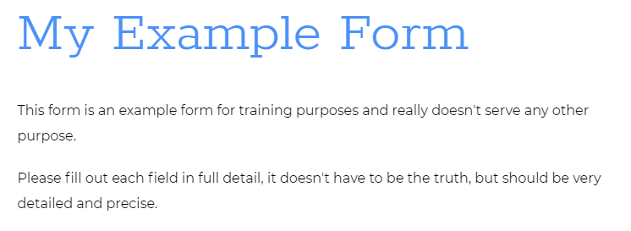

Fields
The fields area holds all the entry fields that have been created for the form. To add a new field to the form click on the “+” symbol.
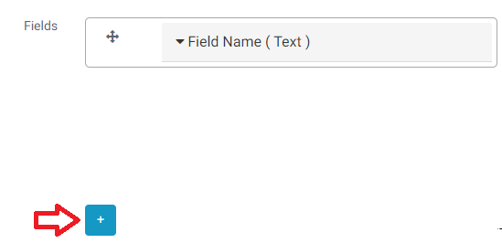
Edit the new field by clicking the name of the field, this will expand the card out with more details.
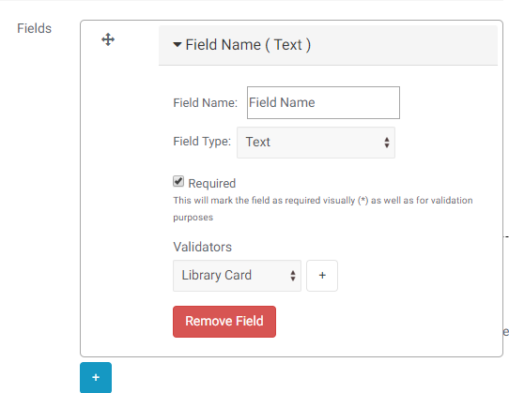

Field Name
This is the name of the field, it appears on the left of the field.
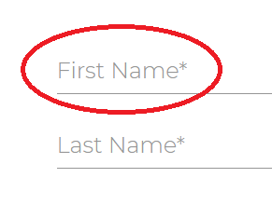

Required
If this box is checked then a user MUST enter data for this field or they can not submit the form.

Validators
There are four types of validators which can be used to verify that the data entered into the field is appropriate.
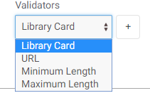
Library card ensures the user has entered the right number of digits, it does NOT check that the card is valid or in good standing.
URL ensures a user has entered something in the format http://www.somesite.com
Minimum/Maximum length allow you to control how much information can be entered in to a field. For example: Province – Maximum 2 (for abbreviations), Postal Code – Minimum 6, Maximum 7 (with space).

Field Type
There are 9 types of fields
- Single/Multiple Choice
  - Used to present a list of options for user selection
- Date
  - Provides a clickable calendar for a user to enter a date, or allows a manually entered date
- Date and Time
  - Same as Date, but with a time field
- E-mail
  - For user email addresses – this is used for multiple purposes
- Integer
  - Whole numbers only
- Number
  - Allows decimal numbers
- Password
  - For entering passwords, the user will see **** rather than the characters entered
- Text
  - General field for single line text entry
- Text Area
  - For entering multiple lines of data
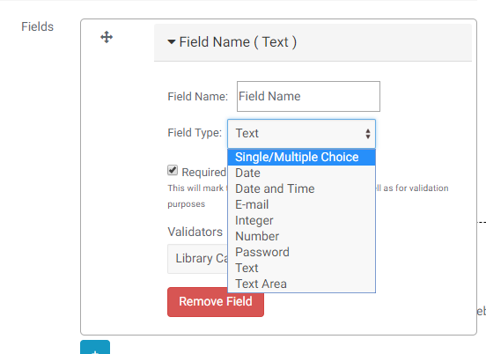

Single/Multiple Choice
Once you select the Multiple choice Field type, more options are presented to you. There are four different types of choice fields.
- Select
- Select Multiple
- Radio Buttons
- Checkboxes
SELECT: Options appear as a drop down list
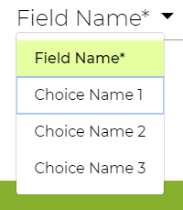
SELECT MULTIPLE: Options appear as a drop down, where users can select multiple options
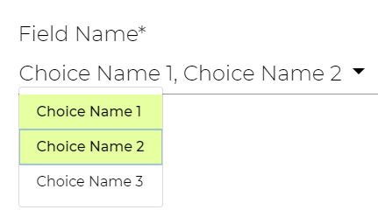
RADIO BUTTONS: Options appear as a list where users can select one button.
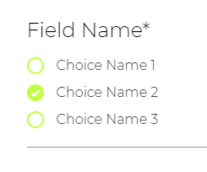
CHECKBOXES: Options appear as a list where users can select multiple boxes.
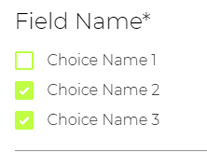
CONFIGURING OPTIONS:
You can add items by clicking “Add Option” then editing the text in the “Choice Name” Field.
Click the Red “-“ to remove an item
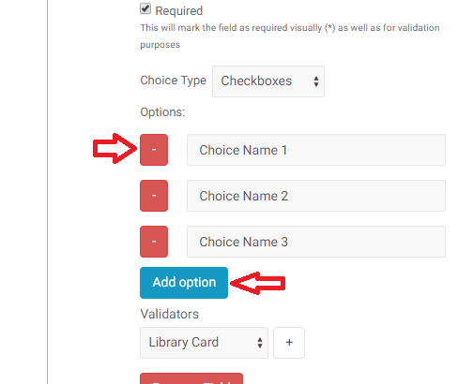

E-Mail
There is an extra option to “send copy of this form to this user” – which will send the user a copy of the information submitted, at the email address entered in this field.
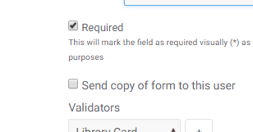

Re-Order Fields
You can drag and drop fields to change their order on the form.
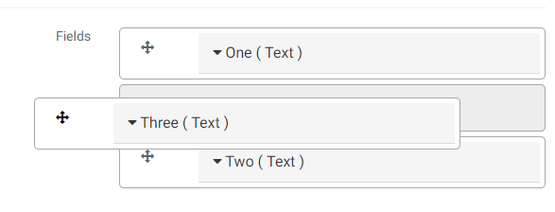

Remove Field
To remove a field from the form, click the red “Remove field” button.
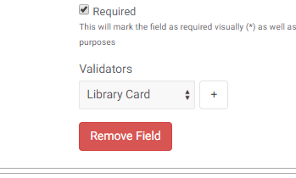

Recipient
Enter the email address(es) of the person(people) who should receive the information submitted in this form. You can enter multiple email addresses separated by commas.
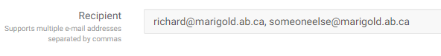

Thank You Text
After submitting the form, the user will be shown this content - followed by a summary of the data they entered in to the form.
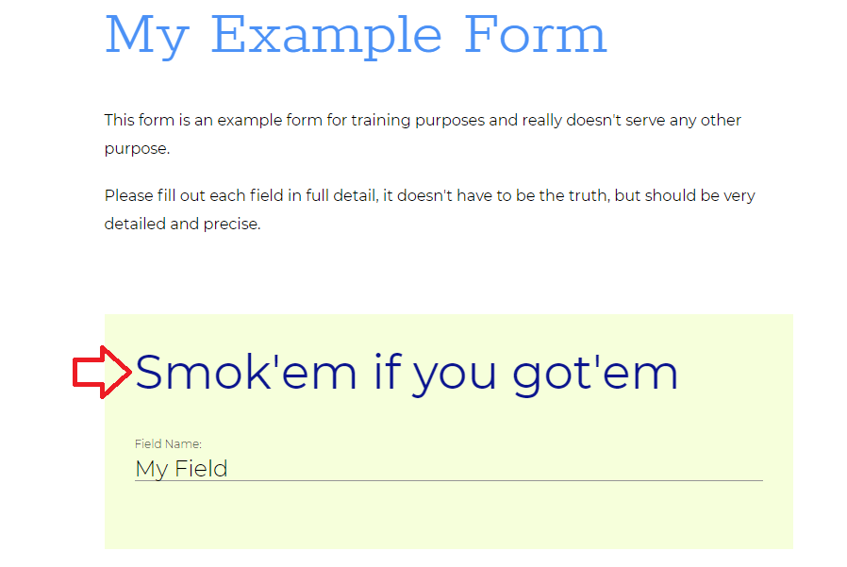

View Form Submissions
You can review the form submissions by navigating to the Form and clicking the “overview” option.
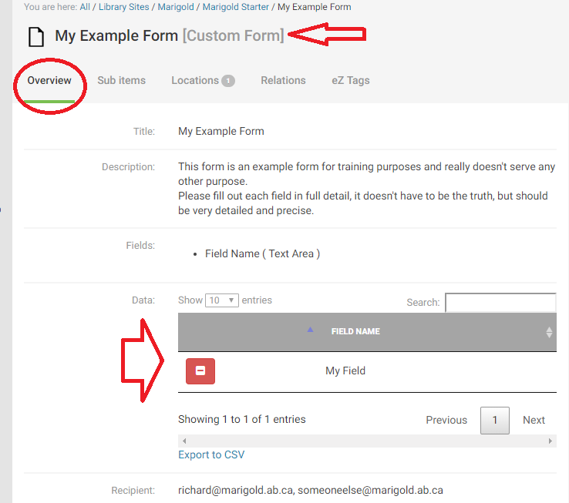

Remove Form Submissions
You can delete submission data by navigating to the Form and clicking the red “-“ next to the form information you would like to remove.
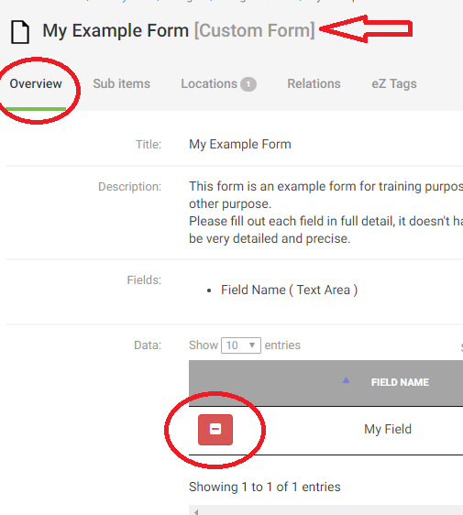

Exporting Form Data
You can export the information from the form to a CSV file and open it in Excel or a similar program to sort and manipulate the data for other purposes. Click on the “Export to CSV” link, then select a location on your computer to save the file.
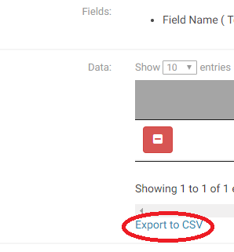

Viewing Registrations for Different Dates
If you have a registration form that has separate registrations for different Event days, you can view the registrations for a specific event by selecting that Event from the “Event Occurances” dropdown and clicking the “Filter” button.
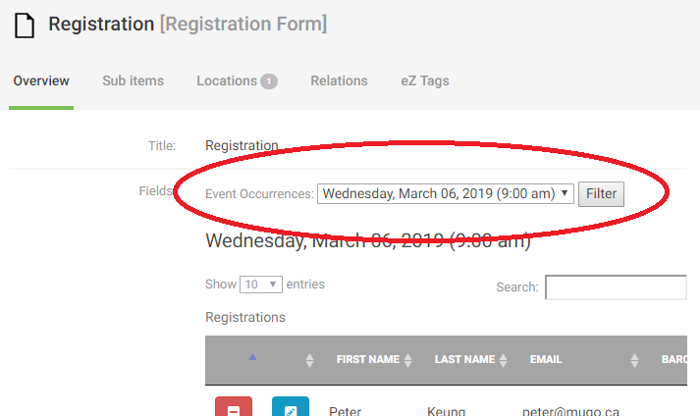

Folder
Folders are purely organizational objects. They can be used to group other types of objects together in a single location for easy access.
To create a folder, navigate to the location you would like to create it, and click “Create new subitem” and select “Folder”
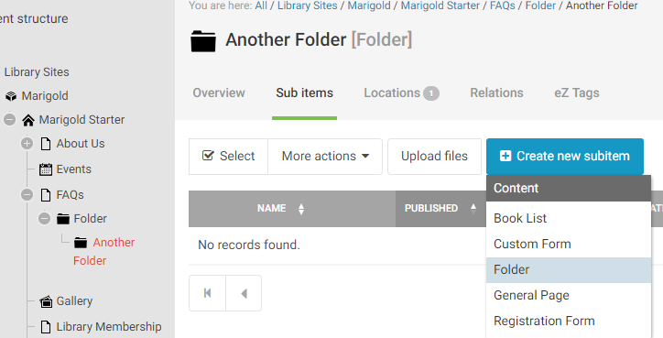
Folders appear in the Tree structure to the left and can be expanded or contracted by clicking the symbol next to them.
NOTE: The name of the folder appears in the URL of the page, keep them short and appropriate for public viewing.

Book List
There are two types of book lists; the standard Carousel, and Featured Book lists. Each is created in the same way but will appear slightly differently on the website.
To create a Book List, navigate to the location you want to create it, click the “Create new subitem” button and select “Book List.”
NOTE: Book lists do not “appear” where you create, in the folder structure, you have to insert them in to pages, or add them to the home page directly. For Inserting on pages please see Using the Editor. To add to the Home page please see Homepage.
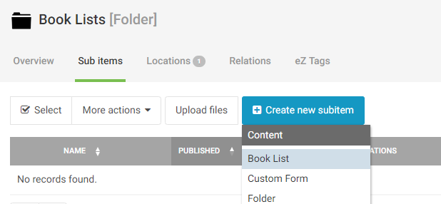
Book lists have 4 sections to fill out:
- Title
- Short Description
- Read Alike Header
- Books

Short Description
This appears at the top of the book list once a user has clicked to view the full list.
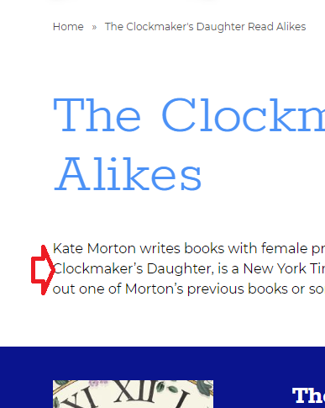

Read Alike Header
In a “Read Alike” or “Featured” book list, this header appears on the carousel view beneath the featured title and before the carousel. This field is not mandatory, in which case “Read Alike” will appear here.
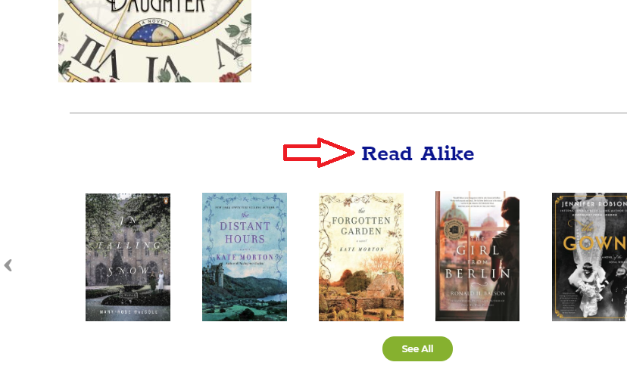

Books
This area is for adding books to the list. Books can be added by ISBN, UPC, or Control Number. You can easily scan the books if you have the hard copies available, or manually enter the numbers into the field.
NOTE: There is a maximum of 25 books per list.
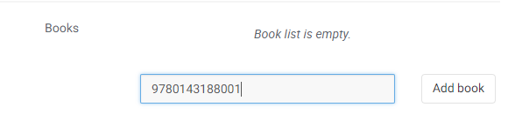
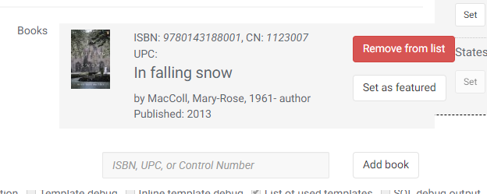

Featured Book List
To make this list a featured book list, click the “set as featured” button next to one of the books.
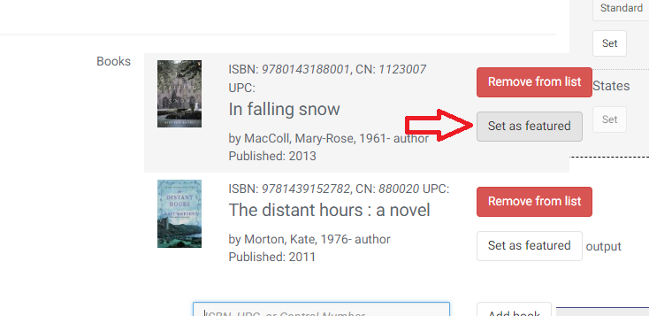
The book will then be marked as featured.
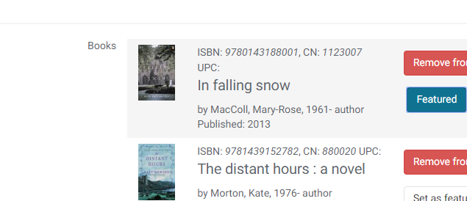
Click the button again to de-select it.

Importing a Book List
When creating a new book list (or working with an empty list), you can import from a list that has been previously created by PLS staff for your use. To do so, instead of manually adding items, select the book list from the Import dropdown and click “Import.”
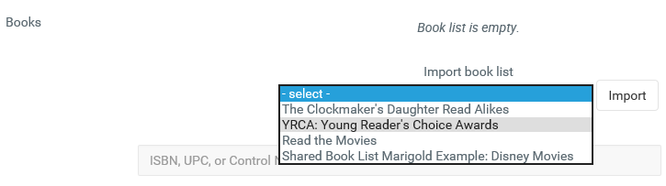
This will automatically copy all the books from that original list into yours.
NOTE: You can add or remove books from this list at your own discretion, it will not affect the original list. If you would like to re-import the books from the original list, remove all books and the dropdown to import will appear.

Events
Events are the items that appear on the Calendar views on the website. Each event has a schedule (for how often it appears) and may include a registration form for people to sign up for the event.
To create an event, select the “Events” landing page from your Tree view, and click “Create new subitem” then select “Event.”
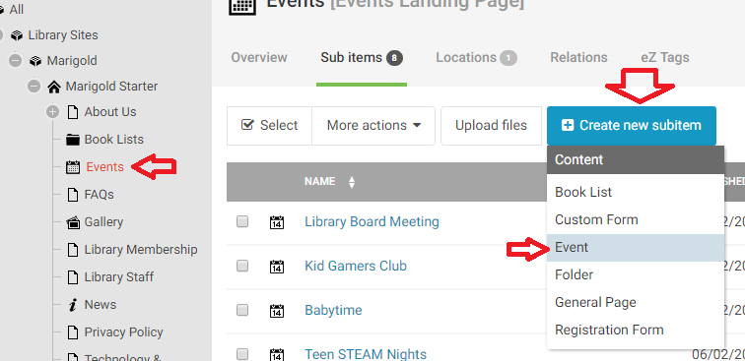
Events have 8 sections to fill in:
- Title
- Image
- Date Information
- Location
- Cost
- Short Description
- Description
- Categories

Image
The image serves two purposes for the Event Pages. It appears on the Event List View next to the short description, and is used as the “Hero Image” for the Event Page.
NOTE: To get the best effect from this image, it should be close to 1440 pixels wide, and around 1000 pixels high. This will create a nicely square sample image on the News Landing Page, and a full size Hero Image for the News Page. In this case, the image will automatically be cropped (to the center) of the image for the News Page.
Alternatively: Use a wide and skinny image (1440 x 400) to get the best effect from the Hero image, but the sample image will be small and stretched on the News Landing Page.
To add an image, click the Browse Button and select a file from your computer.
Alternative image text will appear if for some reason the image is unable to load and for visually impaired users this description is used by their screen reader. You can enter a brief description (one sentence or less) of the image here.

Date Information
This is where you set the schedule for the event. You can have multiple schedules if the event runs on different days or on alternative schedules.
By default the event will have a single entry:
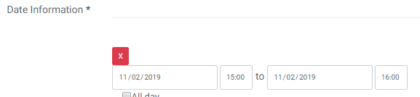
You can edit this or remove it. If the event only happens once, select the date and time the event will happen.
If the event is on a schedule, set the first day that the event will be happening, and then click the dropdown and select “recurring.”
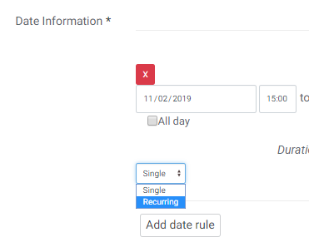
To set up a recurring schedule, select the frequency (Every X weeks/months) and the day that the event re-occurs (Sunday-Saturday). If the event runs for a set period of time, select “on” from the “ends” dropdown and select a date when the event will no longer be held.
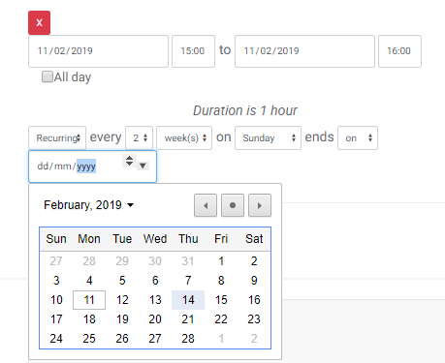
NOTE: Click the downward arrow in the date field to bring up the calendar view

Multiple Schedules
To add a second recurring schedule, click the “Add Date rule” button, and repeat the same process as above for adding a new date rule. For example: An event that happens Every Tuesday at 2:30pm and Thursday at 11:30 am would look like this:
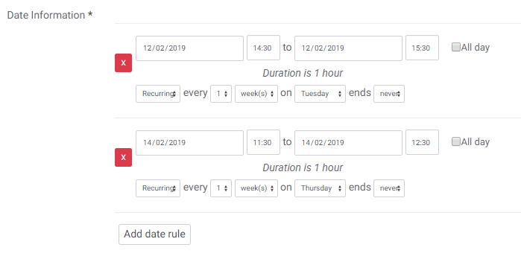

Location
The location appears in the event list view and on the event listing page.
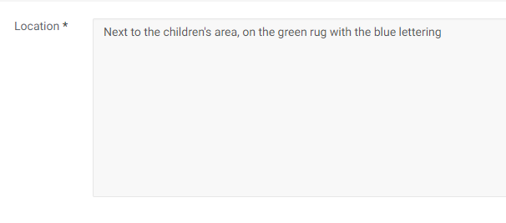
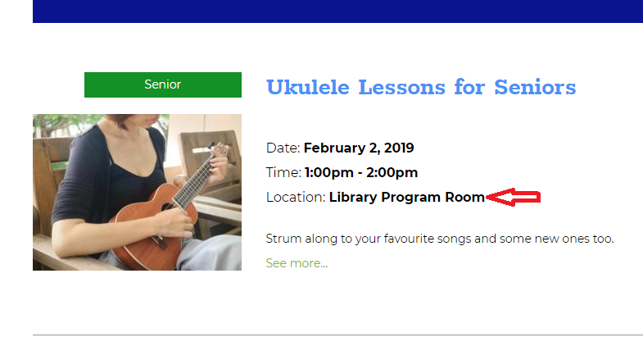

Cost
The cost appears on the event list view and the event listing page.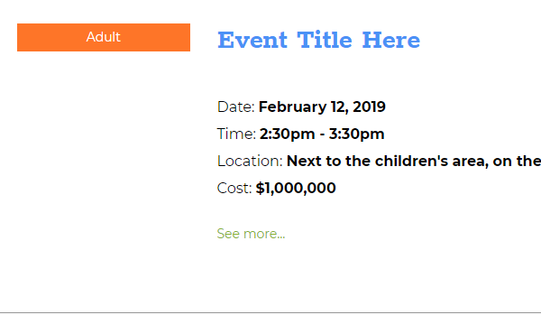

Short Description
The short description appears on the event list view and should be a brief summary of the event.
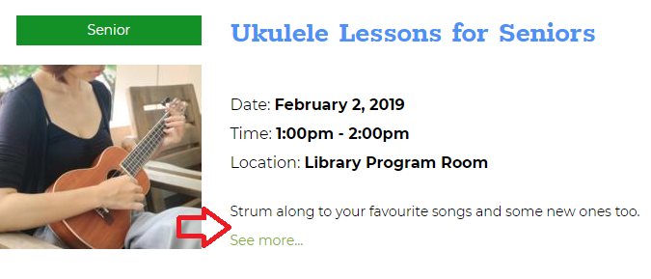

Description
This should be a full description of your event, it can include text, graphics and other content just like a General Page.

Categories
There are 9 main Categories to select from, and each one contains several subcategories. Each event must belong to one (and only one) main Category, but can appear in multiple subcategories. When filtering for items on the calendar, users can filter by multiple main categories, and if they select only a single category, they can further filter by the subcategories selected.
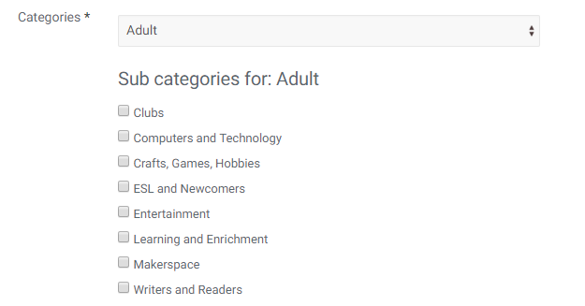
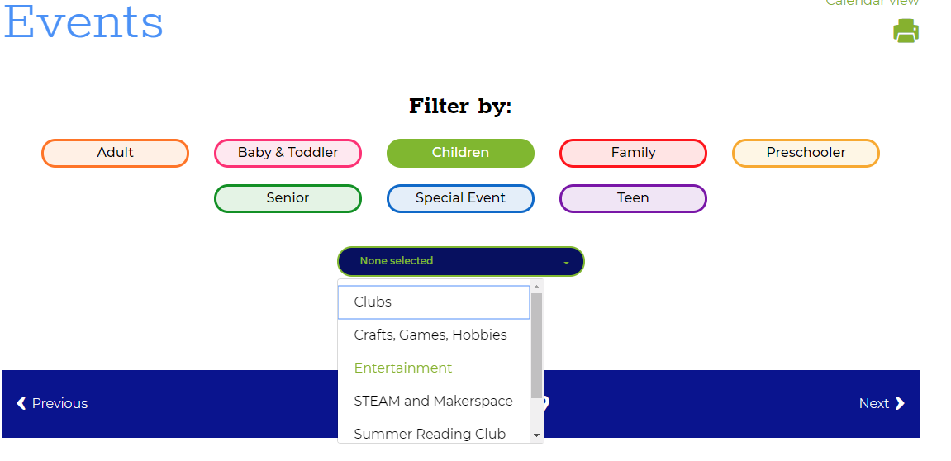

Event Schedule Exceptions
If a recurring event needs to be rescheduled because there is something else taking place at that time, or to cancel a single day, you can add that exception without having to manipulate the overall schedule. To do so, navigate to the Event, but do not edit it. You should be at the main Event page.
Click “Create new Subitem” and select “Event Exception”
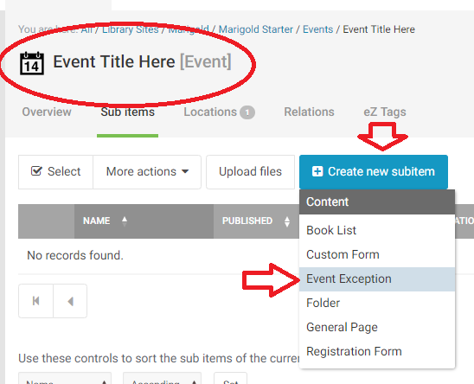
The Event Exception has all the same fields as the standard event type except the Category selector. The Date Field is slightly different.
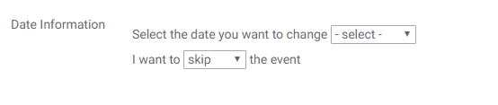
If for some reason some of the event details are different on a specific day. EX: Thursdays the event is in Meeting room 2 instead of Meeting room 1.
Select the date you want to change
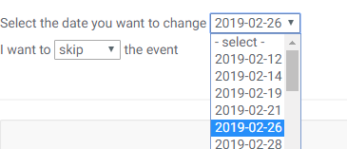
And select “change” from the dropdown.
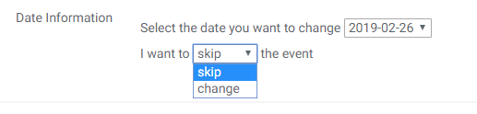
NOTE: The “skip” option is only for when you need to cancel the event for this day altogether.
Once you have selected the date to change, edit the information in the fields that is different, and publish the event exception.
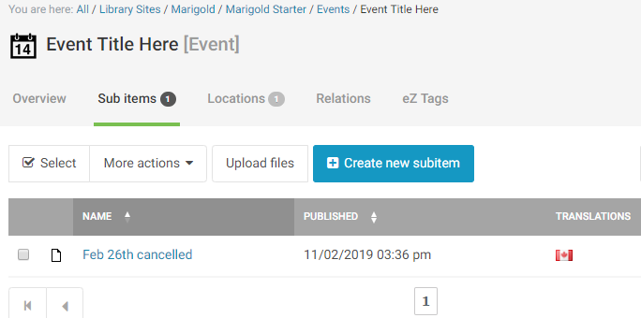

Event Registration Forms
Registration forms use a unique registration system to allow patrons to sign up to scheduled events. The event creator can define the maximum number of participants, and add a waitlist where users can sign up to be automatically registered if/when a slot opens up from another user cancelling.
To add a registration form to an event, navigate to the event and click “Create new subitem” then select “Registration Form.”
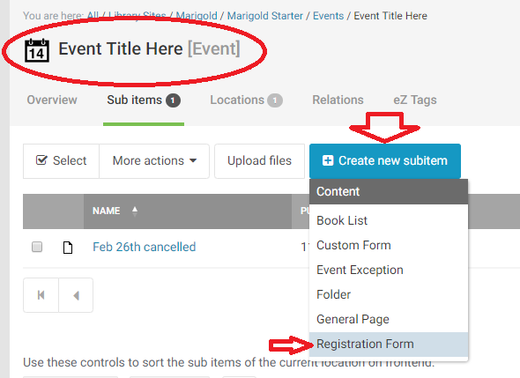
Registration forms are simplified versions of the custom form with some minor changes. There are 6 options to fill out:
- Title
- Fields
- Registration Limit
- Wait List Limit
- Recipient
- Event Type Checkbox

Fields
The registration form fields are preconfigured and you can add as many (or few) as needed. To add a field to the form, click and drag it from the “inactive” fields list to the “active” fields list.
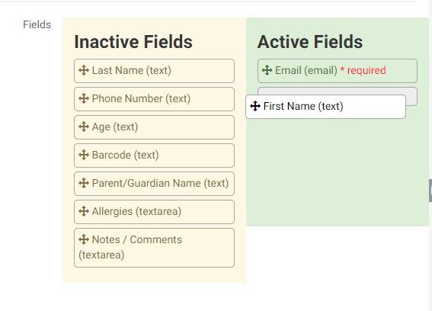

Registration/Wait List Limit
Enter numeric values in these fields dictating how many people may register, and/or how many people may be included in the waitlist.
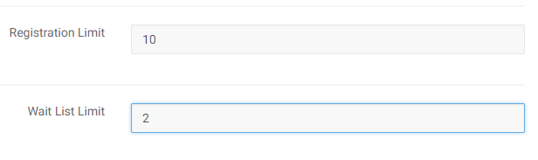

Recipient
Enter the email address(es) of the person(people) who should receive the information submitted in this form. You can enter multiple email addresses separated by commas.

Event Type Checkbox
There are two overall types of event registrations:
- 1: Users must register for each individual event. EX: Paint Night every second Thursday – users would need to register for each session they were interested in.
- 2: Users register for the whole event series. EX: 6 weeks of Guitar lessons – users would register once and expect to attend each upcoming lesson without having to re-register.
By default, the registration form is “Type 1” where a user registers individually for each event. To change the form to “Type 2” where users register for the entire series, click the checkbox.
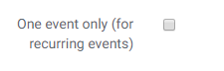
Once you have completed the form, publish it to activate the registration features.
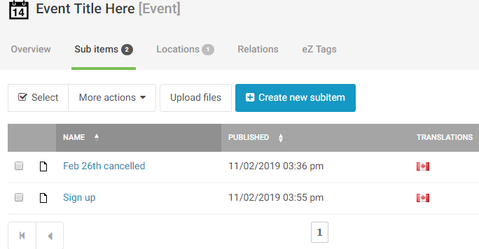

Review Registrations
To view your registrations, see View Form Submissions.

Home Page Objects
There are several types of content that are only available on the home page. They are created in the “Media Library” rather than the “Content Structure.” These include:
- Banners
  - These are advertisements that appear at the top of your Home Page
- Featured Cards
  - These are advertisements that appear as small cards with short descriptions
  - These need to be created in groups or 2 or 3 cards.
- Fun Facts
  - This appears as a section break on the Home Page
First click on “Media Library” on the black bar to the far left.
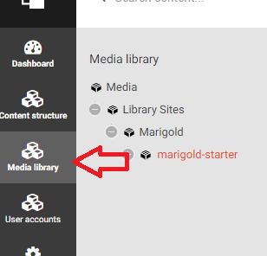
Expand your Tree and you will see the different item types in the library:
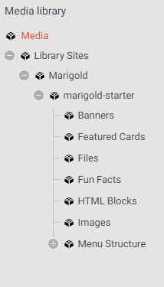

Banners
Click on Banners to add/view banners for your site. To create a new banner click “Create new Subitem” and select “Banner.”
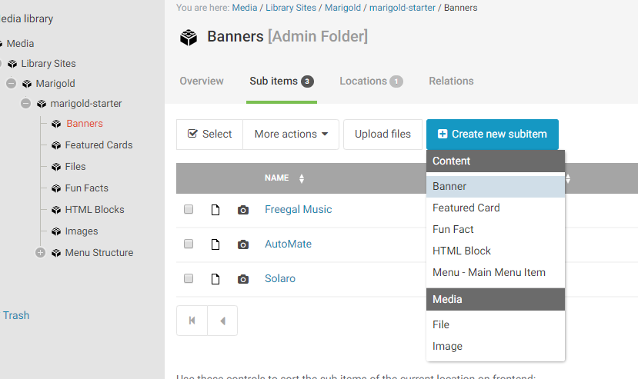
Banners have 8 fields to fill in:
- Title
- Description
- Image
- CTA Text/Colour/Link
- Text orientation
- Blend Background Colour

Title
For Banners, the title does not appear on the live website.

Description
This text appears over the banner and should be a short description of what you are trying to advertise. Use one sentence or less.
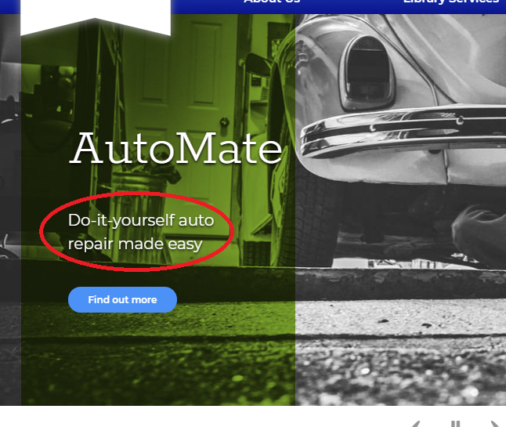

Image
The image needs to be a high-quality image that is free of text or other additions. It should be a clear picture that highlights the product or service you are trying to highlight
NOTE: Images need to be at least 1440 x 500px – if the image is larger, it will be cropped automatically by the software.
To add an image, click the Browse Button and select a file from your computer.
Alternative image text will appear if for some reason the image is unable to load and for visually impaired users this description is used by their screen reader. You can enter a brief description (one sentence or less) of the image here.

Call to Action
The call to action (CTA) section allows you to customize how the banner appears on the site.
The CTA Text is the text that shows on the button
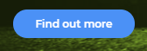
The CTA Colour is the colour that the button appears as.
The CTA Link is where you want a user to be directed when they click on the button.

Text Orientation
The text can appear to the left or right side of the image. Depending on the image, one side is usually better than the other.

Blend Background Colour
This either enables or disables the colour overlay selected in the text section. For some images it isn’t necessary to include a colour overlay for the text to be readable, but for most it is.
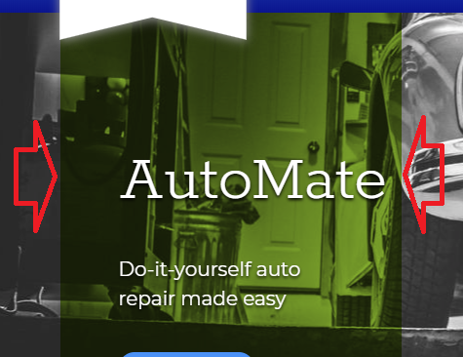

Featured Cards
Click on “Featured Cards” to add/view featured cards for your site. To create a new card click “Create new Subitem” and select “Featured Card”
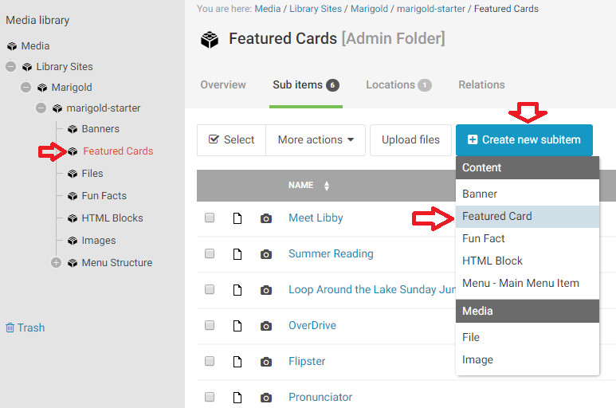
Featured cards have 7 fields to fill in:
- Title
- Code
- Description
- CTA Text
- CTA Link
- Background Image
- Background Colour Overlay

Code
Using the code field overrules all other content on the page and should only be used for a very specific purpose. In general, leave this blank.
NOTE: This will not remove the background image, so you can upload an image and it will still appear behind the code.

Description
This appears as the body of the card, it should be a short description (one sentence or less) about what you are trying to advertise/direct people toward.
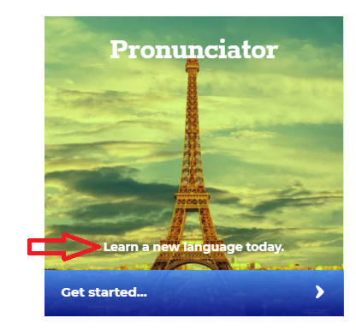

CTA Text
This it the call to action text that appears on the lower part of the card.

CTA Link
This is where a user should be directed after clicking on the card.

Background Image
This image appears as the background for the card. It should be a regular image without additional text or added features.
NOTE: This image is limited to 380x380px. You should crop your image to this size before uploading.
To add an image, click the Browse Button and select a file from your computer.
Alternative image text will appear if for some reason the image is unable to load and for visually impaired users this description is used by their screen reader. You can enter a brief description (one sentence or less) of the image here.

Background Colour Overlay
There are three options for the overlay, this can be set to one of the two template colours, or turned off. Depending on the image that is being covered, some effects might look better than others and/or the text may be easier to read.
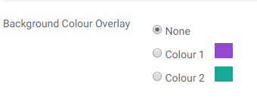
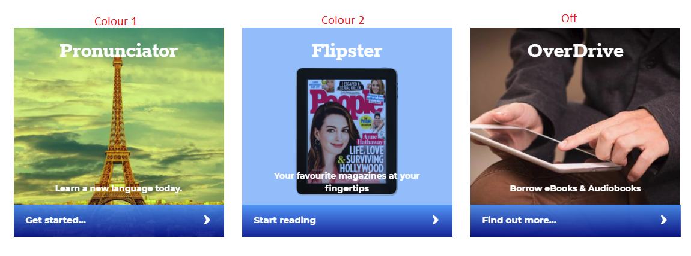

Fun Facts
Click on Fun Facts to add/view fun facts for your site. To create a new fun fact click “Create new Subitem” and select “Fun Fact.”
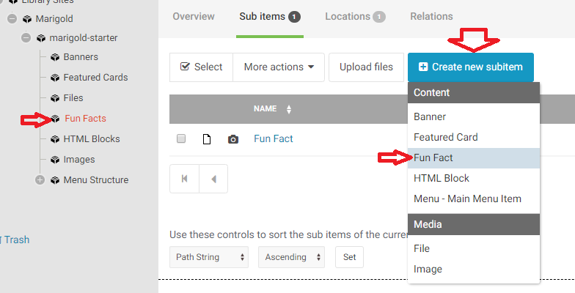
Fun Facts have 3 fields to fill out:
- Title
- Text
- Background Image

Title
The title does not appear anywhere for the fun fact.

Text
This is the content that will display in the fun fact area. It should be short – one sentence or less.
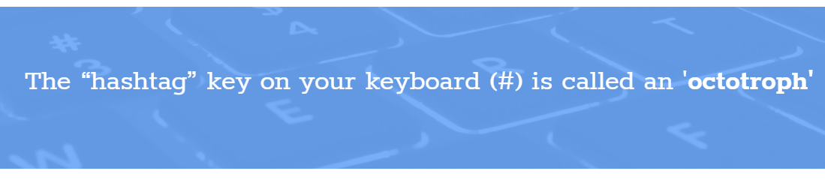

Background Image
The background image appears behind the text. It should be a textured graphic or otherwise abstract image. It needs to be at least 1440px wide.
NOTE: An overlay will be applied to the image automatically to help contrast with the text and make it easier to read.
To add an image, click the Browse Button and select a file from your computer.
Alternative image text will appear if for some reason the image is unable to load and for visually impaired users this description is used by their screen reader. You can enter a brief description (one sentence or less) of the image here.

Library Information and HomePage
To edit general information about the library, the design template, system settings and the Homepage settings, click on your library name from the tree view, and click the blue “Edit” button.
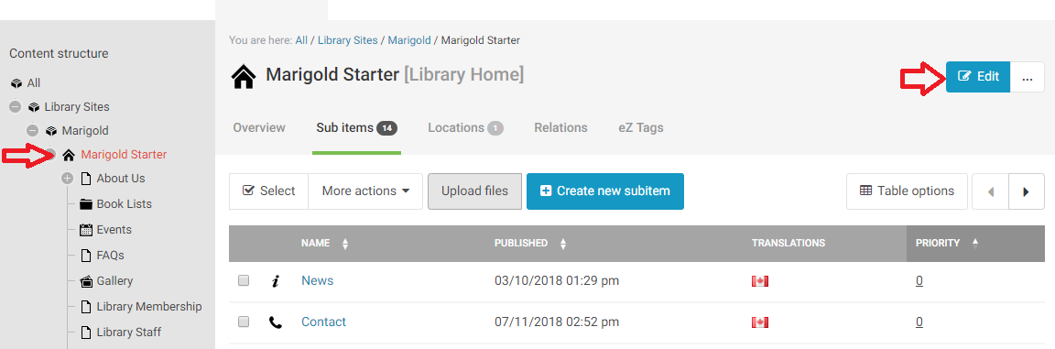

Library General Information
Select the “Content” tab from the menu on the left.
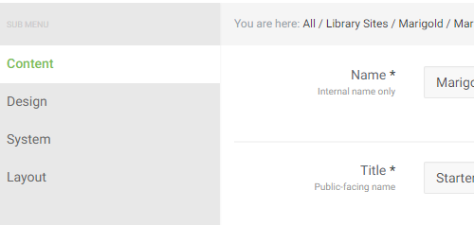
Here you will find:
- Library Name (Internal – this is what appears on the tree view)
- Title (this appears on the website itself)
- Address
- Opening Hours
- Opening Hours Description
- Phone Number
- Fax Number
- Email Address
- Social Media (Facebook/Twitter/Instagram etc)
- Manager
- Assistant
- Board chair
- Card fee
- Population
- Library Symbol
- Services Provided
- Map Link
- Staff List Page
- Newsletter (Title/Text/Button/LInk)
- Support your library link (Donate/Volunteer)

Opening Hours
Setting a schedule both allows the website to dynamically tell users if the library is open or closed today, as well as to provide a listed schedule for them to review.
There are four sections to the hours:
- All year
- Summer Time
- Special Rules
- Special Days
Fill in your regular schedule in the All Year Area
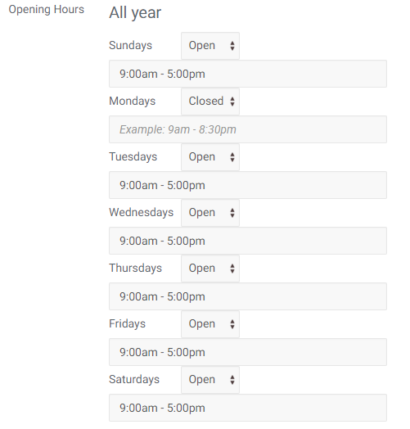
If you have Summer hours, enter the dates when the summer hours apply to your library. Once you fill in both fields, another list will appear (same as above) for you to fill in the summer hours.
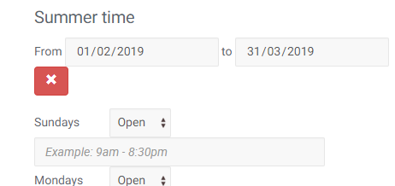
If there are specific days that the library is open/closed outside of a regular schedule (ex: those who are open only a few days over the summer rather than on a weekly schedule) you can add those days in the Special Rules. Click “Add Rule” then fill in the information. This can also be used to add STAT holidays that occur yearly.
For example, if you are only open June 27th and July 14th over the summer (every summer) you would enter the following:
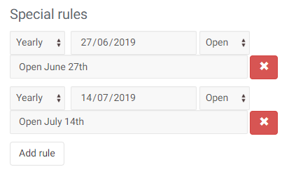
To add Special days, click “add day” under special days and fill in the information. The only difference between special rules and special days, is that special days do NOT recur, they happen once only, ever. EX: Library is closed because everyone is on vacation.
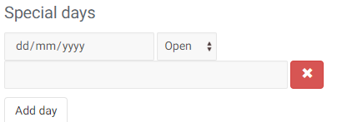

Opening Hours Description
If you have special considerations for your hours, you can add a comment here that appears below the regular schedule. Often simply “Hours may change without notice” or something to that effect is included. This is not mandatory.

E-mail Address
This address is used for the contact form, and anywhere the email address for the library is displayed.

Social Media (Facebook/Twitter/Instagram etc)
Please include the link to your social media accounts, with the http:// included.
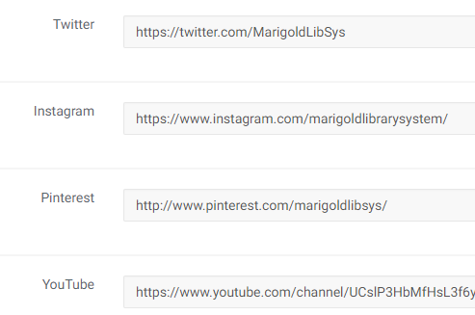

Services Provided
This should be a link to a page where you have described the services in the library

Map Link
This should be a link to a map showing the Library’s location.

Newsletter
At the bottom of your website homepage is a section talking about your library newsletter. These fields allow you to fill in the information for it. If you do not have a newsletter you can disable this section from appearing on your home page and can ignore this section.
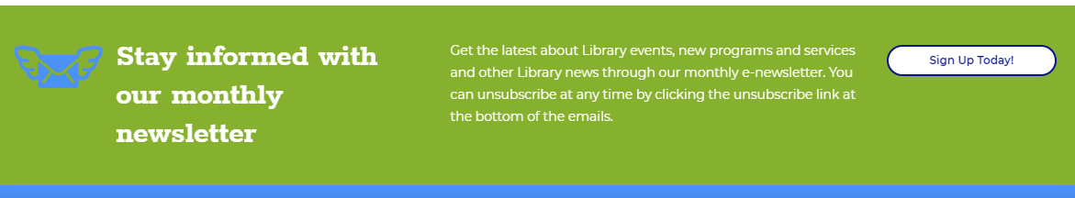

Support your library links
This section appears in the footer on each page of your website. It has two buttons, one to Donate and one to Volunteer. You will need to provide links to forms or pages that provide direction to your users on how to proceed.
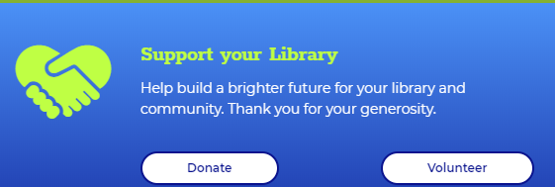

Design Template
Select the “Design” tab from the menu on the left.
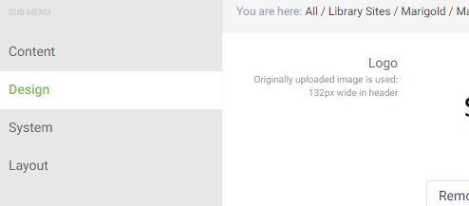
Here you will find:
- Logo
- Favicon
- Map
- Theme Colours

Logo
This is the main logo for your Library. Please note that the width is limited to 132px in the header, so size your image accordingly. Provide as close to a square image as possible, images that are long or tall and narrow will appear badly.
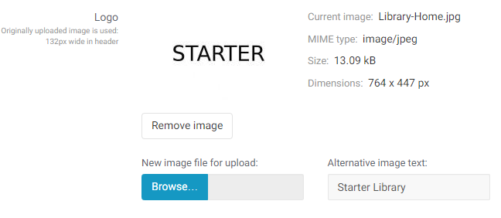

Favicon
The favicon is the small symbol that appears on the browser tab next to the title of the page. By default, this will appear as the Peace Library System symbol unless it is changed.
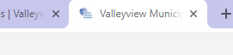
NOTE: These images are designed to be small and not very detailed, but still recognizable. Do not use a complicated logo for your favicon. If in doubt, please contact PLS for assistance.

Map
This is an image of a map view showing your Library’s location. The link to the map is in the “Content” settings.
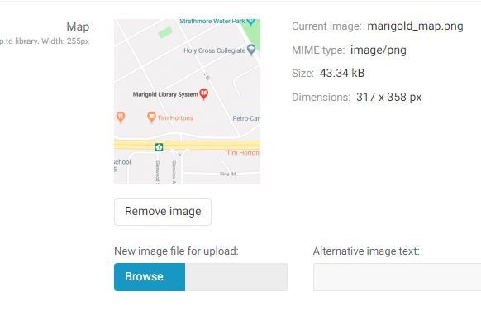

Theme Colours
There are several sections to the Theme Colours:
- Preset Selector
- Base Colours
- Special Colours
- Backgrounds
- Buttons
- Text
- Text Decorations
- Icons

Base Colours
There are 6 colors that are defined and control how everything on the website is displayed. These can be found here. You can individually change these colours either by pasting in a HEX code or clicking in the field and using the colour selector.
Alternatively, you may fill in a “theme” by using the “Preset Selector” picking an option and clicking “Apply”
NOTE: Until you publish these changes, they will not be live on the website
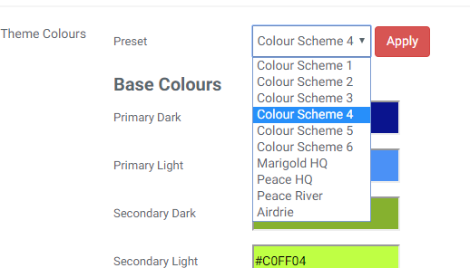
The Base Colours are applied through the template based on the following:
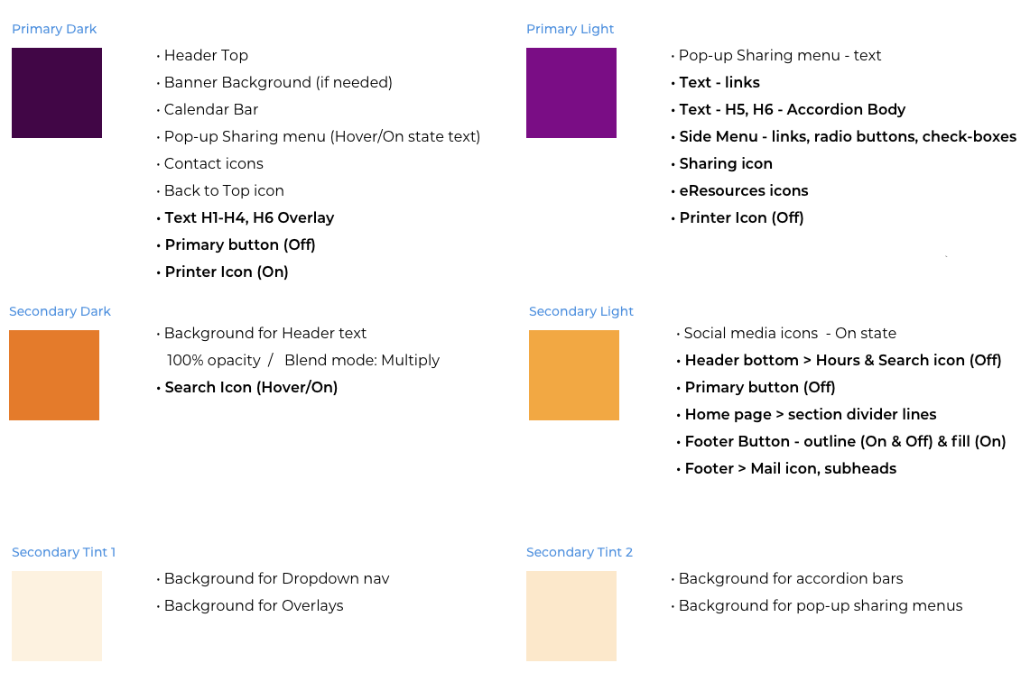
NOTE: If you have any problems aligning your brand colours with the base colours on the website, please contact PLS for assistance.
WARNING: If you do not have specific brand colours, you will need to select an overall colour palette before attempting to design a colour scheme for your website. Entering random and/or non-complimentary colours here can destroy the overall look and feel of your site.

Advanced Colour Selection
Because of how colours vary, sometimes the light/dark needs to be swapped to provide more contrast and better visibility to the end user. The remaining colour selectors allow you to make these minor tweaks, as well as show where each colour is used on the website and what it is used for.
Not every item can be individually altered, and the ones that can will only have two options.
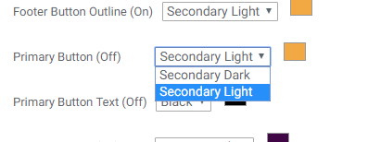
NOTE: Only change these if you notice that objects on the site need to be changed because they are difficult to see and/or read.

System
Select the “System” tab from the menu on the left.
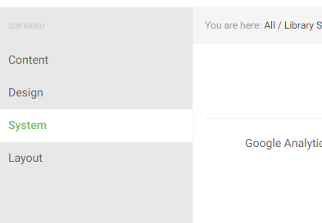
Here you can enter your website URL, and Google Analytics ID. The website URL is used when generating the member library listing.
NOTE: You should not have to change these settings after they have been created.

Homepage
Select the “Layout” tab from the menu on the left.
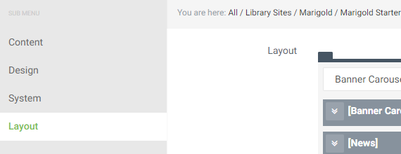
This is where you can manipulate the content that appears on your library Homepage. There are six sections that can be added to your site:
- Banner Carousel
- News
- Events
- Book List
- Fun Fact
- Featured Cards
The order of these items can be manipulated by drag-and-drop or using the arrow buttons on the right. Clicking the Trash button will remove that type of content from your home page.
NOTE: This does not delete any actual content, it just removes the object from appearing on the Home Page.
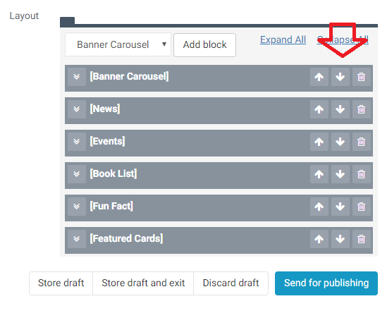
Click on the arrow to the left of any item to expand it and view the information displayed in that section of the Home Page.

Banner Carousel
These banners appear at the very top of the Home Page beneath the main menu.
NOTE: For creating banners see the section “Banners” under Homepage Objects.
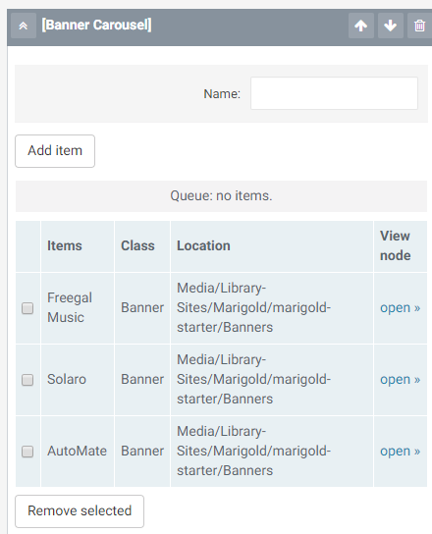
You can add up to five banners, and they will rotate based on the order in which they were set up. You can click-and-drag the items to change their order.
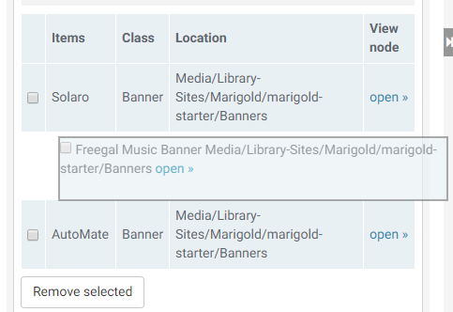
To add a banner, click the “Add item” button.
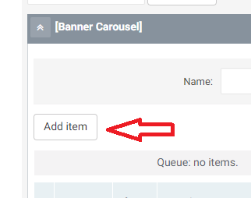
Select “Banners” in the Browse page.
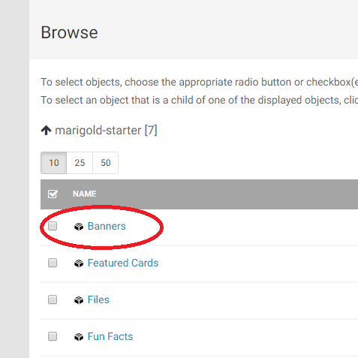
Click the checkboxes next to the banners you would like to add and click the “select” button.
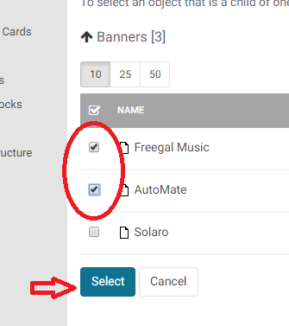

News
By default, this section will be filled with the 3 latest news items in chronological order (newest first). If you would like to manually insert items in to this list you can do so here.
NOTE: We recommend you do not edit this area unless there is a very specific reason to semi-permanently “feature’ a news article. Static information is better suited for other elements, such as the banners or featured cards.
Click on “Add Item” to add a specific news item. Select “News” in the Browse page.
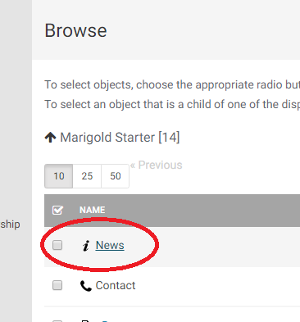
Click the checkboxes next to the news items you would like to add and click the “select” button.
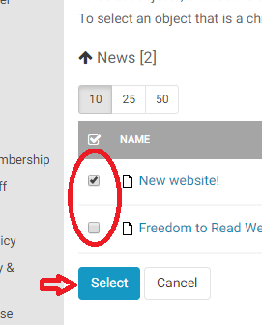

Events
Events function exactly as News Items (see section above)

Book List
You can have multiple book lists in a single section on the home page, and you can have multiple book list sections.
To assign a name to the Book list group, fill in the Name field:
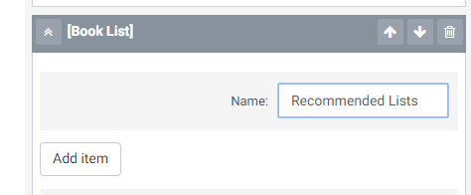
NOTE: If you want to show a “Featured” book list, make sure it is the only list in the section. If you add multiple lists you will lose the “Featured” look.
NOTE: To create book lists, see the “Book Lists” section under Content Types.
To add a list, click on “Add Item” and select the book list from the browse page (if you have a folder that the book lists are in, select the folder first, then the book list inside it).
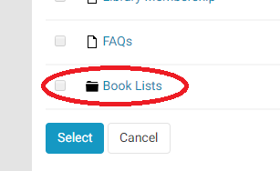
Click the checkbox next to the book list(s) you want to insert and click “Select.”
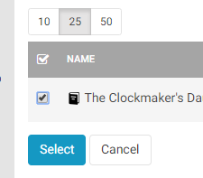
When multiple lists are added they appear as a carousel with multiple tabs:
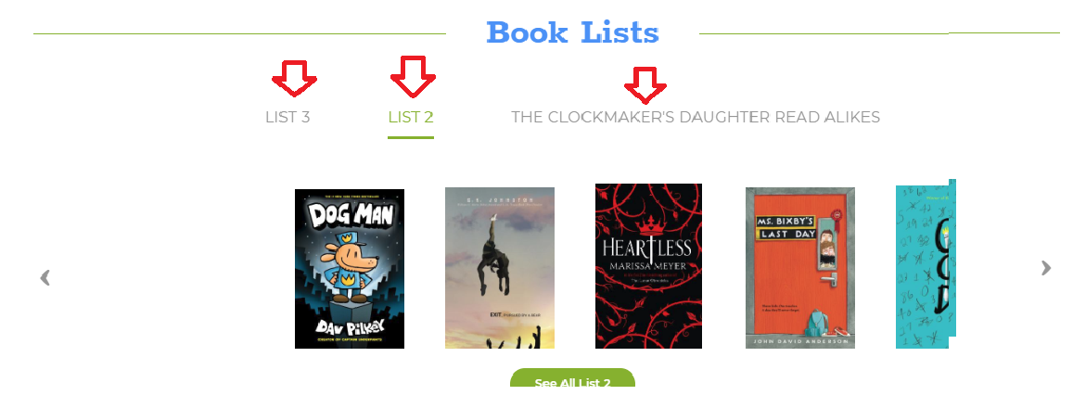

Fun Fact
Fun facts act as section breaks on the home page.
NOTE: For creating fun facts see the section “Fun Facts” under Homepage Objects.
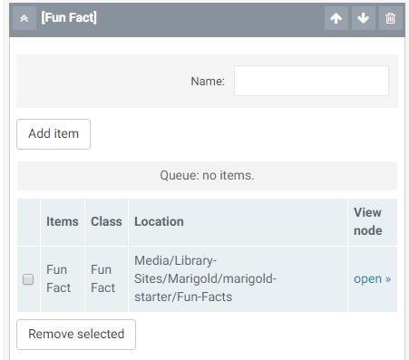
To add a fun fact, click the “Add Item” button, then select “Fun Facts” from the Browse menu.
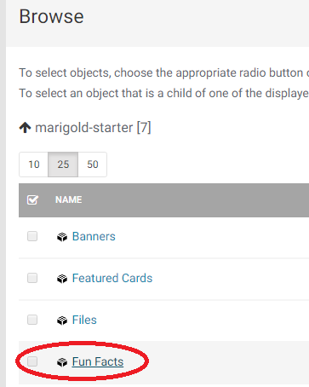
Click the check box next to the fact you would like to enter and click “Select.”
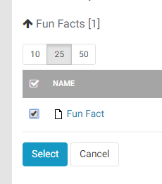
NOTE: Only one fun fact should be inserted in to each section.

Featured Cards
Featured cards appear as a group of clickable objects on the Home page.
NOTE: For creating featured cards see the section “Featured Cards” under Homepage Objects.
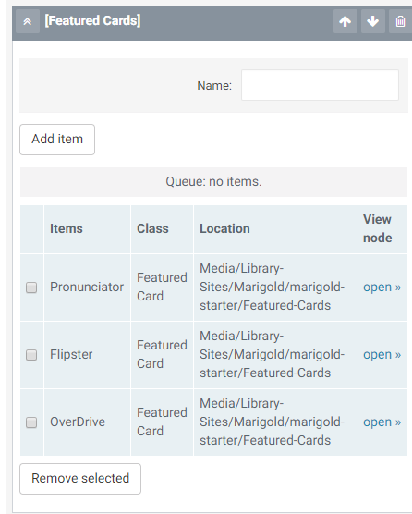
To add a featured card, click the “Add Item” button, then select “Featured Cards” from the Browse menu.
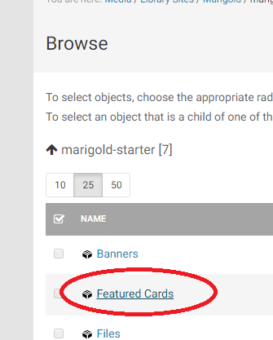
Click the check box next to the card(s) you would like to add and click “Select.”
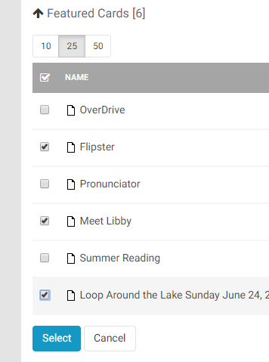
NOTE: For each feature card section make sure there are at least 2 cards and no more than 3 cards.

Menu Structure

Menus are all managed in the “Media Library” section from your black side menu. Click on “Media Library” then expand the “Menu Structure” section to view the three menu types.
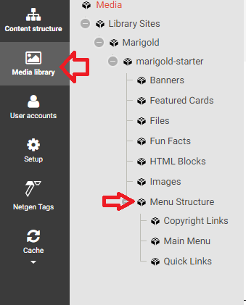
There is the:
- Main Menu
  - Appears in the top header of the site
- Quick Links
  - Appears in the footer
- Copyright Links
  - Appears beneath the footer

Link Order
The order the links appear is managed by the “Priority” assigned to each link. By default you can not see this option in the table. To turn this on so you can modify the links click the “Table Options” button.
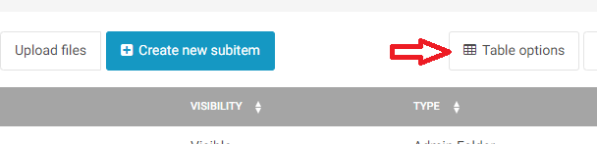
Then click the box for “Priority” and click “Close”
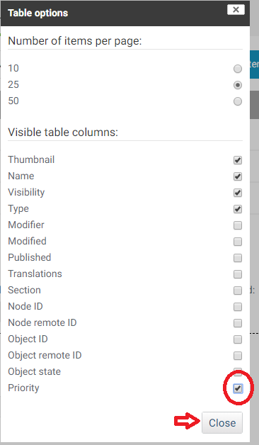
Items with a LOWER priority appear FIRST (at the top or to the left).
NOTE: You can create negative values (ex: -1).
To edit the priority, click on the number and type a new value.
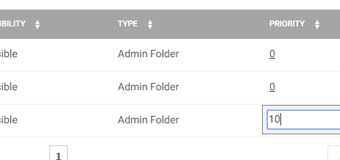
NOTE: Everything is created with a default priority of 0. When things have the same priority, the item created first appears first.

Creating Links
There are two ways to creat a link to a menu item. You can use an Internal Link or External Link. Each menu item allows you to create a link using either.

Internal Link
If you are linking to a page on the website use the Internal Link. You can either browse for the object by clicking “Add Existing object” or type in a name and click “Find Object.”
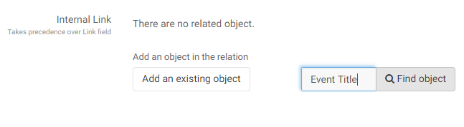
If you click “add an existing object it will open the Browse menu. Click through the menu items (or use the tree view on the left) until you find the item you are looking for.
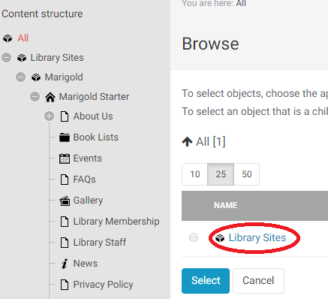
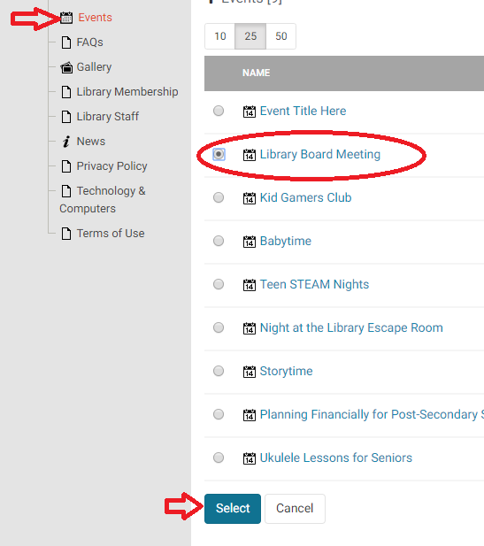
If you use the Find Object a list of relevant items will appear for you to select from.
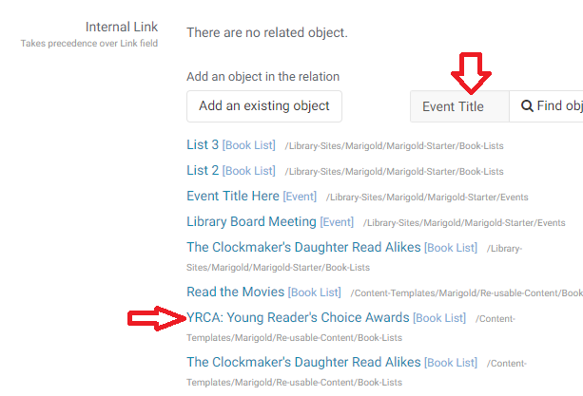

Link
Manually enter the link you would like to send the user to.
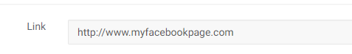

Main Menu
The main menu is broken down into three layers of items.
- Menu – Main Menu Item
  - This appears directly on the menu of the page as the topmost category level.
- Menu – Menu Column
  - Each Main Menu Item can have up to three inner columns and must have at least one.
- Menu – Sub Menu Item
  - These are the clickable menu links that take users to pages on the site. They can be added to any menu column.
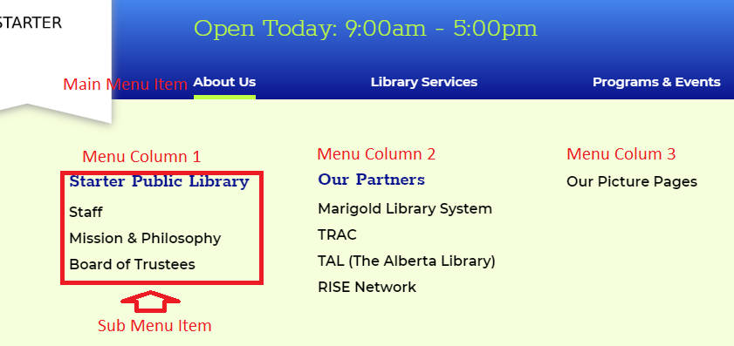

Main Menu Item
The site template is designed to have up to a maximum of four main menu items. These should be very broad categories beneath which you can fit multiple subcategorie. We have provided examples for what we believe are useful generic headers for your use.
To add a Main Menu Item, click on “Main Menu” from the media library, click “Create new subitem” and select “Menu – Main Menu Item.”
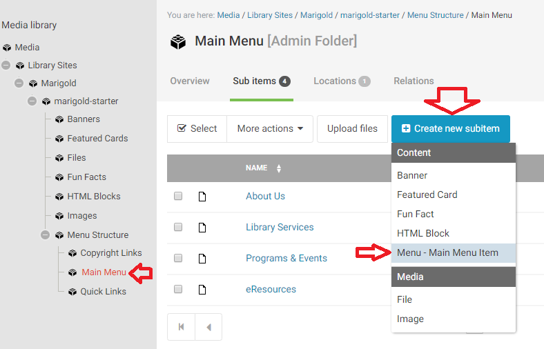
There are 3 fields to fill out:
- Title
- Internal Link
  - Links to a page on your own website
- Link
  - Links to a page not on your website

Title
This is what appears as clickable to the user.

Links
See “Creating Links” above.

Menu Column
To add or edit menu columns, click “Main Menu” on the media library tree view, then select the menu for which you would like to edit the column.
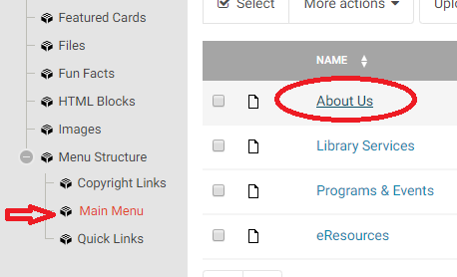
NOTE: There are two types of Menu Columns; a list of text links or an image link.
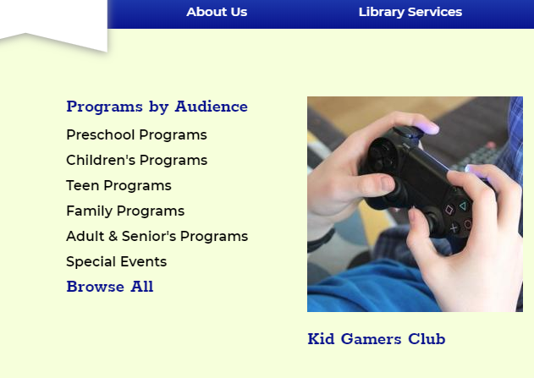
You may have up to three columns in each Main Menu item. To add a Column click “Create new subitem” and select “Menu – Menu Column.”
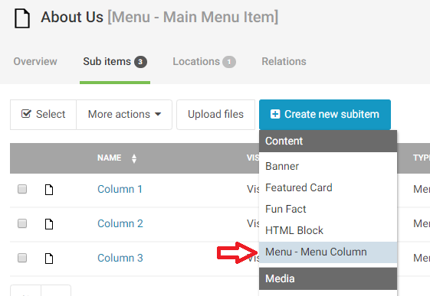
There are 5 items you can fill in for a Menu Column:
- Title
- Image
- Image Description
- Image Internal Link
- Image Link

Title
The Title only appears if you are making an Image link Column. If this is a text link column the title will not appear and we recommend labelling it Column A/B/C or 1/2/3 (or similar).
If you are making an image column this title appears below the image.

Image
If you are creating an image link, this is where you upload the image you would like to use. Please note the image size is 255x255px.
To add an image, click the Browse Button and select a file from your computer.
Alternative image text will appear if for some reason the image is unable to load and for visually impaired users this description is used by their screen reader. You can enter a brief description (one sentence or less) of the image here.

Image Description
This appears below the title and should be a short (one sentence or less) description of the page you are sending the user.

Links
See “Creating Links” above.

Sub Menu Item
To add text links to columns, click on the menu column you want to add the link to, click “Create new subitem” and select “Menu – Sub Menu Item”
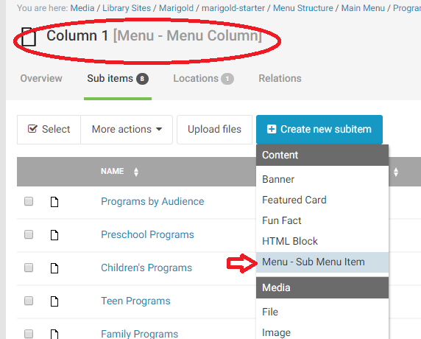
There are 4 Fields to fill in for a Sub Menu Link
- Title
- Display as Header
- Internal Link
- Link

Title
This is what the user sees as clickable.

Display as Header
This will format the link a different way. It isn’t necessary to have column headers, but it helps organize the data. Columns may have multiple headers in them to break links into sub groups.
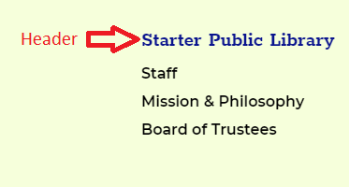
NOTE: Headers can be links, but do not have to be links, they can just be text. For just text, don’t add a link in the link sections.

Links
See “Creating Links” above.

Quick Links
These links appear in the footer of your site and should be a “Quick” navigation to lesser used pages. Normally people look for About us, Contact, Policy and FAQ pages in the footer.
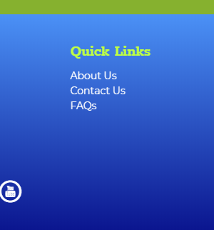
Quick links only include “Main Menu” Items. For creating main menu items see “Main Menu Items” section above.
When creating Quick Links, navigate to the quick links section on the tree and add new Main Menu Items.
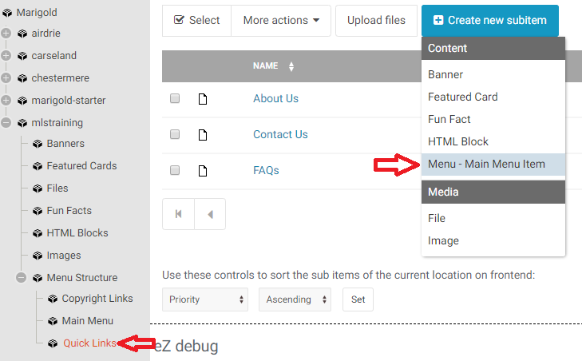

Copyright Links
Copyright links appear beneath the footer on the right side of the page. Generally Terms of Use and Privacy Policy links go here.
Copyright links only include “Main Menu Items”. For creating main menu items see “Main Menu Items” section above.
When creating Copyright links, navigate to the copyright links section on the tree and add new Main Menu Items.
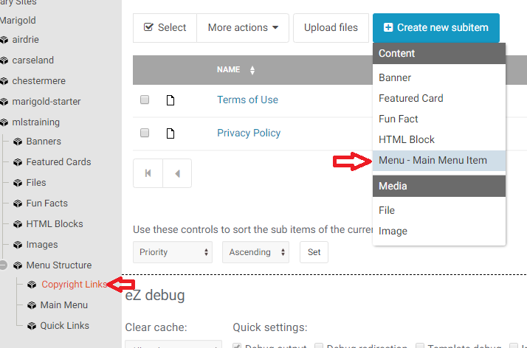

Advanced Tips
There are many ways to accomplish things using the new website platform. As you become more familiar with the platform you may look for different ways to accomplish similar tasks. The main goal of this manual is to provide easy to follow step by step instructions. For those people who would like a more in depth understanding of using the platform this section will detail option for using advanced features to perform tasks.

Testing
There is a testing platform where you can experiment with the system and not worry about affecting your live site or changing content on the live site. Everything on the production environment is mirrored on the staging environment, the URLs are the same, except anywhere you would normally see “production” it would be “staging”.
NOTE: The staging environment will be overwritten and “reset” on a semi-regular basis. Back up any content that you would like to keep.
Editor access:
https://manage.staging.peacelibrarysystem.ab.ca
Live access:
https://website.staging.peacelibrarysystem.ab.ca ex: https://peace.staging.peacelibrarysystem.ab.ca

Navigation
Some tips for navigating the platform.

Breadcrumbs
Wherever you are on the website, there will be trail broken out for you to see where you current are, and to easily navigate back to higher levels. In the editor you will see the breadcrumbs at the top, just beneath the top menu:
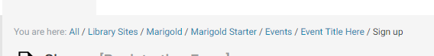
You can click on any of these links to go back to that level of the editor. For example, if I wanted to return to the “Events” item to add a new event, I could click on “Events”.
On the live site, breadcrumbs appear beneath the site logo, and are used the same way.
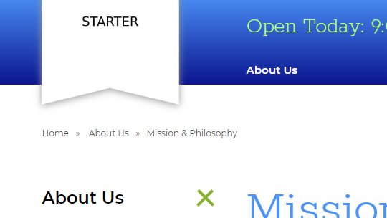

Moving between edit and live
You can easily navigate between the editor and live view of the site by pasting a portion of the URL back and forth. To do this, open the editor, and the live site in different tabs.

Then, for example, if you are viewing the “Mission and Philosophy” page at the URL:
https://www.peacelibrarysystem.ab.ca/About-Us/Mission-Philosophy
Copy everything after your main site url (/About-Us/Mission-Philosophy) and paste that into the editor tab so your URL would be:
https://manage.production.peacelibrarysystem.ab.ca/About-Us/Mission-Philosophy
This will take you directly to the page in the editor, so you can edit it and make changes. You can also copy from the editor side and paste it on to the live side to navigate to the page you are currently editing.

Create Here
If you would like to create content inside a container, you can do so by clicking on the menu for the container, and selecting “Create Here” then selecting the type of content to create.
NOTE: Be careful, the create here menu contains all content types, many content types will not display properly (or at all) when created in the wrong location.
For example, if you wanted to create a new “News” item, you could do so by selecting the News Landing Page and clicking “Create Here” then selecting “News Page”. This saves you from having to click in to the News landing page, and use the “Create new subitem” button.
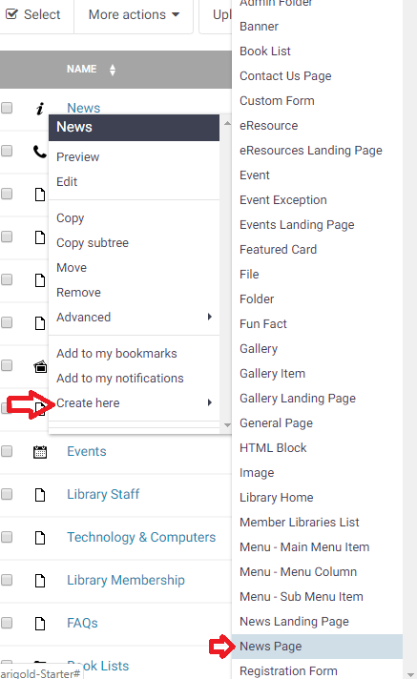

Manipulate Content
There are many ways to manipulate content in the editor. When viewing a piece of content, next to the blue “Edit” button is a button with “…”. Click to Move/Copy/Remove and Manage versions for the current content piece.
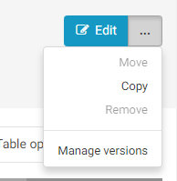
You can also click on the icon next to the item in the table and perform many different operations.
Preview/Edit/Copy/Move/Remove/Add to Bookmarks/Add to Notifications/Create Here
Advanced -> Swap/Hide/Sitemap/Manage Versions/Manage Aliases
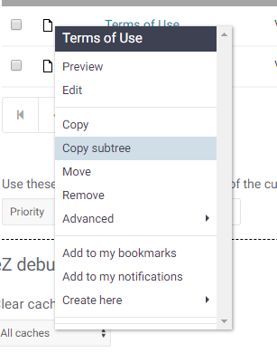
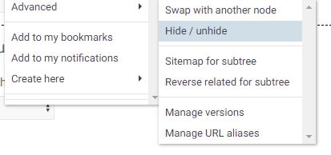

Move or Copy Content
If you would like to move content on the site to a new location, you can do so in several ways – ie: you have created a new folder, or want to re-locate an item to a different menu location.
To move content you can use the “…” button next to the “Edit” or click on the menu link and select “move.”
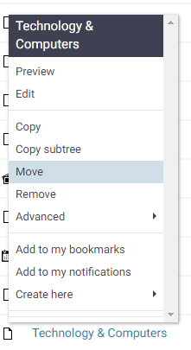
This will open the Browse tool. Navigate to the location you would like to move the content to, click it, then click “Select.”
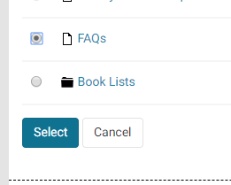

Navigating
When viewing the browse screen, you can navigate through the tree structure of the website.
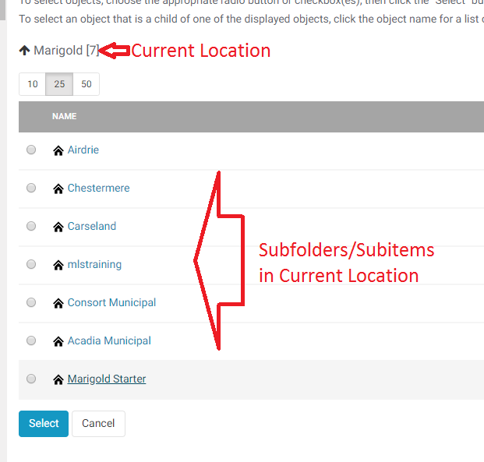
To enter an object, click on its name, you will then move “in” to that item/folder and see the contents inside.
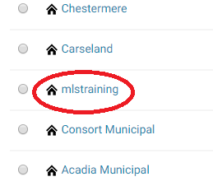
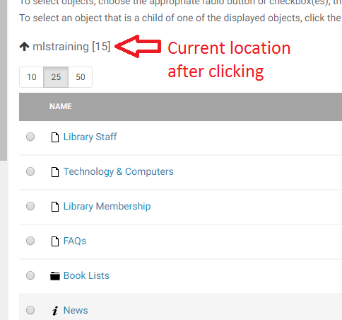
To select the object click on the radio button (or checkbox) next to it and click the blue “Select Butotn”. The action will then be performed on that object.
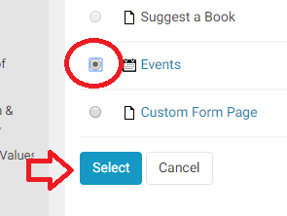
To Go back to a higher level in the tree structure, click on the “Up Arrow” icon next to your current location.
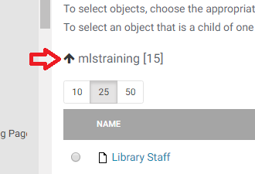
You can also use the full tree structure on the right to navigate to a specific location.
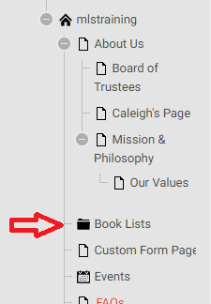
After clicking you will arrive in the selected object or folder.
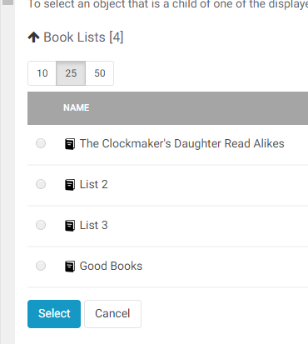

Change Page URL
You can change (or add) the URL that a page appears at by managing the URL aliases. This can be used to shorten a URL if you need to include it on print and want to make it easier for patrons to manually enter in to their browser. For example – a URL like: http://maps.google.com/maps?f=q&hl=en&geocode=&time=&date=&ttype=&q= Stadhouderskade+42,+Amsterdam,+The+Netherlands&sll=40.71451,-74.0071 4&sspn=0.625578,1.560059&ie=UTF8&z=16&iwloc=addr&om=1
Would be really difficult for a user to type in to their browser. You can shorten that to anything you would like by clicking on the menu item for the content and selecting “Advanced” and “Manage Url Aliases”
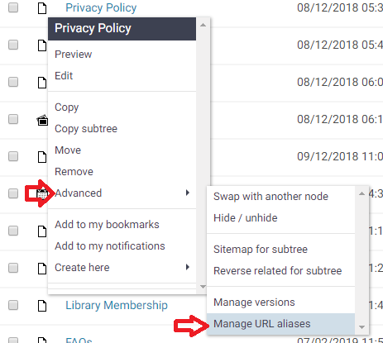
Note: the current URL alias is in the format /library-sites/PeaceLibrarySystem/website/location/location/location
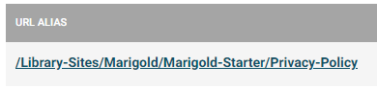
You can add a new alias by entering the name in the URL Alias name field – NOTE: You must include /Library-Sites/PeaceLibrarySystem/Library-Name and capitalization DOES matter here.
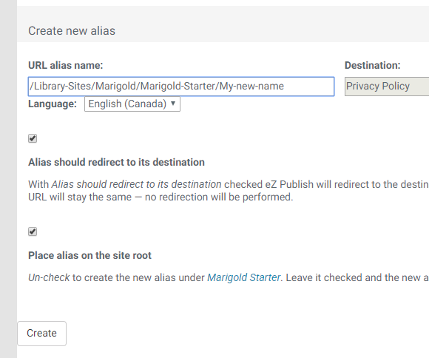
Then click “Create.”
NOTE: The Alias cannot contain spaces, use a “-“ in place of the space bar.
Your new alias will appear in the URL Aliases section.
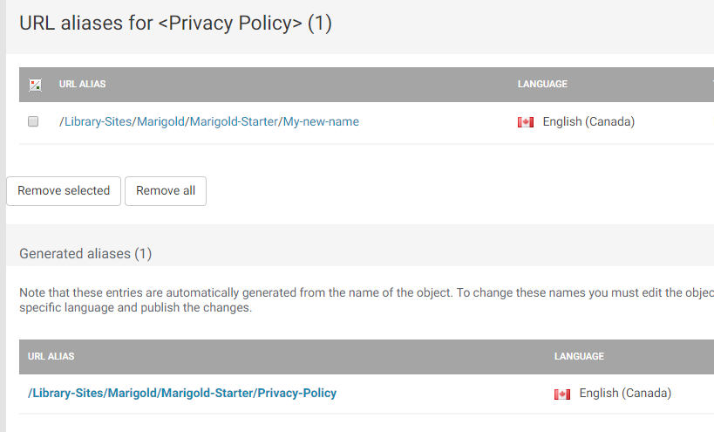
You can then navigate to http://www.mylibraryname.com/My-new-name and the page will display.

Hide a page
If you would like to keep a page active but not visible to the public, you can hide it from the menu list. Click on the menu item -> Advanced -> Hide / unhide
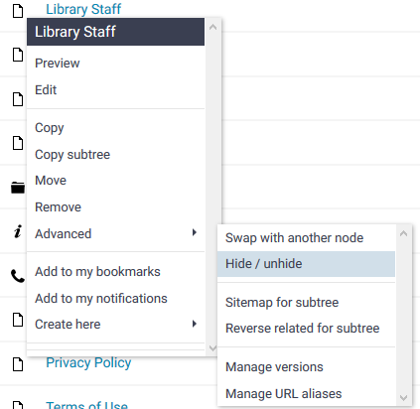
On most tables the “visible” column is not shown.
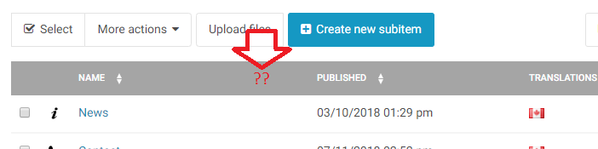
To show it, click the “Table Options” button and select “Visibility.”
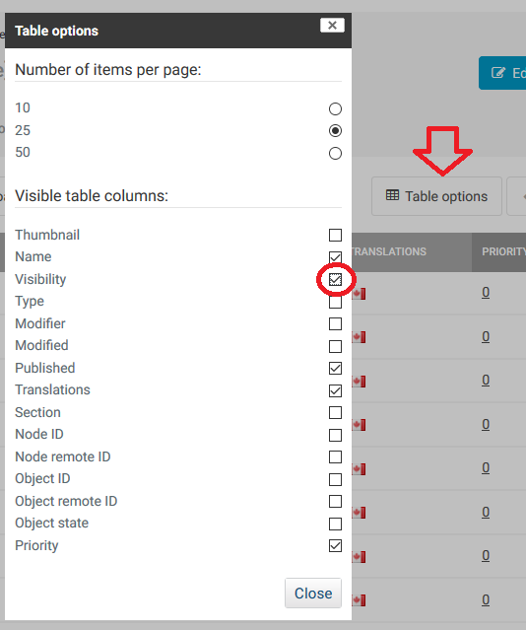
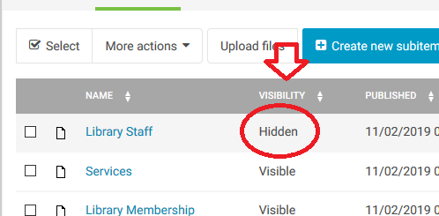

Custom Code

The platform can embed pieces of custom code that you may receive from outside sources to embed in your website. These are commonly used for outside forms, newsletters, facebook/twitter feeds etc. Any time you have a piece of code that you need to embed on your website you will use the “HTML Blocks” content type.

Creating an HTML Block
HTML blocks are located in the Media Library. Navigate to the library, and click on “HTML Blocks” on the tree menu.
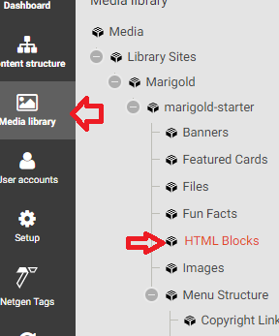
Click “Create new subitem” and select “HTML Block.”
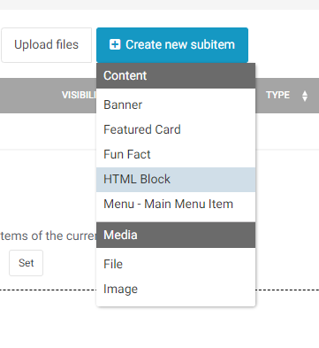
The Title will not appear anywhere on the site, but the block needs to have a name.
Paste your code in the “Code” field.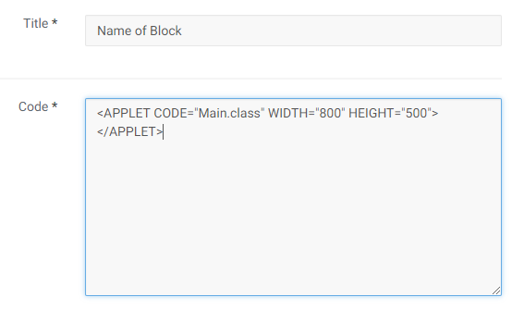
NOTE: The code can only contain HTML, CSS and Javascript.

Embedding HTML Block
Blocks are embedded the same as all other objects. Once they have been created you can find them when inserting objects in the editor. For help using the editor see “Using the Editor” and/or “Insert/Edit Objects.”

Version History

Version 1.02
- Added version History page
- Updated feature card section to include new editor interface and explain how the code section interacts with the background image
- Updated Custom Forms section to better describe the number and integer fields
- Added more detailed instructions for Moving/Copying data and how to use the browse interface
- Adjusted some image spacing
- Added Image Max Width screenshot and note
- Adjusted General Page Side Menu section for clarity
- Added hero image from library field to General Page
- Added selecting different registration dates to Custom Form Section

