Craft for: B is for Bulldozer: a Construction ABC

Cranes

Materials:
- Construction paper
- White paper
- Scissors
- Glue
- Something to colour with

Instructions:

- Print out the crane template for each child to colour and cut out.
- Have the children glue the crane onto a background piece of construction paper.
- The children can then decide what their cranes are picking up. They can either draw the object onto the paper, or cut it out from another piece of paper and glue it on.
- Have the children add on anything else in the background they would like, such as buildings or construction workers.

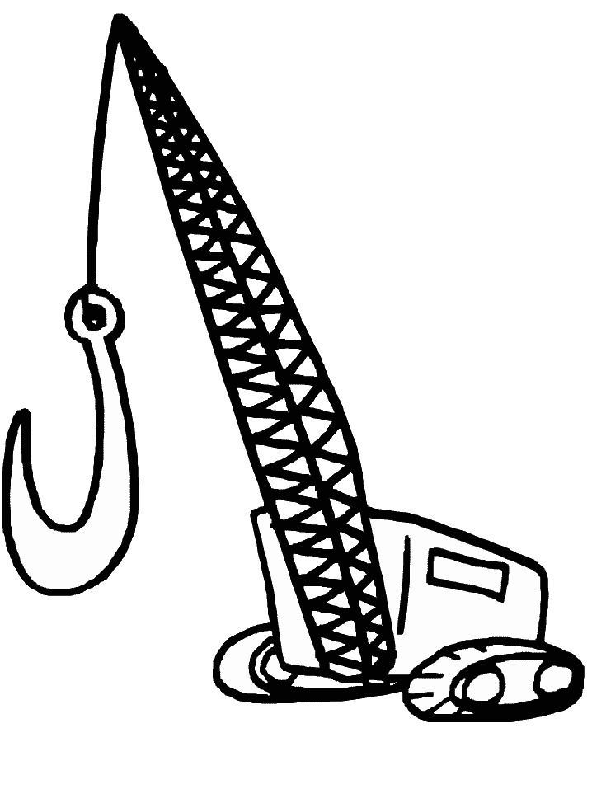
Alternate Craft for: B is for Bulldozer: a Construction ABC

Popsicle Stick Buildings

Materials:
- Construction paper
- Popsicle sticks
- Glue
- Paint, markers or crayons

Instructions:

- Give each child a handful of Popsicle sticks and a piece of paper.
- Have the children create buildings by gluing Popsicle sticks onto the paper.
- They can break the sticks in half to create smaller pieces.
- You may want to discuss the elements of a building, such as sides, roofs, doors, windows, etc to give the children a few ideas.
- To make this a little easier, have the children draw a building onto the paper first and then glue the Popsicle sticks onto the building.
- Once finished, the children can colour or paint their Popsicle stick buildings.

Craft for: Building with Dad

Construction Mobile

Materials:
- Paper
- Something to colour with
- Scissors
- Glue
- String or yarn
- A small paper plate or circle of cardboard (old cereal boxes are a good source of cardboard) AND two straws or sticks

Instructions:

- Print out the template pieces for each child to colour and cut out along the dotted lines.
- Have the children fold the template pieces in half and glue the back and front together.
- Poke a small hole in the top of each piece and tie with yarn or string.
- Give each child a paper plate or circle of cardboard with a hole poked through the center and two straws.
- Have the children arrange the straws in an X shape and tie with string, or do this before hand.
- Tie a long piece of wool to the center of the X. Slide the circle of cardboard or paper plate onto the wool (through the hole you made).
- The children can tape the straws to the plate to keep them in their X shape and to help them balanced.
- To finish, the children can string each mobile piece onto one of the straws (and in the center if desired).

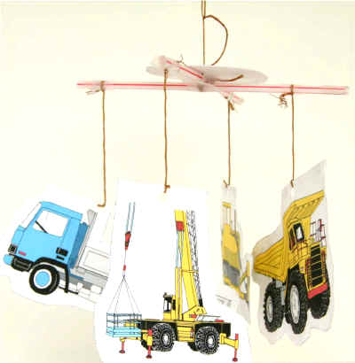

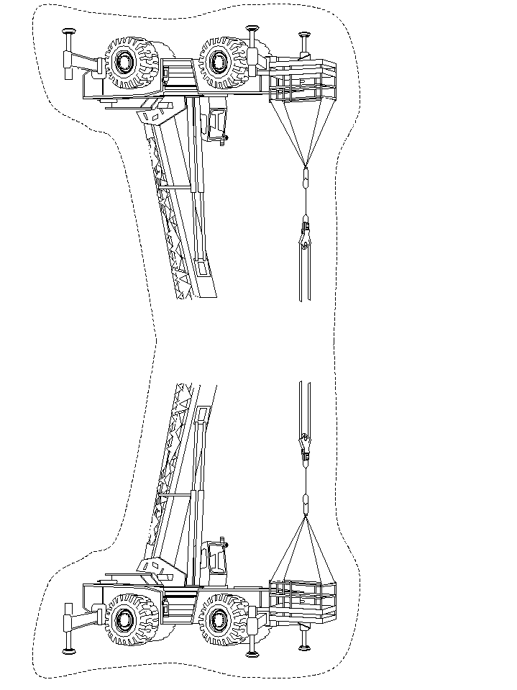
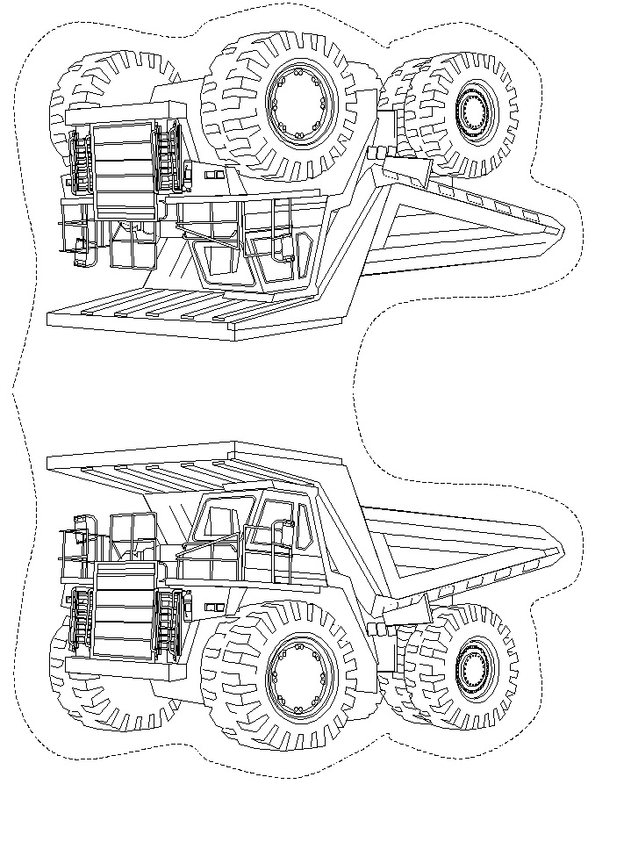

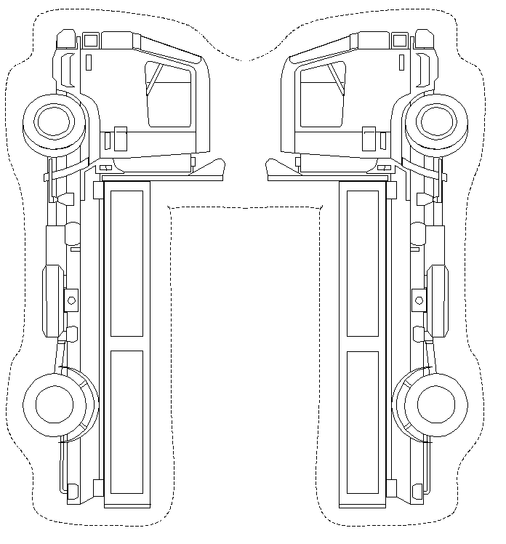

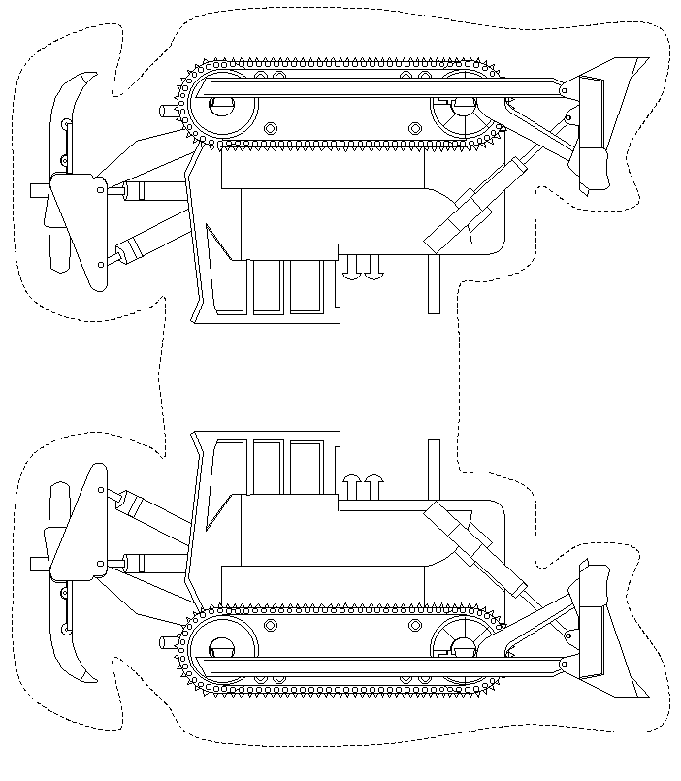

Craft for: Chugga-chugga choo-choo

Arm Tracing Train

Materials:
- Coloured construction paper
- Scissors
- Tape
- Glue
- Cotton balls
- Crayons
- Pen or pencil

Instructions:

- Give each child two pieces of coloured construction paper to tape together end to end for background paper.
- Next, trace each child’s hand and arm to the elbow onto another piece of construction paper, making sure the fingers are together and the thumb is flush with the palm.
- Have the children cut out the hand and arm tracing. They can then cut the hand off the arm, to make the train’s engine, and cut the arm into about 3 sections for the train cars.
- The children can then glue the train pieces onto the background paper.
- The children can cut out or draw on a smoke stack and wheels. They can also add windows, connections between the cars, and cotton ball smoke puffs.
- If desired, the children could also draw on train tracks, and anything else in the background they would like.

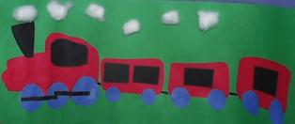

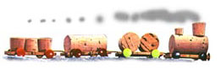
Craft for: Crossing

Cork Train

Materials:
- 3 large, round corks
- 4 small corks and half a very small cork
- a piece of cork tile 1/8" (3mm) thick
- different color thumbtacks
- glue
- embroidery thread
- a large needle
- some paraffin or a piece of candle wax
- sandpaper

Instructions:

- For each child, cut the 4 bases for the cars from the cork tile (see drawing 1 for size). Use a ruler to do this. The cork cuts easily if you pass the knife through the paraffin once. Sand the cut part.
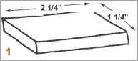

- For the locomotive, the children can glue the large cork to a base. Then glue the smokestack on the large cork. Make it from a little cork and half of a very small cork. Put 2 red thumbtacks on the front of the base. Stick in 4 coloured thumbtacks to make wheels (see drawing 2).
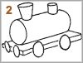

- For the first car, cut a large cork in half. Sand the cut ends. Glue the two halves onto the base (see drawing 3). Stick in 4 thumbtacks for wheels.
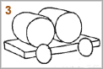

- Have the children build 2 more cars by using different sizes of cork.
- To attach the cars together, use the large needle to thread the embroidery thread through the cork tile.
Alternate Craft for: Crossing

Egg Carton Train

Materials:
- Cardboard Egg Carton
- Paint or markers
- Circle stickers
- Cardboard tubes
- Other collage materials

Instructions:

- Give each of your children a row of six egg cups cut lengthwise from a cardboard egg car-ton.
- Have the children turn their egg carton sections upside down and paint or colour them to make trains.
- The children can then add details such as round slicker wheels, paper windows and cardboard-tube smokestacks.

Craft for: Dig

Log Cabins

Materials:
- Brown construction paper
- Tape
- Glue
- Other construction paper
- Scissors

Instructions:

- Cut the brown paper in half the long way. Cut the two strips to about ¾ of their length. Give each child a bunch of these strips.
- Have the children roll the strips of paper into logs and secure with tape.
- Once the children have at least 10-12 logs, they can build a log cabin. Show them how to stack the logs in order to make a square box. Glue and/or tape the logs in place.
- For a roof, the children can take a large piece of construction paper, fold it in half and secure it on top of the cabin with tape.
- The children can also add doors and windows made from squares of construction paper.

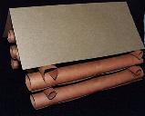

Craft for: Emergency

Box Fire Truck

Materials:
- A cardboard box
- Four paper plate
- Red and black paint
- Black, white, blue and orange construction paper
- Scissors
- Glue

Instructions:

- Have the children paint their boxes red and their four paper plates black.
- The children can then cut two headlights and fenders from white construction paper and glue them to one end of the truck.
- Cut a windshield and windows from light blue construction paper and glue them to one end of the truck.
- Have the children glue the wheels to their trucks.
- The children can then cut two ladders from orange or brown construction paper and cut two hoses from black construction paper. Cut white hub caps. They can glue all of these to the sides of their trucks.
- You can cut out the bottom of the box (before making the craft) and the children can enter the box, carry it, and walk around pretending to be a fire fighter.

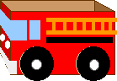

Alternate Craft for: Emergency

Fire Truck Rubbings

Materials:
- Paper doilies or sandpaper
- Thin white paper
- Crayons
- Scissors
- Larger piece of paper

Instructions:

- Using the templates, cut fire truck shapes out of paper doilies or sandpaper. Give each child several shapes.
- Have the children place a piece of thin white paper over the fire trucks and rub a crayon over the fire truck. The fire truck shape will come through.
- The children can cut out their rubbings and glue them onto a larger piece of paper. They can make a collage or create a fire truck scene from the rubbings.

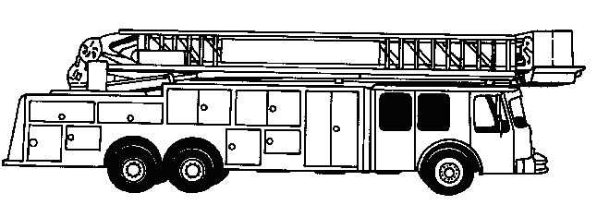

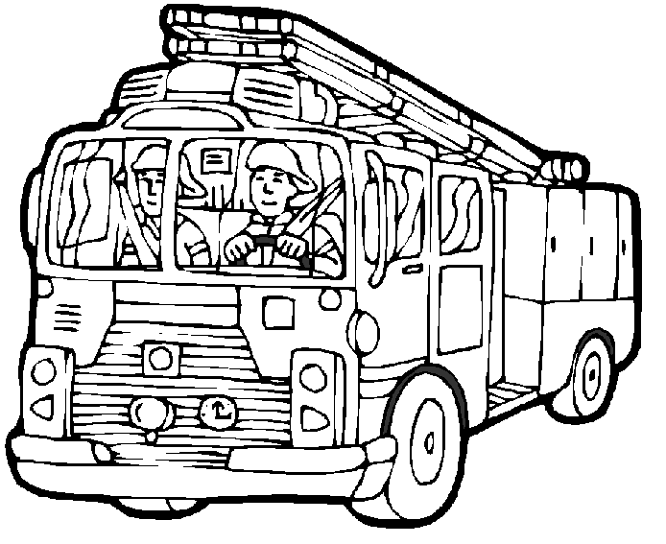

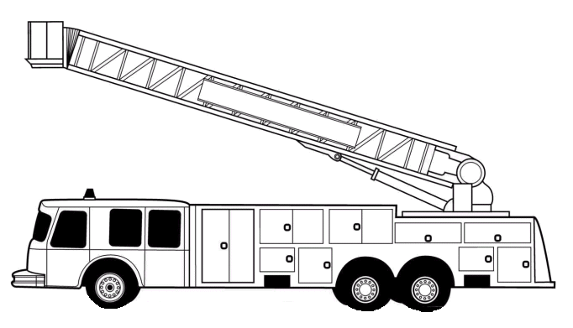

Craft for: Fire Truck

Fire Engines

Materials:
- Red, black and white construction paper
- Scissors
- Brass fasteners
- Something to colour with
- Glue

Instructions:

- Print out the templates for each child. The truck can be cut out of red construction paper, the wheels out of black, and the ladder out of white.
- The children can colour the ladder. The spaces between the rungs can be cut out, except for the bottom so the ladder can be attached to the truck with a brass fastener.
- Have the children attach the wheels and ladder with brass fasteners so they can move.
- The children can also glue on a window, a hose, a firefighter, and a fire dog if they would like.

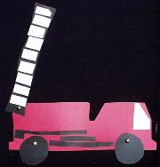

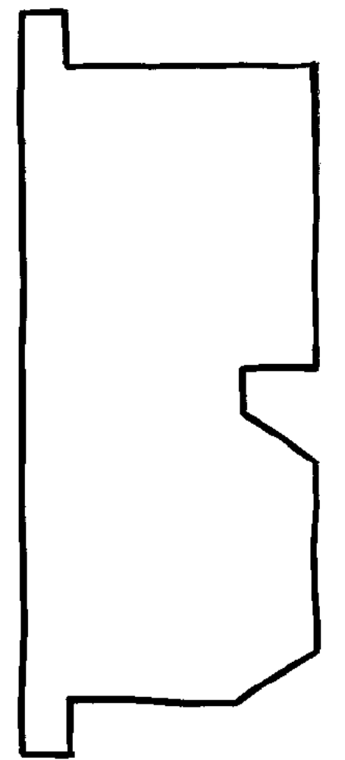



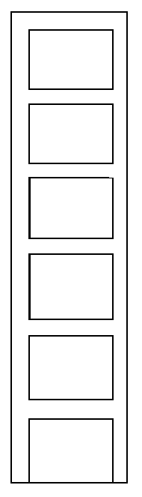

Craft for: Freight Train
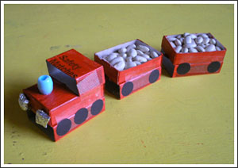
Matchbox Train

Materials:
- Four matchboxes
- Acrylic paint
- Buttons or black stickers
- Scissors
- Glue
- Marker pen
- Ribbon
- Button
Instructions:

- Each child will need both parts of three matchboxes, plus the lid from a fourth matchbox cut in half.
- Have the children paint the outside of all these pieces with acrylic paint.
- The children can then line up the lids, place a length of ribbon over the top and tape them on.
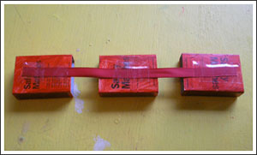
- Have the children glue/tape the trays on the top as pictured. Then glue on a bead to make a funnel.
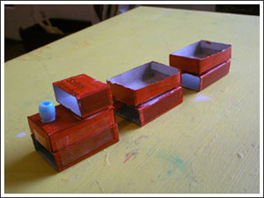
- To finish, the children can stick on some buttons or stickers for wheels, use scrunched up aluminum foil for lights and fill with some dried beans or gravel.

Alternate Craft for: Freight Train

Shape Train
Materials:
- 12 x18 sheet blue construction paper per child
- 2 red rectangles per child
- 4 small black squares per child
- 1 thin rectangular strip for child
- 4 gray wheels per child

Instructions:

- Have the children cut out all the shapes (or do this ahead of time)
- The children can then glue on the 2 red rectangles on the blue construction paper to make a train.
- Next have them glue on the small black squares to be the windows of the train. Then have them glue on the wheels.
- The children can then glue on the thin rectangular strip in between the two trains to connect them.
- Have them draw tracks that the train is sitting on. They can also draw trees, grass, etc.

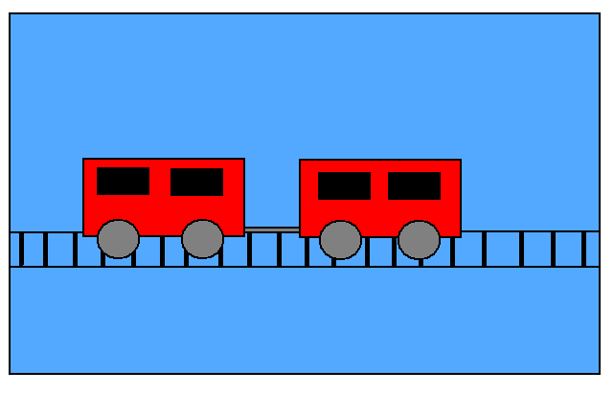

Craft for: Get to Work, Trucks!
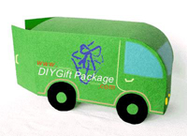
Box Truck

Materials:
- A4 or Letter sized cardboard (color of your choice)
- Glue
- Scissors and craft knife
- Cutting mat
- Crayons or Paints

Instructions:

- Print the template onto the cardboard stock for each child. Make sure you print on the 'bad' or 'ugly' side of the cardboard so the template will result in the inside of the truck.
- Score along the fold lines (dotted lines) for easier folding and cut out the truck shape.
- Using a craft knife, cut out the lines on each child’s template indicated in red on the "back" and "base" panels.
- The children can fold along the fold lines and pop out the wheels off the "base" panel by folding the "side" and "base" panels up (see Fig. 1).
- The children can then glue the "base" panel to the other "side" panel by applying glue to the strip of the "base" panel (see Fig. 2).
- Have the children stand the truck up and glue down the "front" panel to the glue strips of the "side" panels.
- The children can now close the back doors by sliding the semi-circle into the straight-line cut on the "back" panels. (The truck opens and closes just like a real truck!) If desired, the children can put a little something inside of their trucks.
- Using color crayons or paints, the children can decorate their Truck Box by adding windows, door handles, lights, license plate and tires. (You can also paint the name of the recipient on the truck or license plate if using as a gift box!)
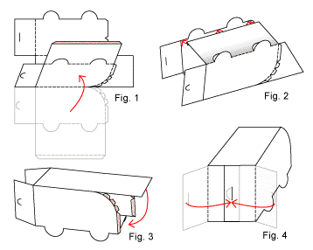

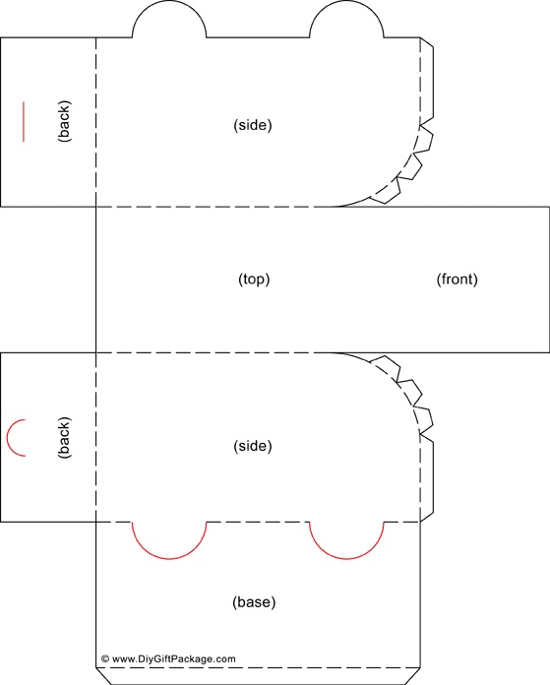
Craft for: Good Morning: Digger

Milk Carton Buildings

Materials:
- Clean milk cartons of any size
- Scissors
- Coloured construction paper
- Paint, crayons, markers
- Glue

Instructions:

- There is quite a variety of options for this craft. The children can use milk cartons with the tops on for a peaked roof line. They can also open out the top of the cartons, cut two of the flaps off, and fold down and tape the other flaps flat. These cartons can be made into taller or wider buildings by stacking and grouping them together.
- Let the children decide what kind of building their milk carton will become.
- The children can paint their milk cartons or cover them with construction paper.
- The children can then add windows, doors, and anything else that relates to the type of building they are creating.

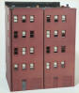

Craft for: Good Night Engines

Airplane Bookmark

Materials:
- Coloured construction paper
- Colourful pipe cleaners
- Scissors
- Glue/tape
- Something to colour with

Instructions:

- Print out the template pieces for each child. These can be cut out of coloured construction paper. Use heavier paper to make a sturdier bookmark.
- Have the children decorate their airplanes and banners however they would like. They could add stripes to the wings, a name, numbers, etc.
- The children can then attach one end of the pipe cleaner to the banner with tape and/or glue, and attach the other end to the airplane.

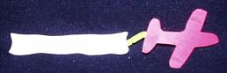

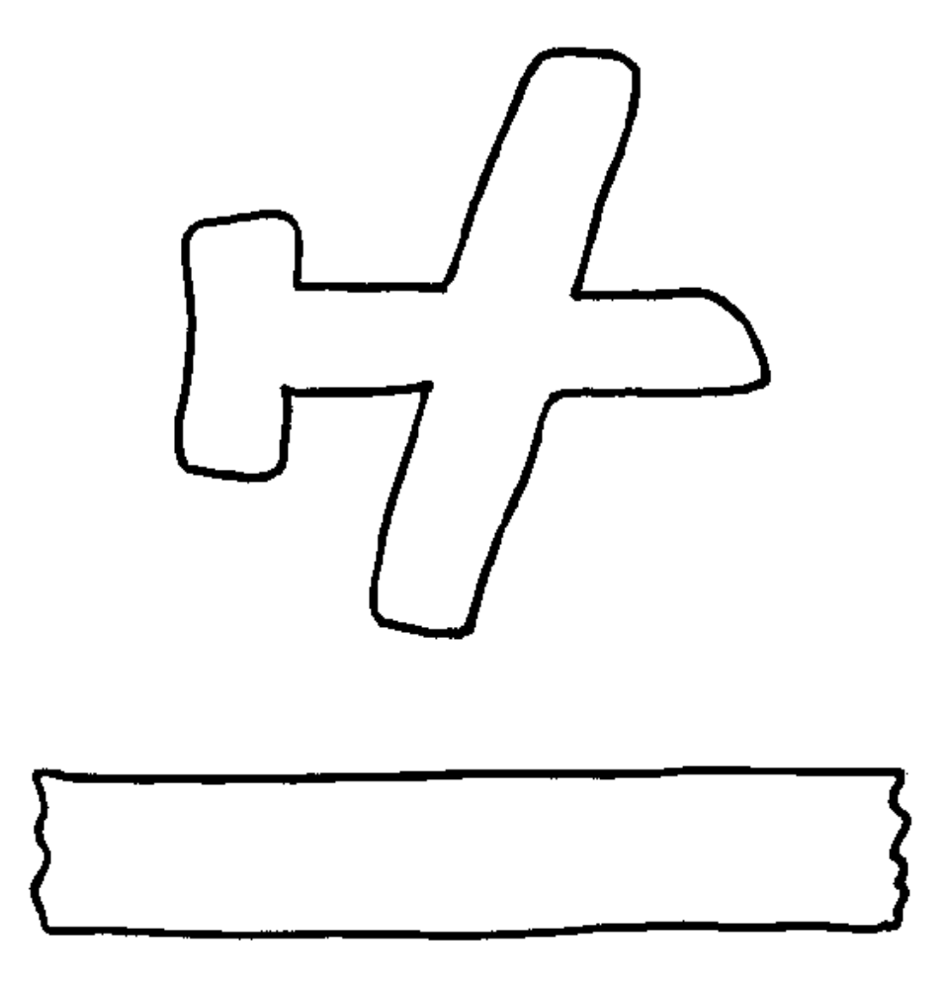

Craft for: Hard Hat Area

Free Standing Buildings

Materials:
- Coloured construction paper
- Scissors
- Tape
- Something to colour with

Instructions:

- Print out the template for each child onto coloured construction paper.
- Have the children cut out and decorate their building with markers, crayons, coloured paper, or anything else they would like.
- Once finished decorating, the children can bend the bottom of the buildings in a circle and tape in place, so the building will stand on their own.

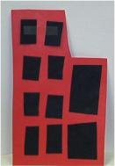

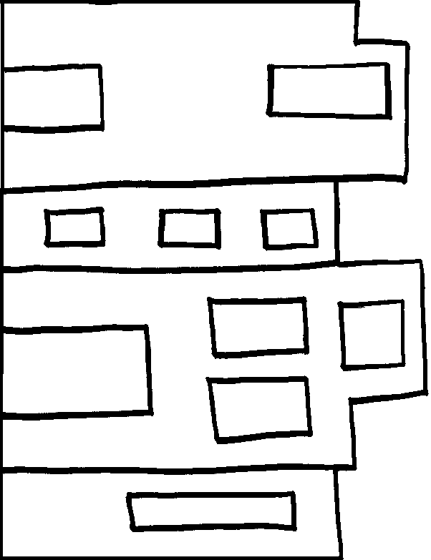
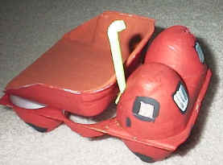
Craft for: I Stink!

Egg Carton Dump Truck

Materials:
- Styrofoam egg carton
- Straws cut into 3 inch pieces
- Glue
- Scissors
- Paint or markers

Instructions:

- Give each child the following three pieces from an egg carton:
  - From the top, cut 1/3 of the egg carton to make the bed of the dump truck
  - From one side of the bottom, but the first two cup strip
  - From the other side of the bottom, cut the first 6 cup strip. Cut the bottom of the middle two cups off this strip.
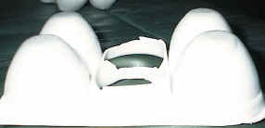
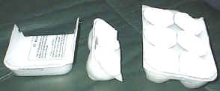

- Have the children glue the two cup strip onto the front of the six cup strip.
- Glue the base of the dump truck onto the back of the 6 cup strip (or just place it on so the kids can move it up and down when they play with it).
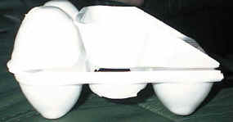

- Have the children colour or paint their trucks yellow or red.
- They can draw black windows on the front and black wheels on the side of the 4 bottom cups.
- Make a small hole in one of the top egg cups. Place the straw in the hole as a smoke stack.
Craft for: The Little Engine that Could

Paper Train
Materials:
- Paper
- Something to colour with
- Scissors
- Glue
- Construction paper
- Cotton balls
- Uncooked spaghetti

Instructions:

- Print out the template pieces for each child to colour and cut out.
- Give each child a large piece of background paper.
- Have the children glue the pieces onto the paper. Start with the body of the train. Next glue on the face on the front and the smokestack on top. Glue the wheels on the bottom.
- Glue the car on next and then the caboose.
- The children can glue cotton balls onto the top of the smokestack to look like smoke.
- To make the train tracks, have the children glue pieces of uncooked spaghetti onto the paper.
- The children could also draw on trees, people, etc.
- To make a sturdy train that doesn’t need to go on background paper, glue the template pieces onto cardboard and then cut them out.

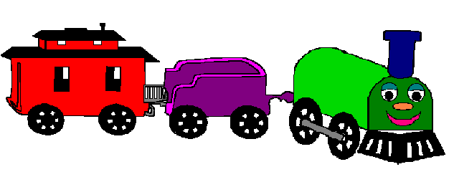

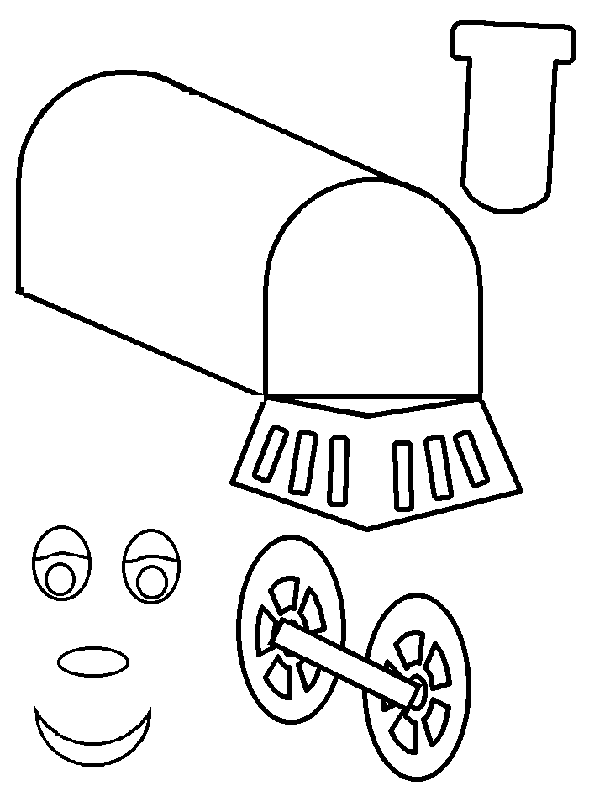
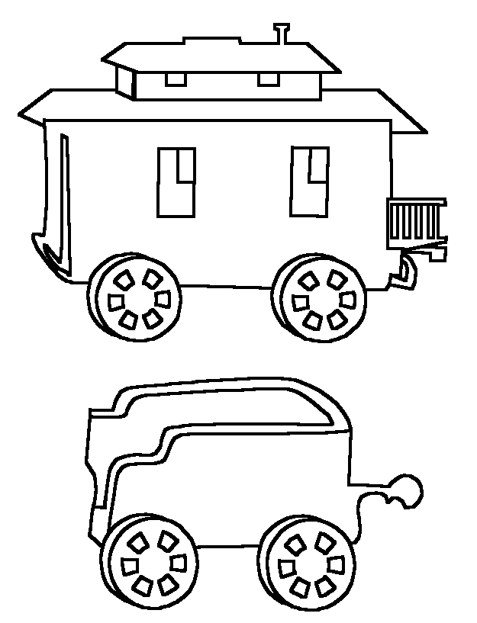
Craft for: Machines at Work

Toy Car Print

Materials:
- Toy cars and trucks
- Paper towels
- Styrofoam Plate, Meat Tray, or Other Shallow Dish
- Construction paper
- Paint

Instructions:

- Fold a towel into fourths and lay it on the bottom of a shallow dish for each child. Pour paint into the center of the paper towel to make it into a stamp pad.
- Have the children dip the wheels of the car or truck into the paint.
- The children can roll it around on the paper towel to wipe off excess paint, and then roll it onto the paper or other surface to make a unique print.
- Have the children try using different sized toy cars and trucks.

Craft for: Monster Trucks!

Dump Truck

Materials:
- Coloured construction paper
- Scissors
- Brass fasteners
- Something to colour with
- Glue

Instructions:

- Print out the template pieces for each child. The truck body can be cut out of one colour of construction paper, and the wheels and back part out of another colour.
- The children can attach the wheels and dumping part to the truck body with brass fasteners, so the parts move.
- The children can further decorate their trucks with markers, crayons, cut-outs of paper, etc.

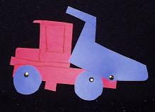

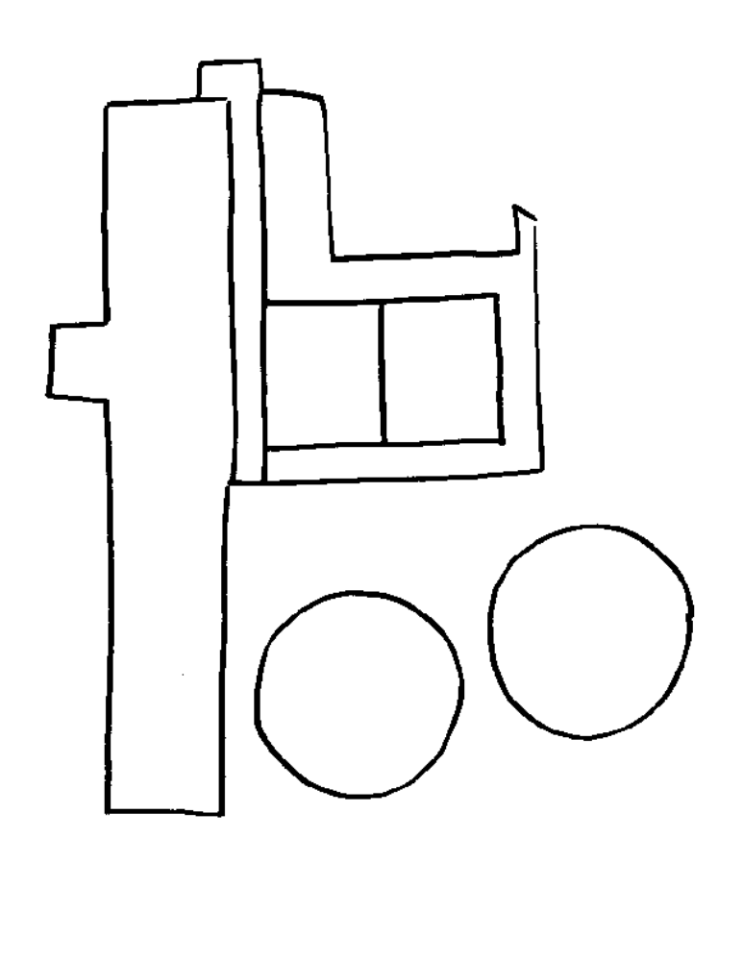

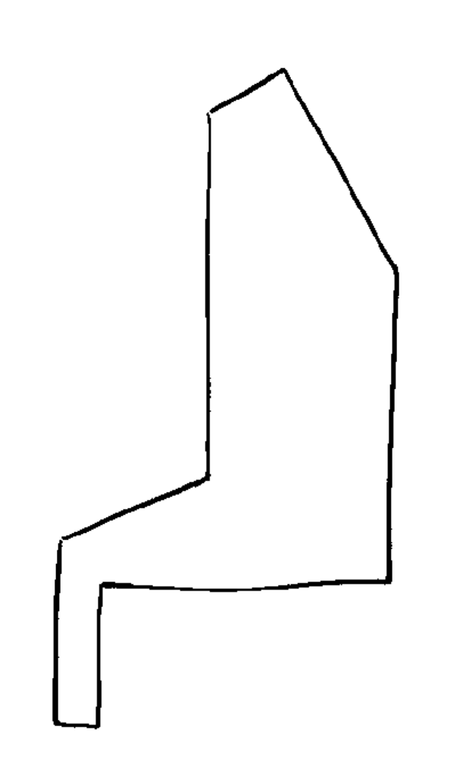

Craft for: My Truck is Stuck

Tow Trucks

Materials:
- Coloured construction paper
- Scissors
- Glue
- Brass fasteners
- Ribbon
- Paper clip
- Something to colour with

Instructions:

- Print out the template for each child to cut out of coloured construction paper.
- For the wheels, either have the children create their own or pre-draw them on construction paper for the children to cut out.
- The children can attach the wheels to the truck with the brass fasteners so they spin.
- Next cut a small piece of ribbon for each child and attach a paper clip to the end of it. The children can attach the ribbon piece to their tow trucks to create the towing mechanism.
- Have the children decorate their tow trucks with crayons, paper shapes, etc.
- The children could also draw and cut out a broken down car from construction paper. Punch a hole through the back or front bumper to hook the car up to the tow truck with the paper clip.

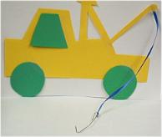

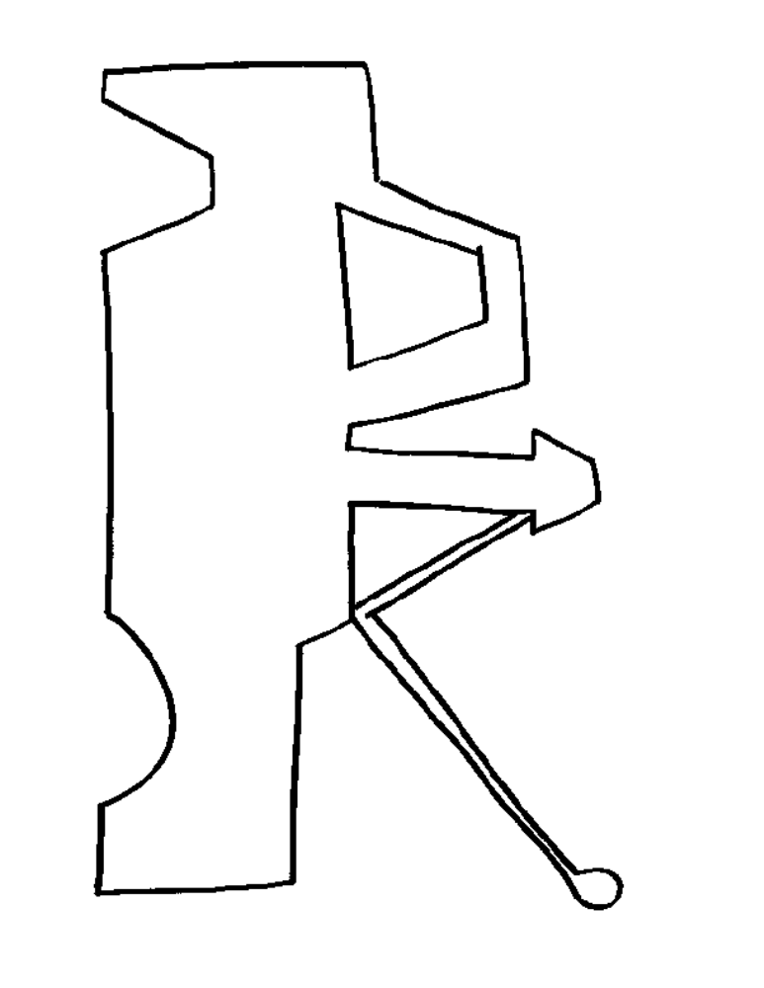
Craft for: The Night Worker

Toilet Roll Handy Man

Materials:
- Toilet roll
- Paper
- Glue
- Scissors
- Something to colour with

Instructions:

- Print out the template for each child to colour and cut out.
- The children can first glue the large rectangular piece around the toilet paper tube.
- They can then glue the smaller rectangle (tool belt) around the center of the toilet roll.
- Next glue on the head and arms, and then the feet onto the front of the roll.
- To finish, glue the hammer onto the tool belt or into one of the hands.

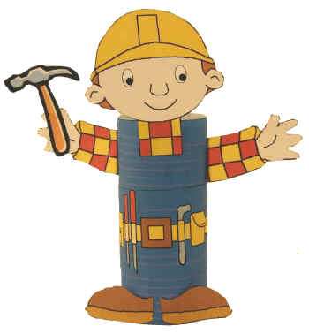

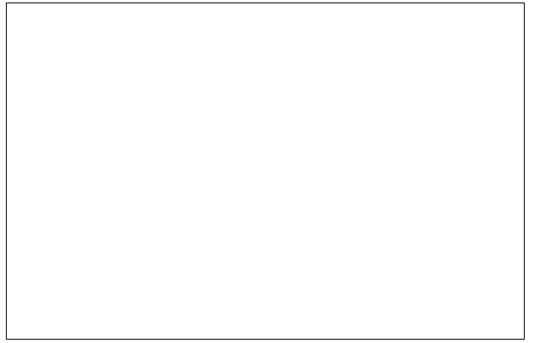

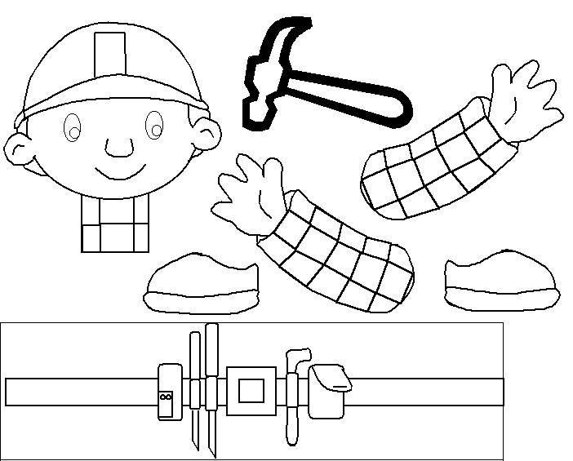

Craft for: Trucks: Whizz! Zoom! Rumble!

Soapbox Truck

Materials:
- Small, non-corrugated cardboard box
- Scissors
- Glue
- Craft wire
- Something to colour with
- 4 black buttons
- 2 beads
- Optional: paint, toy figure

Instructions:

- Have the children paint the box with acrylic paints, or turn the box inside out and reseal the seams with double-sided tape. Set the box upright on one of its longer edges so that the box top becomes the front of the truck.
- Then, cut away the upper corner of the truck front and glue closed the lower portion. This provides a place for the driver (a toy figure) to sit.
- To attach wheels, insert a piece of craft wire through one side of the truck and out the opposite, positioning the wire an inch in from the back of the truck and as near to the truck floor as possible. Slip each end of the wire axle through one of the holes in a black button, and bend the tips to keep them from sliding back through. Use the same method to attach a second set of wheels just behind the driver's seat.
- The children can glue on a set of bead headlights.
- To finish, the children can decorate the outside of their box trucks. They can also put a toy figure in the box for a driver.

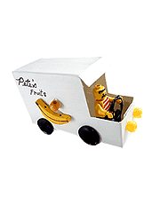

Craft for: Tugga-tugga tugboat

Foil Fleet
Materials:
- Baby foil loaf pan, or aluminum foil formed into a loaf pan shape
- Non-hardening modeling clay
- Flexible vinyl report cover (or construction paper)
- Permanent marker
- Scissors
- Bamboo skewer
- Fishing line

Instructions:

- Have the children gently pinch one short end of the loaf pan to shape the boat's bow and then re-straighten the sides of the pan, if necessary.
- The children can then press a 1 1/4-inch-wide ball of clay onto the center of the boat floor, sticking it securely in place.
- On the report cover, draw a triangular sail (about 7 1/2 inches high and 7 inches across the base) for each child.
- Have the children cut out the sail, fold it in half vertically, and make a tiny cut into the fold 1 inch from the top, and another 1 inch from the bottom. Unfold the sail.
- Cut a 9 1/2-inch length from the bamboo skewer and have the children thread it through the holes in the sail.
- They can then insert the mast bottom straight down into the clay.
- Make a small hole in the bow and tie on a long piece of fishing line for maneuvering and retrieving the boat once it's launched.

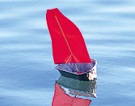

Alternate Craft for: Tugga-tugga tugboat

Paper Ferry

Materials:
- Paper
- Blue construction paper
- Scissors
- Glue
- Something to colour with

Instructions:

- Print out the pattern for each child to colour and cut out. The smaller shapes can be used as windows.
- The children can then glue the boat onto a piece of blue background paper.
- They can glue the windows onto the ferry, however they would like.
- Have the children add a background to the ferry, such as waves, passengers, seagulls, etc.



